INSPIRING TEACHERS
ELT PLAN TEMPLATE

Complete with the information about you
Author
Teacher´s name | Denys Sandoval
Email | Denissan07 gmail.com
School | Inst. Educativa Técnica Francisco de Paula Santander

Select the type of plan
Lesson plan | Activity plan | Task plan | Project plan
 | X

Author’s remarks
This plan aims at improving students oral, listening and written skills based on the topic Teenagers, their culture and social problems.
This class gives the teachers a good opportunity to identify the abilities of their students to express their ideas, tips and suggestions and work on the practice of reading comprehension.

Complete with the information about your students
Grade | Length of lesson | Number of students |  | Average age
10th | 70 minutes | 40 |  | 15 to 17
Area |  | English level
Rural | Urban X | A1 X | A2

Select the curricular axe or focus
Curricular Focus / Axes
Environmental / Sustainability Education
Sexual / Health Education
Construction of Citizenship / Democracy / Teenagers | X EP! Teen culture Lesson 4
Globalization

Topic | Teen culture
Module / Unit | Module 1 unit 2 pages 22 – 26
Language focus | Language Function | Language skills | Vocabulary
Language focus | Identifying social issues | Reading | Suggestion  Advice
Principles / approach | Noticing approach

Learning objectives
Aim | By the end of this lesson, students will be able to give advice and suggestions about different social issues
Subsidiary aims | By the end of this lesson, students will be able to …  - discuss and suggest solutions for teenage problems.  - Identify the use of should, shouldn’t, could, couldn’t to suggest solutions.

Materials needed
Book:
http://aprende.colombiaaprende.edu.co/sites/default/files/naspublic/colombiabilingue/ep_sbook/student_ep2.pdf
dictionary, markers, cards, short posters, photocopies, video bean, sticky tape

Sc  tage | Procedure | Time and Patterns of interaction
Warm up:  Ice-breaker | Board Race (5 mins)  The class is divided into two teams and T gives each team a coloured marker. T draws a line down the middle of the board and writes the topic at the top: Activities you do with your friends in your free time. SS must then write as many words related to the topic in a relay. The first person writes the first word and pass the coloured marker to the one next in line. Score each team with one point for each correct word. Unreadable or misspelled words are not counted. The groups should be attentive and check that the words written on the board are correct. If there is a mistake, the student will check with his group, will go to the board and will correct it.  Words: Cycling, having lunch, playing basketball, watching tv,…  T asks SS to say what the connection between these words is. Then, T asks SS to copy the words on their notebooks. | 10 minutes  T-SS  SS-SS  Revise useful vocabulary
Warm up:  Ice-breaker | Assessment: Peer assessment to help each other find and write the correct word. | 10 minutes  T-SS  SS-SS  Revise useful vocabulary
Lead in | Learning strategies (10 mins)  T tells students that they are going to work in pairs on a reading activity but first, they have a look at the Reading tip to improve this skill.  T shows page 22 on the book and asks three volunteers to read aloud the paragraphs. Teacher gives each pair of students three cards with one question and three possible answers in each of them. Questions and answers:  1.What kind of text is it?  A. They are notes asking for advice B They are local news C. They are advices.  Teacher gives 30 seconds silent thinking before any answers; Teacher asks learners to brainstorm in pairs first for 2-3 minutes, and Asks learners to discuss with a partner before answering. Teacher uses hand signal to check the correct answers. Teacher asks one student to read the question and the answers one by one. A thumb up means “it is true”, A thumb down means “it is false”  Answers:  1.What kind of text is it? A. They are notes asking for advice  2. Where can you find these texts? B. On a school magazine  3. What are they about? B. They are about typical teenage problems  Reading (5 min)  Answers: 1b 2c 3a  T writes on the board two questions and ask students to work in pairs and discuss question 2, after reading the situation on page 22:  - What is Rachel¨s /Aleja´s / Jack´s problem?  - What is your idea to solve each problem?  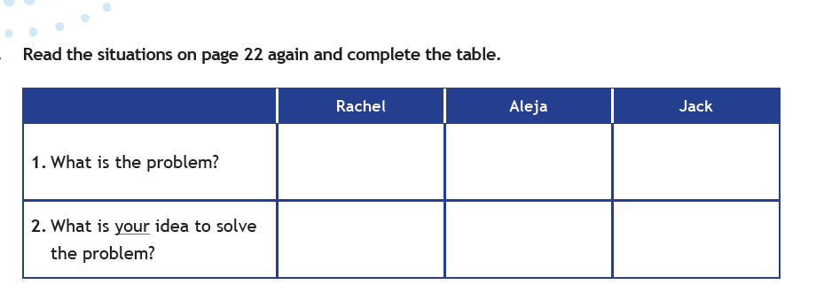  Teacher asks students to stand up and ask questions of classmates in other groups. T asks them to prompt for more information, e. g, “why do you think that?” “Persuade me! | 10 minutes  T-SS
  Where can you find these texts?
  A. On a newspaper B. On a school magazine C. On a religion book.
  3. What are they about?
  A. They are about life in my neighbourhood B. They are about typical teenage problems
  C. They are about history events
Lead in | Assessment: peer assessment - Post its  T gives all ss a post it which must be used as a short poster to tell any friend anything about his performance.  Poster adaptation | 10 minutes  T-SS
Language discovery | Focus on language (10 mins)  T shows focus on language page 23, exercise 4 and asks SS to copy them on their notebooks and match the advice with pictures a (Aleja), b( Rachel), c (Jack). T asks students to volunteer to read the advice and match the answer.  Answers. A. Jack B. Aleja c. Rachel D Aleja E. Rachel f. Jack  T focuses SS attention on exercise 4. T uses them to elicit meaning from SS:  Which verb do we use in exercise 4. T asks SS to write verbs on the blackboard (Find, be ask, worry..). Elicit what the modal verbs in exercise 4 are (should, shouldn’t and could). Highlight these forms on the board (should/shouldn’t/could go). T puts SS in pairs and have them match the verbs to the uses. T asks concept questions to elicit meaning from SS: Does the speaker think it is a good or bad idea? Are they giving a suggestion?  T then clarifies SS that these words (should, could) are modals and asks SS to write this title above their sentences on their notebooks.  Then, teacher write on the board:  Which verb do we use to:  a. give a suggestion?_________  b. give advice and tell someone to do something?_______________  c. give advice and tell someone NOT to do something?_________________  T gives learners time to review and make corrections in pairs.  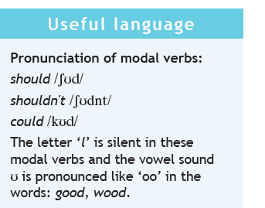  Answers:  - Could B. should C. shouldn´t  T reads the note box in page 23 and models the pronunciation of the three modal verbs and drill. T tells SS we don’t say the l in these words. The letter “l is silent in these modal verbs and the vowel sound u is pronounced like “oo” in the words. | 10 minutes  T-SS  Get to understand how language Works
Language discovery | Assessment: peer assessment about the three-modal pronunciation | 10 minutes  T-SS  Get to understand how language Works
Production | Practice (10 mins) T glue half of some sentences on the walls of the classroom and gives the other part to each of the groups. Students work in groups, they receive a half sentence, they have to find the complement of this walking around the classroom. Each group read loudly its sentences and write it on the blackboard. They have to say if it is a suggestion or an advice. Groups help each other to check every answer and correct it if it is necessary.  T asks students to read the gapped sentences in exercise 7. T tells them they should listen and write should, shouldn’t or could.  T plays audio track 7 and have SS compare their answer in pairs. T plays audio track 7 again if needed. T plays audio track 7 again to check answers as a class, pausing after each question.  Answers  a could  b shouldn’t  c should  d should  e shouldn’t  f could | 20 minutes  T-SS  Ss – Ss
Production | Assessment: T adapts the rubric page 44 (appendix 2) and shows it to SS, and asks them to check the chart and describe how they feel about them.  At the end of the lesson, T asks learners to make a list of two things they learned, and one thing they still need to learn, they do not have to write their names on the papers (Two stars and a wish) | 20 minutes  T-SS  Ss – Ss
Wrap-up | T uses the notes that the students made about their learning in class, and make explanations and give new examples.  T clarifies doubt and sets homework | 20 minutes  T-SS
Wrap-up | Assessment: The following is an extra exercise T can use if it is necessary. SS are asked to work in pairs to do exercise1 in photocopies. (appendix 2) T clarifies that the answers depend on the situation on the left column, so he asks the class to help him match the first one thus it is done as an example.  SS complete the exercise and then T checks it with the class. | 20 minutes  T-SS

Implementation alternatives
T ask students to Search the newspapers for a problematic situation in the region, read it in the group and suggest possible solutions, then put on the billboard of the school the problems and their possible solutions.

Key words
Topic | Skill | linguistic | vocabulary | grade
Teen culture | Reading | Should  Could  would | Suggestion  Advice | 10°

Exercise 1
What did you think about Alison’s idea? | If you want to arrive early you should take a plane.
Your girlfriend is angry with you | They don’t have money, they could come by car
Planes are faster than trains. | At first, I didn’t like it, but now I think she could be right
Cars are cheaper than planes | She could speak several languages
She was the best in the contest. | You should send her flowers.

Appendix 2
Skills | Statement | I can do this | I can do this with help | I need to work on this
Reading | I can read a test about teenage problem
writing | I can write an advice or express a possibility in a sentence
Speaking | I can give advice to teenagers about their problems.
listening | I can understand teenagers talking about their hobbies  and interests.

