INSPIRING TEACHERS
ELT PLAN TEMPLATE

Author
Teacher´s name | Melba Sofía Cifuentes Rodríguez
Email | sociro@gmail.com
School | José Joaquín Casas- Chía

Lesson plan | Activity plan | Task plan | Project plan
X

Author’s remarks
This plan will enable students to reflect on the characteristics they consider important in a role model giving them the opportunity to express their point of view and to talk about important roles for them. The lesson presents useful vocabulary in a context that creates a good speaking framework then, students will be able to enhance their communicative skills.

Grade | Length of lesson | Number of students |  | Average age
10th | 110 minutes | 32 |  | 14-17
Area |  | English level
Rural | Urban X | A1 | A2 X |  | B1

Curricular Focus / Axes
Environmental / Sustainability Education
Sexual / Health Education
Construction of Citizenship / Democracy / Teenagers | X
Globalization

Topic | Teen Culture
Module / Unit | EP! 2- Unit 2- Lesson 5 – pages 26-28
Language focus | Language Function | Language skills | Vocabulary
Language focus |  | Speaking
Principles / approach | Integration of the four language skills

Learning objectives
Aim | By the end of this lesson, students will talk about everyday role models and their achievements.
Subsidiary aims | By the end of this lesson, students will learn how to use appropriate expressions and tenses to talk about past events and situations.
Materials needed
Equipment: computer, TV set, speakers.
Copies: Appendices
Materials: Colours, markers, papers, magazines, a frame

Stage | Procedure | Time and interaction
Warm up | T explain SS that they are going to watch the video “ordinary people change the World”. Taken from: https://www.youtube.com/watch?v=KFeyPtBA1Vg&feature=youtu.be and asks SS to complete the sentences in exercise 1. (Appendix 1)  Answer key:  - Ordinary people can change the world.  - Being famous is very different than being a hero.  - Their lives shaped our world.  - I believe in regular people and their ability to change in this world.  - Their values taught us how to live.  - Goodness lives within each of us.  Then, T checks answers with the whole group. | 5 minutes  Individual work  5 minutes  Whole group
Introducing language | Ss work in the vocabulary task in appendix 1 where they find some useful vocabulary and expressions about the topic. SS to work in pairs in order to match each word or expression with its definition in the right.  Answer Key  1 E 2 G 3 H 4 A 5 I 6 C  7 M 8 D 9 L 10 O 11 N 12 F  13 K 14 R 15 J 16 B 17 P 18 Q  T checks the words and expressions with their corresponding meaning to confirm SS understand. Drilling is also done to practice pronunciation of all words and expressions. Once SS have read all word cloud at least twice, T corrects any pronunciation mistakes.  T writes on the board the sentence: “Heroes are ordinary people who make a difference” and pastes a word cloud with the vocabulary and expressions taken from the video. The word cloud can be created at https://wordart.com/ (See appendix 2)  Vocabulary:  Brave determination Noble Authenticity  self-sacrificing positive influence Walk your talk living examples right answers live up your own values make a mistake take risks  Influence others helping others Listen deeply be present  take time be patient Rewarding role strong  T. asks Ss why these characteristics are necessary to make the difference. Ss work in pairs and say what they think about these words.  T asks these three questions about the three beloved American heroes shown in the video “ordinary people change the World” at the beginning of the session: Albert Einstein, Martin Luther King and Neil Armstrong.  - Who was Albert Einstein?  - What good qualities did he possess?  - How did these qualities help him to achieve his dreams?  T allows SS to share their ideas and SS take turns to write on the board their answers using the words in the cloud about the three heroes seen on the video. Then, T checks answers with the whole group. | 10 minutes  Pair work  5 minutes  Pair work  Whole class  10 minutes  T- Ss
Practice | T. tells the class that the people in the video are role models for us. Now. He/she asks SS to think about who their role model in life is. T tells SS that the role model can be a famous person, a family member, familiar people, neighbors or friends they admire in their own lives similar to the famous people in the video.  Now, that they have identified who their roles models in life are, they write down some things about that person. They can use these questions to guide them:  - Who plays an important role in your life?  - How does he /she influence your life?  - What qualities do you think your model can influence others?  - Does he/ she live up his/her own values? Why?  T writes these sentences on the board as examples:  - I am inspired by my aunt because she takes risks and is patient.  - I think she influences my life very positively because she is everything I want to be.  - I admire her because she is respected and demonstrates confidence and leadership.  T goes around to assess students or clarify any doubts or encourage them to use vocabulary, expressions, and examples written on the board)  Then, T tells SS they have to create a portrait or poster to honor their favorite role model using markers, color pencils, newspapers, etc. including the details in the checklist given. (Appendix 3). They are given 30 minutes to do it.  SS use the vocabulary cloud and useful language as guidance, and while SS write and draw T goes around if they need any help to see whether they are using the right expressions and vocabulary.  When time is up T asks SS to show and present their poster to the class. T. writes the useful language box on the board and encourages SS to use them for their narrations:  USEFUL LANGUAGE:  My role model is… I am inspired by_____ because…  I think he/she is great because he/she…. I like him/her because….  I admire _____ because…  When the task is finished SS hang their posters on the wall prepared in advance to exhibit their works and labeled with the banner ROLE MODEL HALLWAY OF FAME.  After SS display their posters the whole class checks and selects the best according to the checklist. | 15 minutes  T- SS  25 minutes  Individual work  20 minutes  Ss-SS  5 minutes  Ss-Ss
Assessment | T. gives Ss appendix 4 and asks them to tick the column that best describes the progress along the lesson.  T gives rewards to students to motivate and incentive their participation and attitude in classes. They are given some pass according to their performance in the lesson. You can get, print and cut them for your SS from https://worldlanguagecafe.com/reward-ideas-high-school-students/ | 10 minutes

Implementation alternatives
This plan was made for a multilevel English level group, the school has Jornada Unica and moreover it has an inclusion programme. Depending on students’ characteristics and pedagogical model it is possible to adapt other strategies including speaking and take the advantage of choice boards to take into account different learning strategies.

Key words
topic | skill | linguistic | vocabulary | grade
Teen culture | Listening, reading and writing | Live up, take risks, be patient, take time, listen deeply | Adjectives and expressions to talk about role models and past events | 10th and 11th

Appendix 1- Role models

Exercise 1. Complete the following sentences from the video using the words in the box.
- Ordinary people can ____________the world.
hero values
change world ability
lives goodness
regular different live

- Being famous is very________ than being a _____.
- Their ______ shaped our ______________.
- I believe in________ people and their __________ to change in this world
- Their ___________ taught us how to ________.
- ________ lives within each of us.

Exercise 2. Useful vocabulary. Match each word or expression with its definition in the right.
- Brave (____) a. Of an exalted moral
- Determination (____) b. Make the commitment or effort
- Strong (____) c. Unselfish
- Noble (____) d. Suit one's actions to one's words
- Authenticity (____) e. Having or showing courage
- Self-sacrificing (____) f. Do something that may result in loss, failure
- positive influence (____) g. The quality of being firm
- Walk your talk (____) h. Mentally powerful
- living examples (____) i. The condition of being genuine
- live up your own values (____) j. Actively hear
- make a mistake (____) k. Have an important effect on someone
- take risks (____) l. A person or thing similar to another
- Influence others (____) m. Ability to affect with certainty
- helping others (____) n. Do something incorrectly
- Listen deeply (____) o. Identify your own values
- take time (____) p. the quality of having patience
- be patient (____) q. good feeling for doing something valuable
- Rewarding role (____) r. someone who do care for other people

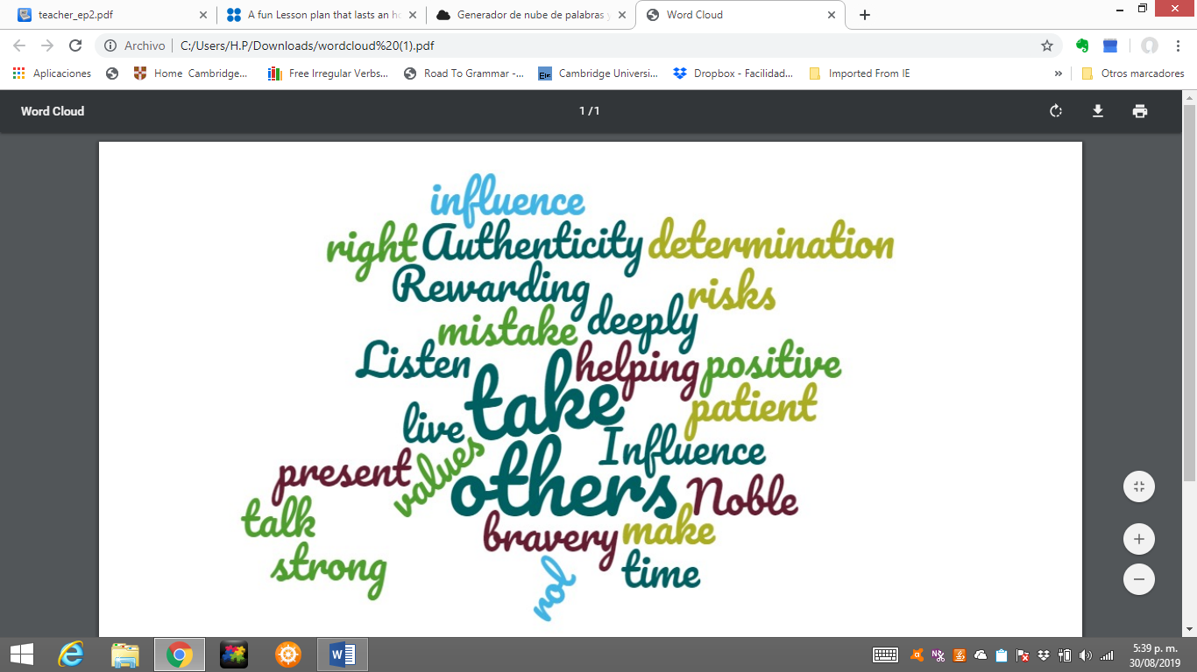
Appendix 2 –Word cloud

Created at https://wordart.com/

Appendix 3

Poster checklist  Tick Yes /No to verify your poster is well designed. | Poster checklist  Tick Yes /No to verify your poster is well designed.
  CONTENT | YES | NO
  Clear purpose
  Organised
  Relevant Information
  Essential vocabulary
  (spelling and grammar)
  DESIGN | YES | NO
  Balanced
  Coloured
  Headings
  GRAPHICS | YES | NO
  Title and sections
  Relevant images
  CONTENT | YES | NO
  Clear purpose
  Organised
  Relevant Information
  Essential vocabulary
  (spelling and grammar)
  DESIGN | YES | NO
  Balanced
  Coloured
  Headings
  GRAPHICS | YES | NO
  Title and sections
  Relevant images
Poster checklist  Tick Yes /No to verify your poster is well designed. | Poster checklist  Tick Yes /No to verify your poster is well designed.
  CONTENT | YES | NO
  Clear purpose
  Organised
  Relevant Information
  Essential vocabulary
  (spelling and grammar)
  DESIGN | YES | NO
  Balanced
  Coloured
  Headings
  GRAPHICS | YES | NO
  Title and sections
  Relevant images
  CONTENT | YES | NO
  Clear purpose
  Organised
  Relevant Information
  Essential vocabulary
  (spelling and grammar)
  DESIGN | YES | NO
  Balanced
  Coloured
  Headings
  GRAPHICS | YES | NO
  Title and sections
  Relevant images

Appendix 4- Self assessment of language skills

Tick the column that corresponds to describe your progress in class.

Skill | statement | Very well | Quite  well | With difficulty
Listening | I can understand audio material related to role models.
Writing | I can write sentences or short paragraphs about a role model
Speaking | I can do an oral presentation about important people to me.

----------------------------------------------------------------------------------

Appendix 4- Self assessment of language skills

Tick the column that corresponds to describe your progress in class.

Skill | statement | Very well | Quite  well | With difficulty
Listening | I can understand audio material related to role models.
Writing | I can write sentences or short paragraphs about a role model
Speaking | I can do an oral presentation about important people to me.

----------------------------------------------------------------------------------
Appendix 4- Self assessment of language skills

Tick the column that corresponds to describe your progress in class.

Skill | statement | Very well | Quite  well | With difficulty
Listening | I can understand audio material related to role models.
Writing | I can write sentences or short paragraphs about a role model
Speaking | I can do an oral presentation about important people to me.

