INSPIRING TEACHERS
ELT PLAN TEMPLATE

Complete with the information about you
Author
Teacher´s name | Yullys del Carmen Alvarino Ochoa
Email | maye0818@hotmail.com
School | Institución Educativa Luis R Caparroso de Soledad.

Select the type of plan
Lesson plan | Activity plan | Task plan | Project plan
x

Write a few lines about the usefulness of this plan for the Colombian English teachers
Example: This lesson plan gives the students a chance to know about you, their new teacher, and it also gives you a valuable opportunity to assess your students' level. It can also be a useful and productive class if you ever find yourself substituting a class at short notice.
Author’s remarks
This lesson plan helps students to think about different real life situations they have to deal with. And at the same time gives them the opportunity to use the modal verb “should / shouldn´t” for giving advices or recommendations. Also, it presents a wide variety of activities and assessments which result valuable for teachers and students alike. The most of the activities were taken from EP! Student Book Fast Track 11grade.

Complete with the information about your students
Grade | Length of lesson | Number of students |  | Average age
11° | 2 hours (120min) | 35 |  | 16-19
Area |  | English level
Rural | Urban x | A1 | A2 x |  | B1

Select the curricular axe or focus
Curricular Focus / Axes
Environmental / Sustainability Education
Sexual / Health Education | x
Construction of Citizenship / Democracy / Teenagers
Globalization

Complete with information about the content and methodological approach of the plan
Topic | Giving advices to live a healthy life!
Module / Unit | Module 3 Love and relationship. Unit 3 Health and responsibility. (EP! 3- Lesson 7- pages 110- 113-114-115.
Language focus | Language Function | Language skills | Vocabulary
Language focus | Suggesting ways of being healthy | Writing and speaking | Good and bad habits to be healthy. Practicing sports like football, eating healthy food and playing videogames all day long.
Principles / approach | Integration of the four languages skills. Noticing approach to language development.

In “Aim”, state what the learning goal is, in other words, what you want your students to achieve by the end of the session.
In “Subsidiary aims”, relate the language skills (communicative and linguistic) students need to master in order to achieve the main aim of the lesson. Make sure the aims are learner-centred, specific, measurable, achievable, realistic, and action oriented.
Learning objectives
Aim | By the end of this lesson, students will be able to give advices and recommendations to be healthy.
Subsidiary aims | By the end of this lesson, students will be able to …  - Recognize the vocabulary related to good and bad habits to be healthy.  - Identify the grammatical function of should and shouldn´t.  - Play an active role in the development of the different activities.  - Respect others´ opinions or participation

List all the materials needed for this plan. Please, do not include any picture or photograph.
Materials needed
Cards, board, markers, a ball, pieces of cardboard, envelope, photocopies, tape recorder, music, EP! Student´s Book 3. Fast Track 11th grade.

Write the name for each state of the plan. Then in the “Procedure”, write a detailed description of what the teacher and students do at each stage of the session.
Be sure to be thorough so any teacher can follow this plan. Write the procedure in third person and present tense.
Use these conventions: T= teacher S= students Ss= students
Stage | Procedure | Time and Patterns of interaction
Warm-up  (game) | Before the warm-up, T makes some routine activities and socializes the objective of the class.  PICTIONARY. (To activate prior knowledge)  The teacher lists the students ( 1,2,1,2…) to split the class in two groups. Then, explains to Ss that one representative for each group has to take a card, read and draw on the board, indicating to his/her team the number of words they have to guess. T gives Ss a clue saying that the vocabulary is related to healthy life. The winner is the team that gets more points.  *CLUE WORDS: Drink water, do exercise, drink soda, eat fruit and vegetables, eat fast food, ride a bike, smoke, eat breakfast, sleep minimum eight hours, drink alcohol, eat breakfast.  T, asks the Ss what the connection among these actions is and how we can call them. – (Good and bad habits to be healthy). | 10 minutes  SS-SS  T- Ss  Team work
Presentation: | T asks Ss to copy the vocabulary on their notebooks and read it with the whole class. Then, T tells Ss that they are going to “talk” with a classmate about all the food they ate yesterday following the instructions on SB. EP! ( page 113 point 12), but first T gives them some speaking tips, inviting them to feel comfortable, relaxed and free at talking without paying too much attention to spelling mistakes, but rehearsing a little with a partner before speaking for the class. Ss complete the chart about what they ate for breakfast, snacks, lunch and dinner on their notebook. Meanwhile, T asks some Ss for sharing their answers and takes notes on the board making questions like: * Is this a good breakfast/ lunch/ dinner? Why? Finally, T analyse with the whole class all the foods they ate and making conclusions about if they are good or bad to be healthy and mentioning possible problems for having an unhealthy diet.  For practicing the vocabulary and extend it, T plays with the Ss “OH, YEAH!” (a game for checking vocabulary) it consists in throwing a ball, the person who catches it says one word from the vocabulary (good and bad habits to be healthy) and gives back the ball to the T, T throws the ball 2 times but explains that the 3rd person who receives the ball doesn´t say any word from the vocabulary, he has to shout: “OH, YEEAAHHH!” for example, drink water, do exercise, Oh, yeeaahh! So, every 3 times someone says that. | 15 minutes  T-Ss  Ss-Ss  Pair work  Class participation.  5 minutes  T- Ss  Class participation  5minutes  T-Ss  Class participation
Presentation: | Assessment: T says Ss it is time to use the colored papers that she put on their desks. It is a self-assessment called The Traffic Light And explains the meaning of each color (green: understood, yellow: needs help and red: didn´t understand) So, Ss have to raise their hands and show one piece of paper according to their level of understanding. Tasks them to indicate if they understood all the vocabulary worked.  
Practice: | Now, T invites Ss to read the case on point 13 on the same page (113), Ss have to:  - Identify the problem  - Think about possible solutions  T reads loudly the conversation and Ss follow it paying attention to the pronunciation and the unknown words. After that, Ss read individually and T verifies Ss’ reading comprehension by questioning them:  *What kind of reading or text is it? – A conversation  *Who are talking? – Tow friends / Charles and Kelly  *What are they talking about? – Charles´ problem.  *What is Charles’ problem? – He isn´t sleeping very well.  *Why? – Because he plays on line computer games.  *And do you think this is the problem? - No. The problem is because he plays at nights with people from different countries and they have different time zone.  *Is this a good or a bad habit to be healthy? – A bad habit.  *What does Kelly say to Charles? - He has to sleep for nine hours and play with people from his country. (T writes this answer on the board) Then, T rewrites Kelly´s opinion but changing the verb “has” by the modal “should” and calls Ss’ attention using a red marker to highlight it. Immediately makes Ss some questions in order that they discover the grammatical function or the use of “should”. T asks Ss to observe the new red word and explains them we use “should” to give advices or recommendations. And also T asks Ss which word comes after “should” T circles it and repeats “sleep” and continues questioning, what kind of word is sleep? (Action or verb) So, after the word “should” we have to write a…? (Verb) notice that the verb is in the base form. T asks Ss to read the new sentences:  - Charles should sleep nine hours.  - Charles should play with people from his country.  To introduce the negative form (shouldn´t) T asks Ss to make more sentences about Charles’ situation. Ex: About playing with people from another country, and about going to bed late. How can you say it using shouldn´t and taking into account the form of the verb?  * Charles shoudln´t play with people from another country.  * Charles shouldn´t go to bed late.  So, for practicing the new words T asks Ss to write all the examples on their notebooks and chooses tow volunteers for reading and dramatizing the conversation, but including the new words (should/shouldn´t) in the moment of giving recommendations.  T says Ss that now they are able to give advices and recommendations as it were proposed in the objective at the beginning of the class. | 20 minutes  T-Ss  Ss-Ss  Pair work  Class participation  5 minutes  T- Ss  Class participation
Practice: | Assessment: Before doing the next activity T applies the HAND SIGNAL CATs (Classroom Assessment Technique) and explains to Ss that they are going to use their fingers to indicate how much they understood the topic, but with their eyes closed. When T gives the order they have to show:  * 1 finger: I didn´t understand the topic.  * 2 fingers: I partially understood the topic.  *3 fingers: I understood the topic very well.  T reinforces, gives feedback and recommends Ss to review the exercises done during the class.
Production: | To reinforce and check the use of the new words (should/ shouldn´t) T splits the class in two groups, spreads on the floor the vocabulary cards (good and bad habits the same she used for the warm-up) and plays music. Meanwhile, some Ss are walking or dancing around; T turns the music down and speaks louder making this question: WHAT SHOULD OR SHOULDN´T WE DO TO BE HEALTHY? And each student has to picks up immediately one card and answer the question using “should / shouldn´t” according to the information on the card. Ex: We should eat fruits and vegetables. T does this 3 times and then changes to the other group. T makes corrections and gives Ss feedback when is necessary.  To assess the topic T explains Ss they are going to work in pairs and for supporting their learning she is going to use a RUBRIC, so the T describes Ss the criteria, descriptors and level of performance she takes into account for the activity. Then, T shows them an envelope and explains that there are some pieces of paper inside with different situations (taken from EP! Page 115) Each pair has to choose one paper without looking, read and invent a short conversation giving advices or recommendations (using should / shouldn´t), Ss have to practice and dramatize for the whole class. T takes notes about the activity and gives feedback to each pair. | 35 minutes  T- Ss  Pair work  Class participation  5 minutes  T- Ss  Ss-Ss
Production: | Assessment:  Before starting the presentation, T explains POSTERS; A Peers Classroom Technique and assigns one partner to each other and gives them a piece of paper (the poster) where each one has to write what he or she liked the most about his classmate´s presentation or some recommendations for improving if it is necessary. T explains that the way in which our friends assess us it is very valuable. So, they have to do it with responsibility and respect being sincere and polite, but never rude.
 | After that, T explains the assignment. Students to read at home point 3 on page 114 from EP! A particular situation about a girl named Sarah. T asks them to write at least 5 recommendations for the girl. For their writing production there are also some aspects (rubric) to take into account, T explains them and gives specific orientations, students have to bring the sentences on a piece of paper on the next class and give it to the teacher. Also Ss have to choose a special case from their family. A person who has health problems and needs some recommendations to be healthy. Ss have to write the advices on their notebooks and bring them to the next class. | 10 minutes  T- Ss  10min  Ss-Ss  Class participation
 | Assessment: As a way to assess the class T explains to the Ss that they are going to do a (self-assessment) “LEARNING LOG”; an activity which is not graded and they don´t have to write their names, it is just a way to help them to get a better understanding of the lesson. So, T invites Ss to feel confident at answering. Immediately T gives them the pieces of papers with some prompts, they have to complete at least 5 of them.  - Something I learnt today was____________________________  - My favourite activity in this class was______________________  - Some good habits to be healthy are_______________________  - Clue words to give advices or recommendations are__________  - Some habits that affect our health are_____________________  - Now I know how to give________________________________  - I would like to practice more about_______________________  T congrats Ss for their participation, mixes the papers and takes several to read and makes specific feedback.  Note: the rubrics mentioned in this lesson are added at the end. | 10 minutes  T- Ss  10min  Ss-Ss  Class participation

List a series of ideas of how this plan can be methodologically adapted so other teachers can implement it in their own educational context.
Implementation alternatives
This lesson plan was planned to be developed in an urban area. However, if teachers from rural ones want to implement it, they can, it is easily adjustable. Just taking into account their particular context. Students can elaborate themselves flashcards about the vocabulary; suggest other situations, maybe some more typical in their region and more related to their way of living to give appropriate advices or recommendations. Also if they don´t have the book or photocopies, use the board and if there isn´t any device to play music invite and encourage everybody to sing!

Write the key word for each category based on the content of this plan. For example:
Topic: environment Skill: reading Linguistic: should Vocabulary: animals, environment
Key words
topic | skill | linguistic | vocabulary | grade
Giving advices to live a healthy | Writing and speaking | Should/shouldn´t | Good and bad habits to be healthy. Practicing sports like football, eating healthy food and playing videogames all day long. | 11°

The following rubrics are implemented to assess Ss’ oral and written performance all throughout the class:

Rubric 1, writing

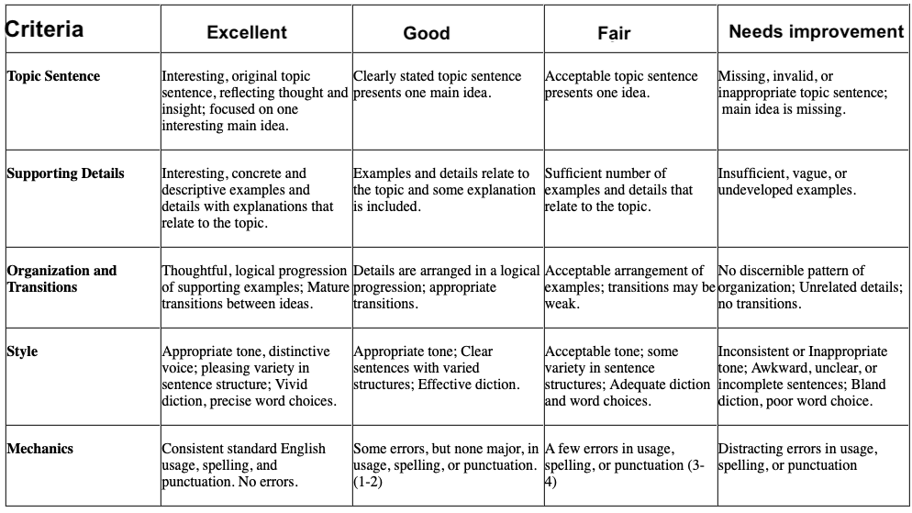
Rubric 2, speaking
