INSPIRING TEACHERS
ELT PLAN TEMPLATE

Author
Teacher´s name | MAYRA YOLIMA SERRANO GUERRERO
Email | Newmayra1030@hotmail.com
School | INSTITUCION EDUCATIVA CLUB DE LEONES – EL ESCOBAL

Lesson plan | Activity plan | Task plan | Project plan
 |  |  | X

Grade | Length of lesson | Number of students |  | Average age
SIXTH | 7 weeks (two hours each week) | 29 |  | 11-12
Area |  | English level
Rural | Urban X | A1 X | A2 |  | B1

Author’s remarks
This plan aims to provide an environment where the students can begin the selection of their profession from the beginning of high school and not wait until they reach the eleventh grade.
The teacher is a guide for the classroom in the construction of the life project of their students in a simple and practical way.
The students create spaces of interaction with the language based on their interests, needs and personal projections. They are protagonists of their own life building.

Curricular Focus / Axes
Environmental / Sustainability Education
Sexual / Health Education
Construction of Citizenship / Democracy / Teenagers | X
Globalization

Topic | “I love my Job”
Module / Unit | MODULE 3 / UNIT 3/ Way to Go 6o
Language focus | Functional language | Language skills | Vocabulary
Language focus | Describing jobs and occupations | Listening/Writing/Reading/Speaking | NA
Principles / approach | Project Based Learning

Learning objectives
Aim | By the end of this project, students will be able to choose the best job that allows them to make a life project.
Subsidiary aims | By the end of this lesson, students will be able to …  - Identify different jobs existing in the community.  - Identify the different universities where they can study their college degree in the community.  - Participate actively in the Job Festival showing their works done in class about their chosen occupation.

Materials needed
Flashcards, posters, signs, flags, markers and colours, school supplies, bell, magazines, brochures, books, public library online, a stand, computer, camera, cell phone, speakers, video beam, internet.
Annexes 1-22

Stage | Procedure | Time and Patterns of interaction
DEVELOPMENT 1 | FIRST WEEK | 60´
ICE-BREAKER | The teacher and students make a list of agreements to work during this project. Annex 1  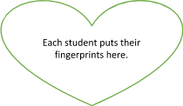    The teacher organizes the class in a semicircle in front of the board and gives the instructions orally and gives these instructions to the students:  1. Look carefully at the alphabet code  2. Guess the message and write it on a piece of paper.  3. Ring the bell when you know the answer.  4. Go to the board and write the message  The teacher presents a disorganized alphabet code (poster- annex 1) on the board to the students  In pairs, the students must guess the sentence (topic) using the alphabet code. | 15 minutes  pairs
Development 1 | The teacher asks students to choose a bottle cap of assorted colors (yellow, red, purple, blue, green, orange, pink) to make seven groups. Each team has four students who have a different role: a secretary, a collector, a speaker and a leader with responsibilities.  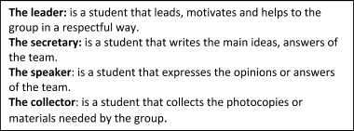  After that, the teacher shares the following questions:      SS answer the questions as a group  Then, only one student reports the answers to the rest of the groups.  As a wrap up, each group completes a template titled “our dreams”  Annex 2 | 15 minutes  groups of 7  Time:10 minutes  whole class
Assessment | 1. The teacher pastes one poster in each corner of the classroom. Annex 3  2. The teacher asks the students to read the four posters.  Then, T plays music in English to start the next activity.  3. The students walk around the classroom reading the posters and when the music stops playing, they place themselves in one of the four corners in which they identify most | 5 minutes  whole group
DEVELOPMENT 2 | SECOND WEEK
Warm up | 1. The teacher shows the video: https://www.youtube.com/watch?v=1gUbdNbu6ak  2. The students do the exercises shown in the video. | 5 minutes  Whole group
Development | 1. The teacher gives a worksheet to the students. Annex 4  2. The teacher gives the instructions and asks the students:  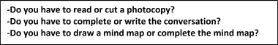  3. The students complete the worksheet (1) while listening to music in English.  4. The teacher stops the music and asks the students to put away the school supplies in their pencil case except the green color.  5. The students check their answers using the green color while their partners are answering orally.  6. The teacher plays the following video:  https://www.youtube.com/watch?v=R69YKFmlcnA  7. Groups of 4, The teacher asks for a team representative to take a piece of paper of a box with the questions on it Annex 5  8. After the warm up round, it’s time for round 2. Annex 6  9. Students get a card with 7 questions.  10. Groups have 3 minutes to answer the questions. Then T provides feedback and assigns points to each team for every right answer.  The teacher writes down the points on the score table. Annex 7  11. After the second round, the 3 winning teams, will answer a final question and the team who answers fastest will be the winner and receives their prize.  FINAL QUESTION  Who works in a Laboratory?  The teacher will give a prize (small eraser) to each member of the the winning team! | Time 15 minutes  individual  10 minutes  Whole class  20 minutes  Groups of 4
Assessment | 1. The teacher writes the aim for this session on a board.  2. The students draw a face over their feelings about this class. Annex 8 | 5 minutes  individual
DEVELOPMENT 3 | THIRD WEEK | 2 hours
Ice- breaker | 1. The teacher shows the following video https://www.youtube.com/watch?v=ORGLQudvMWE  2. The teacher sings the song with the students simulating a karaoke.  3. The teacher gives a copy with the lyrics of the song. Annex 9  4. The students find five mistakes in the text and write the corrections | 15 minutes  Individual
Development | 1. The teacher has seven letter envelopes on a table. Each envelopment has seven different jobs. In each envelopment there are four cards with six disorganized questions and six answers. Annex 10  2. The teacher presents the instructions and explains the activity in the following way:  A student from each team runs to the table, opens the letter envelope and takes out a card, and brings it to its partners. Then, another student runs back to the table and chooses another card until the team has four cards. Finally, the students organize and match all the questions with the correct answers.  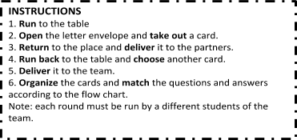  3. The teacher also gives a flow chart (a piece a paper) to the students so their students can guide themselves. Annex 11  4 The students complete the flow chart given by the teacher with the information from the interview they read.  6. The teacher turns on music and the students work together until the music stops playing.  7. The teacher asks their students to close their eyes and open them to see the poster explaining the meaning of an interview. Annex 12  8. The students help to read the mind map.  9. The teacher asks the following questions:  In your neighbourhood, do you know a doctor? Do you know a teacher? Do you know a secretary? Do you know an engineer? Do you know a policeman?  10. The teacher gives a form to each team. Annex 13  11. The students choose a professional who lives in their neighborhood to do an interview using the form (the six questions learnt in class)  12. The students answer the questions and practice the roles: interviewee and interviewer. T monitors and helps with language and pronunciation  Homework: students will record an interview to a professional at home to show in the next class. | 10 minutes  group work  5 minutes  group work  5 minutes  Whole group  10 minutes  group work
Assessment | 1.The teacher reminds the objective on the board.  At the end of the class, I can Interview a professional person using a question format learnt in class.  2. The Teacher gives students a ticket where they show how much they learnt in class. The students draw a hand showing fingers thumbs up, to the side or down to show agreement or disagreement according to the statements. Annex 14 | 5 minutes  individual work.
DEVELOPMENT 4 | FOURTH WEEK
Ice- breaker | 1. The teacher gives a balloon to students and a piece of paper.  2. The students write the job they want to do on the piece of paper and introduce it into the balloon, then the students inflate the balloon.  3. The teacher also gives a toothpick to each student and they should have it in their left hand.  4. The students should always have the balloon in their right hand.  5. The students must protect their dream balloon from the other students with the toothpick trying to pop it.  6. The teacher turns on the music to start and stop the game | 10 minutes  Whole group
Development | The students show to their partners the interview video in this way:  a) The teacher and students organize the classroom in seven groups. In each work table the students put one computer to show the recording of the interview. Each group rotates around each work table until they have watched all recordings.  b) During the rotation, the teacher is going to ask five questions (brainstorm).  1. Do you think that they are happy with their job?  2. What do people think about their jobs?  3. If you were them, would you choose the same jobs?  4. Do you think that they are well paid?  5. Why did you choose this person to interview?  e) The teacher gives a piece of paper to the students to write a message to post around the classroom. The students write a message concerning their jobs and a picture about their dream. Annex 15 | 30 minutes  Group work.  5 minutes  individual work.
Assessment | 1. The teacher reminds the objective that appears on the board  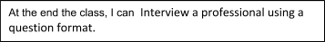  2. The teacher shows them the traffic light Annex 16  3. The students choose a color and tell the partner next to them why they selected that color. | 5 minutes  pairs
DEVELOPMENT 5 | FIFTH WEEK | 120 minutes
Ice- breaker | The teacher plays “broken telephone” with the students.  1. The teacher divides the group into two groups (A- B) making two semicircles to each side of the classroom.  2. The teacher divides the board into two parts.  3. The teacher gives a message to each group.  Message: The doctor works in a hospital.  4. The students pass the message to next partner, and so on until it finally reaches the last student.  5. The last student of each group stands up, runs to the board, writes the message on the board and says it. Repeat at least 4 times with different sentences. | 10 minutes  Whole group
Development | 1. The teacher shows the students several photos or images on a board. (Each image refers to the different professions and jobs with the respective working place)  2. The teacher asks their students the following questions  What job would you like to have?  I would like to be ________________  Why do you prefer that job?  I prefer to be _______because I _____________________  3. The students only decide to choose one job and write the job on a piece of paper.  4. The students must organize themselves in a group according to the chosen job.  5. The teacher gives the instructions to start working.  6. The teacher delivers a copy (a mind map) to the students called “collectors” of each group.  8. The teacher shows four corners in the classroom where there are four posters with a mind map displaying the categories to be completed.  9. One of the students of each team runs toward one of the four corners reads the categories and reports back to the group. Each member takes turns until they have completed all the information needed. Annex 17  10. Then each group gets a table with vocabulary to complete the mind map according to the job they have chosen. They will use a dictionary to find the meaning of the unknown words. Annex 18  11. The teacher provides laptops to research on the internet if they have doubts (universities, professional profile, working places, duration time, etc.)  12. Each team makes a poster using the mind map completed.  13. The students share the mind map with their partners through a Gallery Walk in the yard.  14. In the Gallery Walk the students of each group rotate and switch the role (presenter and viewer) depending on the teacher ́s indication.  Homework: search and crop images about universities in Colombia. | 10 minutes  Whole group  10 minutes  Groups  15 minutes  Groups  15 minutes  Whole Group
Assessment | 1. The teacher reminds the objective that on the board.  At the end of the class, I can identify the different universities where I can study my college major in the community.  2.The teacher asks the students to close their eyes and show their hands indicating with their fingers how they felt in class. From 5 to 1, being 5 the higher score and 1 the lower one. | 3 minutes  Whole group
DEVELOPMENT 6 | SIXTH WEEK | 2 hours
ICE - BREAKER | Teacher invites parents to a school meeting.  1. The teacher shows some examples of magazines, brochures and university posters from our city Cucuta and puts them on a table in the classroom.  2. The teacher also presents the following links of university web in Colombia.  https://bit.ly/34aWPuY : Universidad de Antioquia  https://bit.ly/2opqXn0 :Universidad Nacional  http://www.unipamplona.edu.co/ : Universidad de Pamplona, Norte de Santander.  https://bit.ly/2NnM3ui : Universidad Industrial de Bucaramanga.  https://bit.ly/2BOgeWk : Universidad Francisco de Paula Santander.  3. The students and their parents look at these pages in the technology room. | 20 minutes  Whole group
Development | The teacher gives the copies to the students called “collector” of each team. The teacher asks the following questions:  1. Do you read a worksheet or sing a song?  2. Do you research in a laptop or play in a laptop?  3. Do you answer the questions or make the questions?  4. Do you complete the mind map or a make a mind map?  The students research to complete the worksheet. Annex 19  T monitors and helps with language  5. The teacher gives the copies to the parents and students to read the instructions to make the stand at home. Annex 20  The teacher also gives them the following link:  http://www.ifepaweb.es/stand-feria-de-ciencias-medidas/  https://co.pinterest.com/pin/454652524877440216/?lp=true  6. SS follow these examples to make university brochures; write the messages, cut and paste university images on the collages.  6. The students make the posters inviting to the festival. They can make them using their school supplies and a dictionary. The parents are working with them while their children are making brochures and posters in the yard.  7.The teacher guides students in the writing of sentences in English.  Homework.  1. The parents open a (WhatsApp) group to plan and design the stand.  2. The parents of the students help them to build the stand (recycling materials) using the materials collected by them and their children.  3. Each team with their parents decide how to buy sweets and drinks to give to the public during the festival. | 35 minutes  Group work  Time: 15 minutes  55 minutes  Group work  Place: yard
Assessment | 1.The teacher reminds the objective on the board  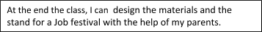  2. The teacher explains the instructions and shows them the following poster. Annex 21  3. Each student draws their face in front of the statement that shows how they feel. | 5 minutes  individual work
DEVELOPMENT 6 | SEVENTH WEEK | 4 hours
CONSOLIDATION | Job festival  1. Each team locates the stand in the schoolyard to present the information about the chosen jobs including university brochures, photos, posters and tools used in these professions. (These evidences were made by students during the development of the project.)  2. Each student in the stand explains to the guests (parents, teachers and students) about the job that they want to have when they grow up (based on their life project).  3. The photos and videos recorded during the festival are uploaded to Club de Leones school web: https://www.colclubdeleones.net/ | Time: 3 hours- 30 minutes  Interaction: Group work and community (families, teachers, students of different grades in the school)  Place: schoolyard
Assessment | 1. The teacher gives a rubric to students and at the same time gives a piece of paper to the parents with some questions. Annex 22 | 10 minutes  Whole group

Implementation alternatives
The teacher can incorporate Transversally with technology and Art classes.
The teacher can organize the time according to the planning of each task and students ́needs in their context.
If the teacher doesn't have the possibility to use technology tools, these can be replaced by posters, flashcards, billboard. As for videos on YouTube, the T can download them in a memory stick and use speakers or give the students the copies with the lyrics or images of the story. The teacher also sends the video by WhatsApp only as information.

Key words
topic | skill | linguistic | vocabulary | grade
“I love my Job” | Listening/Writing/Reading/Speaking | NA | NA | Sixth

Annex 1: ICE –BREAKER
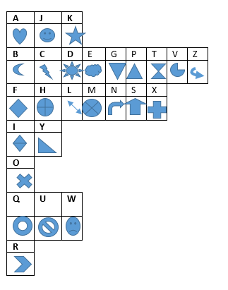

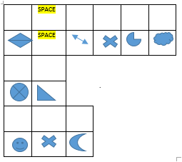

Annex 2



Annex 3

I was happy and willing to learn.
I was insecure and sad.
I was confused and nervous
I was confident and excited.
picture
picture
picture
picture

Annex 4: WORKSHEET

Draw
my picture
Date: ________________________________ school: _________________________________
Student: ___________________________________________________ grade: _____________
Teacher: ___________________________________________ Subject: ____________________

WORKSHEET 1: I love my job!
- Aim: By the end this activity, I will have … _______________________________________
_______________________________________________________________________________
- Time: You have ___ minutes.

I-LOOK AT THE PICTURES AND MATCH THE JOB WITH THE PLACE.
1. _____ 2. _____ 3. _____ 4. _____
Picture of a carpenter
Picture of a scientist.
Picture of a pilot

Picture of a cook

A) in the airport B) in the workshop C) in the restaurant D) in the science lab

II- READ AND COMPLETE THE CONVERSATIONS.
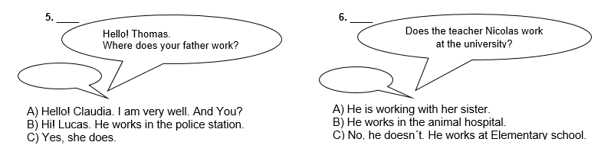

III- Imagine that you are a police officer or another job. Choose the qualities that you want to have and complete the mind map.
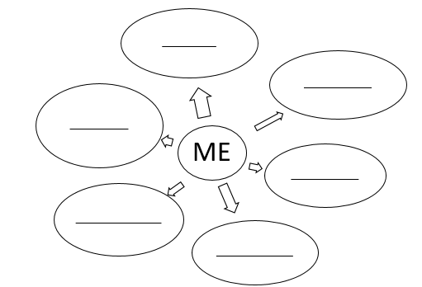
Responsable-irresponsable
unpunctual- punctual
Hardworking- Lazy
Confidence-suspicious
Honest-dishonest
Rude-
kind
Cheerful-
bored
Respectful- disrespectful

An emoticon or any image that corresponds to this expression

Remember: You are a champion!

Annex 5

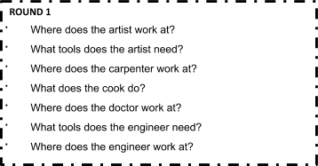

Annex 6
ROUND 2
- Where does the singer work at?
- Where can you find a farmer?
- What tools does the hairdresser need to work?
- Who works at the airport?
- What transportation does the policeman need?
- What does the teacher do?
- Who does the police officer work with?

? ????

SCORE TABLE | Team  1 | Team  2 | Team  3 | Team  4 | Team  5 | Team  6 | Team  7
Question 1
Question 2
Question 3
Question 4
Question 5
Question 6
Question 7
Final Question
TOTAL

Annex 7

Annex 8
Draw your face over the feeling you identify with.
In this class, I felt…
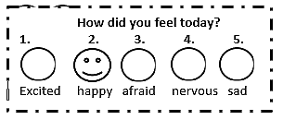

Annex 9
Listen to the song and find 5 mistakes in these lyrics

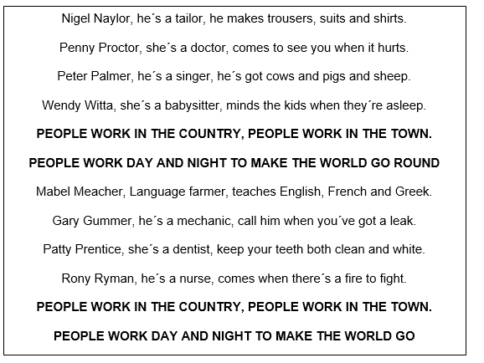

Annex 10: INTERVIEW CARDS

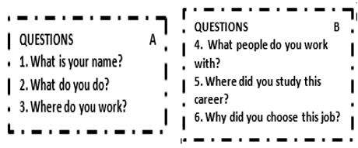
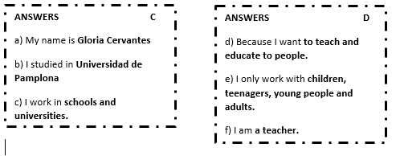
Envelope 1

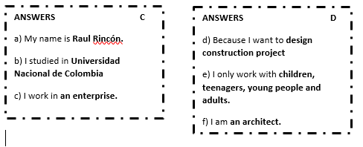

Envelope 2

Envelope 3
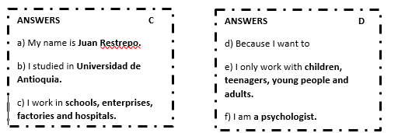

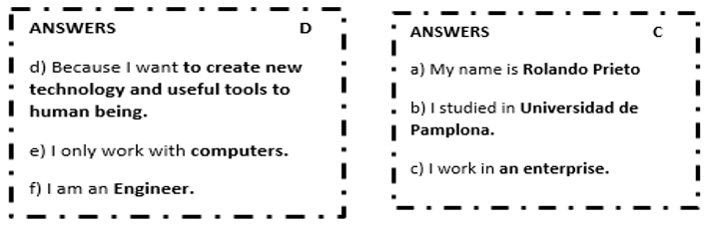
Envelope 4

Envelope 5
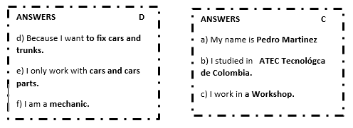

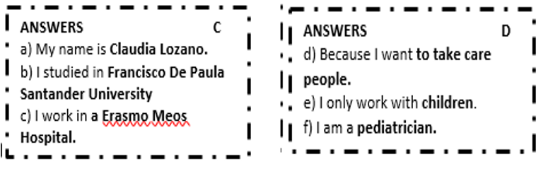
Envelope 6

Envelope 7

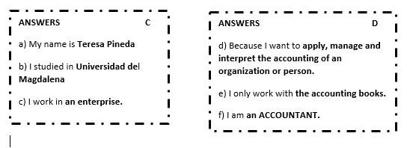

Annex 11

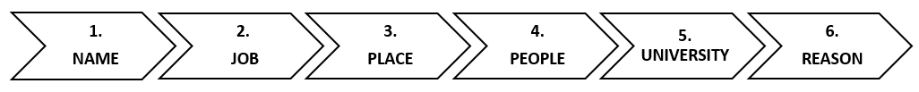
Annex 12
What is an interview?
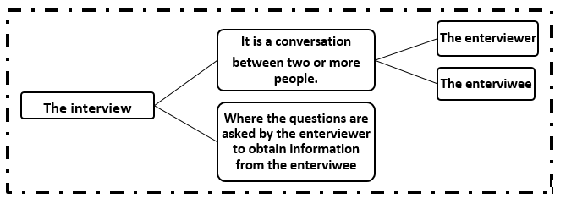

Annex 13
Interview a professional. Use these phrases to help you.
ANSWER interviewee
My name is ____________
I am _______________
I work in _______________
I only work with______________
I studied in________________
I choose to be a _______Because I want____________
QUESTIONS interviewer
1. What is your name?
2. What do you do?
3. Where do you work?
4. Who do you work with?
5. Where did you study this major?
6. Why did you choose this job?

Annex 14
Draw your hand showing thumbs up, thumbs to the side or thumb down according to the statements.
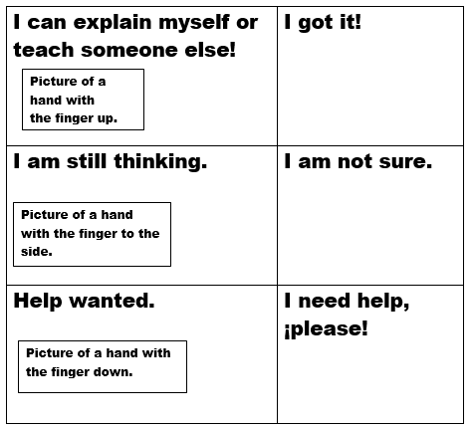

Annex 15
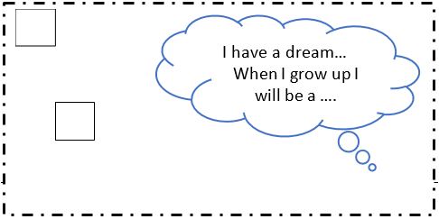

Annex 16
Traffic light
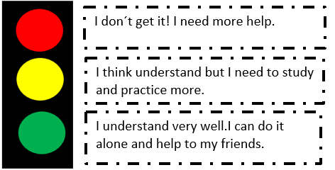
I don’t get it. I need help.
I think I understand but I need to study and practice more
I understand it very well. I can do it alone and help my friends

Annex 17

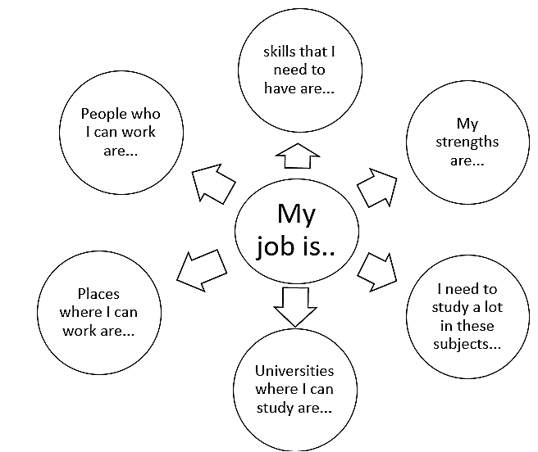
People I can work with are

Annex 18

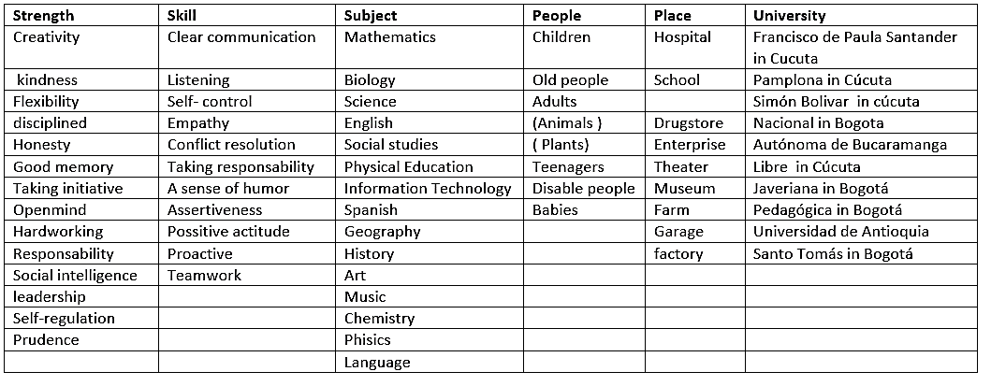

Annex 19
I love my job!
- Aim: By the end this activity, I will have … __________________________________________________________________________

- Time: You have ___ minutes.

I- After choosing your job: ____________________, research information about it on internet to complete the mind map. Using the QUESTION BANK.

Questions Bank
1. Where can you study this degree? 2. What skills should people have to study this?
3. What do people with this degree do? 4. What kind of jobs can they do?
5. Is this job well paid? Why? 6. Why do you like this job?

II- ANSWER THE FOLOWING QUESTIONS BY COLORING THE FACE THAT YOU CHOOSE.

SELF-ASSESMENT: How did you feel today?

Inspired excited happy bored sad

Annex 20

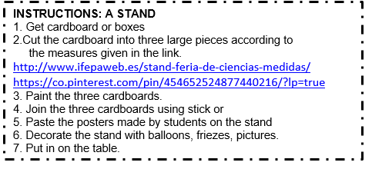

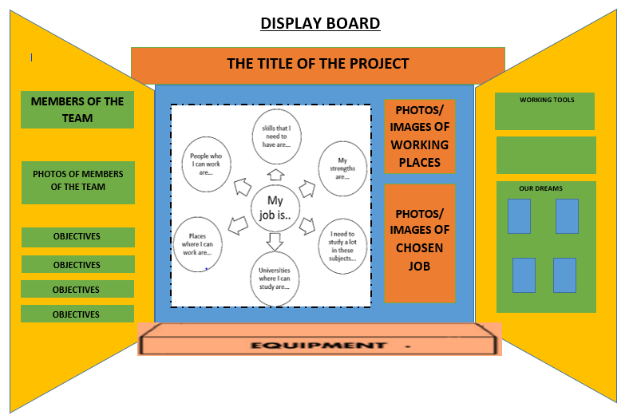

http://www.ifepaweb.es/stand-feria-de-ciencias-medidas/
https://co.pinterest.com/pin/454652524877440216/?lp=true
BROCHURES
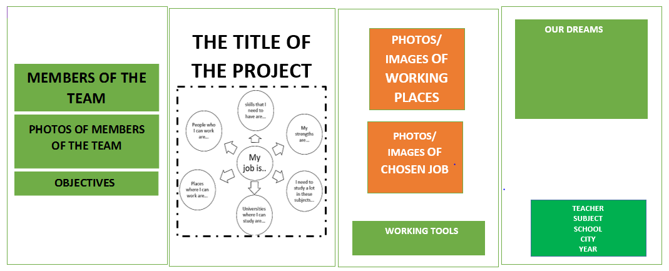
Paste/ draw
my photo
Date: ________________________________ school: _________________________________
Student: ___________________________________________________ grade: _____________
Teacher: ___________________________________________ Subject: ____________________

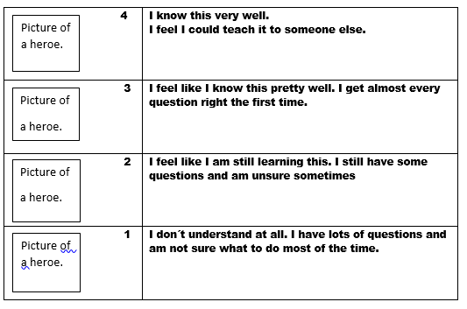
Annex 21

Annex 22

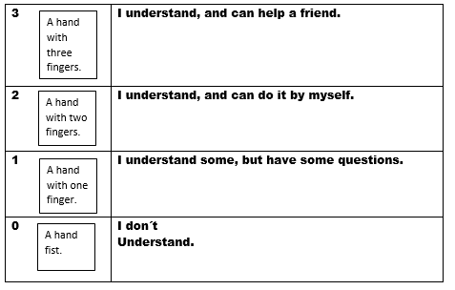

Mayra Serrano Rubric
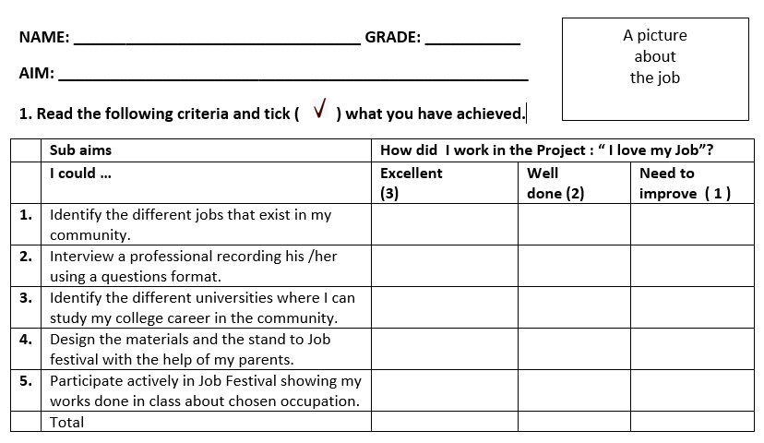
Show my work and participate actively in the job festival
Design a stand for a festival with the help of my parents
Identify different universities where I can study my degree
Record an interview of a professional using a question format

