INSPIRING TEACHERS
ELT PLAN TEMPLATE

Author
Teacher´s name | Lucy milet
Email | heylincanola@gmail
School | Nuestra señora de la merced

Lesson plan | Activity plan | Task plan | Project plan
 |  | X

Author’s remarks
This plan has been designed for students in urban and rural areas with little knowledge of English language. Here you can find an activity that will help students build vocabulary as they practice a little speaking. It is a hands on task that will allow SS to personalize language.

Grade | Length of lesson | Number of students |  | Average age
Sixth | 45 minutes | 30 |  | 11/12
Area |  | English level
Rural | Urban x | A1 x | A2 |  | B1

Curricular Focus / Axes
Environmental / Sustainability Education | X
Sexual / Health Education
Construction of Citizenship / Democracy / Teenagers
Globalization

Topic | Professions
Module / Unit | NA
Language focus | Language Function | Language skills | Vocabulary
Language focus | Describing people’s occupations and place of work | Listening/speaking | Artist/ Carpenter/Cook/  /Fire fighter/Doctor/Farmer/Engineer/Hairdresser/Pilot/Police officer/Scientist/Singer/Teacher/Vet
Principles / approach | Task based learning

Learning objectives
Aim | By the end of this activity, students will be able to name different occupations and their workplaces.

Materials needed
Video beam, board, internet, poster paper, annexes 1, 2 and 3

Stage | Procedure | Time and Patterns of interaction
pre-Task | T plays the video https://www.youtube.com/watch?v=R69YKFmlcnA&t=78s  SS have a worksheet where they match the occupation with the place of work according to the video. Annex 1 | 10 minutes  Whole group
task | Then Students design a poster of what they want to do when they grow up. The poster should have a picture (drawing) of themselves, personal information and the job they choose. Example:  I am Lucy Minet. (nombre)  I am from Colombia.  I am 12 years old. (edad)  I live in Cucuta. (municipio)  I want to be a cook. (ocupacion elegida)  See example Annex 2 | 10 minutes  Individual
post task | Then SS paste the posters on the wall and everyone walks around looking at them. They complete a table (Annex 3) with the names and occupations of 5 of their classmates.  Finally, they answer the question: What does Lucy do? Where does Lucy work? T asks several questions about several students. | 15 minutes  Mingle  10 minutes  Whole class

Implementation alternatives
If the classroom has no video beam the teacher might introduce the class with some images.
If there are many students in the classroom, you must resort to the implementation of more class hours to complete the activity.

Key words
topic | skill | linguistic | vocabulary | grade
Professions | Listening/ Speaking | Vocabulary building | occupations | sixth

OCCUPATIONS | PLACE OF WORK
Artist | Studio
Carpenter | Airplane
Cook | Animal hospital
Fire fighter | Broadcasting stations
Doctor | Carpenter's shop
Farmer | Factory
Engineer | Farm
Hairdresser | Fire station
Pilot | Hospital
Police officer | Police station
Scientist | Restaurant
Singer | Salon
Teacher | School
Vet | Science lab
Annex 1

Listen and match the occupation with the place where they work.

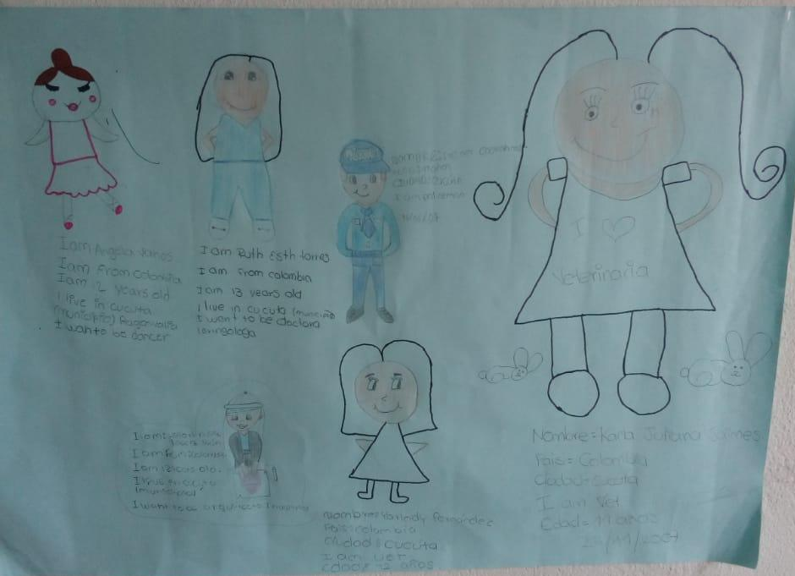
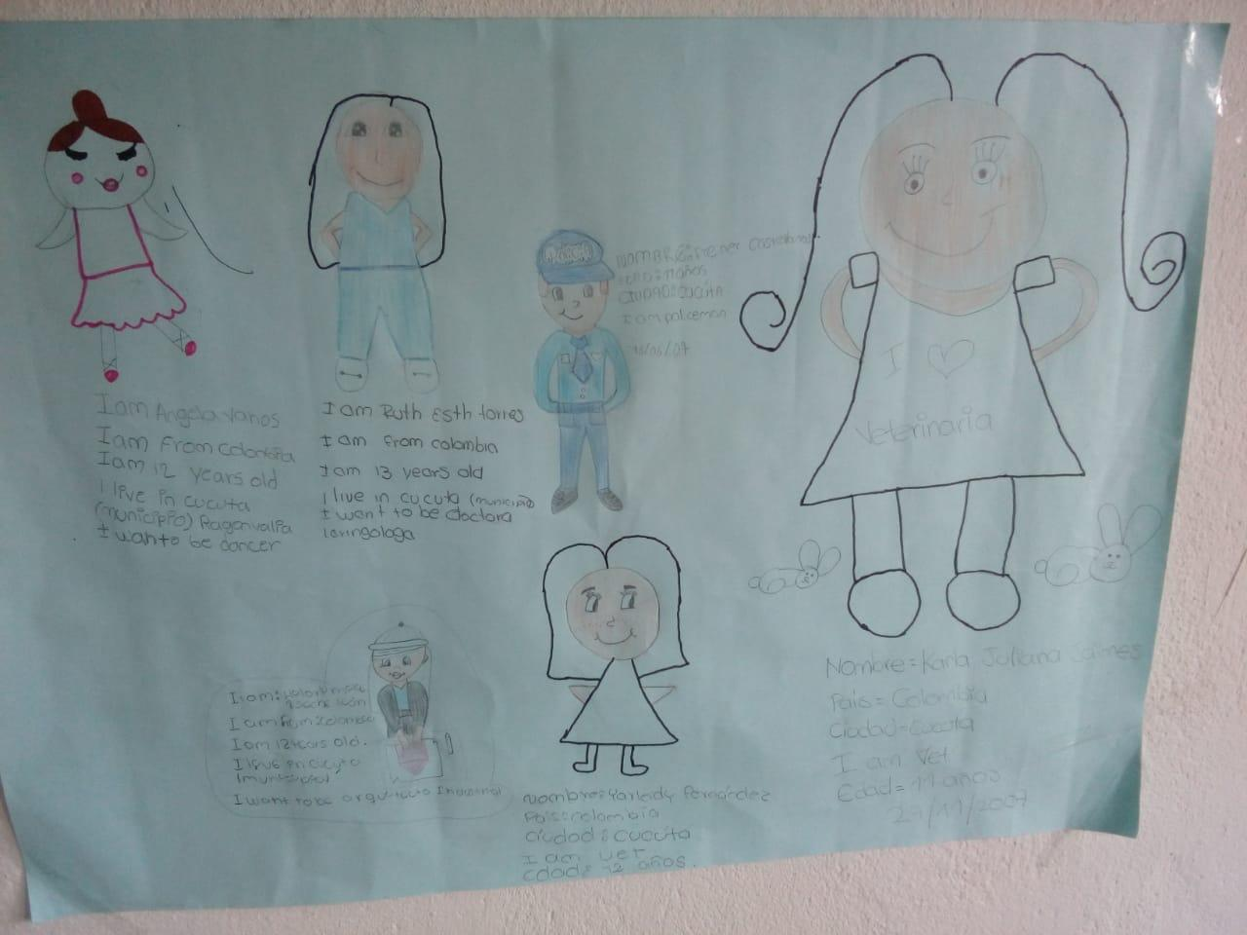
Annex 2

*Pictures taken by Lucy Minet.

Annex 3

NAMES | Occupation | Place of work

