INSPIRING TEACHERS
ELT PLAN TEMPLATE

Complete with the information about you
Author
Teacher´s name | SHIRLEY CONSTANZA MARTÍNEZ RUBIO
Email | shircons01@hotmail.com
School | MANUEL ELKIN PATARROYO

Select the type of plan
Lesson plan | Activity plan | Task plan | Project plan
 | X

Write a few lines about the usefulness of this plan for the Colombian English teachers
Example: This lesson plan gives the students a chance to know about you, their new teacher, and it also gives you a valuable opportunity to assess your students' level. It can also be a useful and productive class if you ever find yourself substituting a class at short notice.
Author’s remarks
This plan allows you to enhance the four skills in English while students describe parts of the body. Ss will learn the topic with interest and motivation since the methodology is very flexible and the activities promote the use of different intelligences: linguistic, interpersonal, musical and kinesthetic. That is why Ss are expected to have fun and learn at the same time.

Complete with the information about your students
Grade | Length of lesson | Number of students |  | Average age
6th | 2 hours | 40 |  | 11 – 14 years old
Area |  | English level
Rural | Urban X | A1 X | A2 |  | B1

Select the curricular axe or focus
Curricular Focus / Axes
Environmental / Sustainability Education
Sexual / Health Education | X
Construction of Citizenship / Democracy / Teenagers
Globalization

Complete with information about the content and methodological approach of the plan
Topic | Parts of the body
Module / Unit | Module 2 Unit 1: Book: Way to go 6th grade.
Language focus | Language Function | Language skills | Vocabulary
Language focus | To describe parts of the body by using adverbs of intensity | All the skills are intertwined but there is an emphasis on reading and writing | Head, Hair, Ears, Eyes, Nose, Mouth, Tongue, Neck, Arms, Stomach, Hips, Legs, Knees, Feet, Finger and Toes.
Principles / approach | Task-based learning, Transversality (Health), Assessment

In “Aim”, state what the learning goal is, in other words, what you want your students to achieve by the end of the session.
In “Subsidiary aims”, relate the language skills (communicative and linguistic) students need to master in order to achieve the main aim of the lesson. Make sure the aims are learner-centred, specific, measurable, achievable, realistic, and action oriented.
Learning objectives
Aim | By the end of this lesson, students will be able to describe parts of the body.
Subsidiary aims | By the end of this lesson, students will be able to:  - Identify parts of the body and understand the song lyrics created by their peers (Listening)  - Sing a song related to parts of the body (Speaking)  - Identify specific information in a written text about descriptions. (Reading)  - Write a song including parts of the body, adverbs and plural nouns.

List all the materials needed for this plan. Please, do not include any picture or photograph.
Materials needed
- Sound system.
- Flash cards about BODY PARTS.
- Whiteboard and markers.
- Grammar workshop.
- Textbook “Way to go! 6th grade”
http://aprende.colombiaaprende.edu.co/sites/default/files/naspublic/colombiabilingue/waytogo/Libros%20PDF/Grado%206/Way%20to%20Go%20Students%20book%20%206.pdf

Write the name for each state of the plan. Then in the “Procedure”, write a detailed description of what the teacher and students do at each stage of the session.
Be sure to be thorough so any teacher can follow this plan. Write the procedure in third person and present tense.
Use these conventions: T= teacher S= students Ss= students
Stage | Procedure | Time and Patterns of interaction
Warm up | - T says the title of the unit and discuss as a class what it means.  - Before starting, T checks SS knowledge by playing SIMON SAYS  - Simon says… TOUCH YOUR HEAD. (SS touch their heads)  - Simon says… TOUCH YOUR FEET. (SS touch their feet)  - TOUCH YOUR STOMACH. (T touches her head and SS who touch their heads lose and sits down.  T continues until mentioning at least 10 parts of the body.  - T asks SS if they know where to go if they have an accident at school. What should they do? Who is responsible for contacting a child’s parents if there is a medical emergency?  - T asks SS to take out their textbooks and go to page 50. T asks a S to read instructions. T plays the track and SS tick the words (parts of the body) they hear. | 20 minutes  T  T – SS  SS – SS  T – SS  T – SS
Introduction | T shows SS flashcards about parts of the body. First, T shows the pictures and then, T shows SS the name of the part of the body. T reads it aloud and asks SS to repeat Head, Hair, Ears, Eyes, Nose, Mouth, Tongue, Neck, Arms, Stomach, Hips, Legs, Knees, Feet, Finger and Toes. | 10 minutes  T – SS
Practice | Reading:  T asks SS to go over page 51 (Way to go 6) in order to match some pictures (1-6) to the corresponding definitions (a-f).  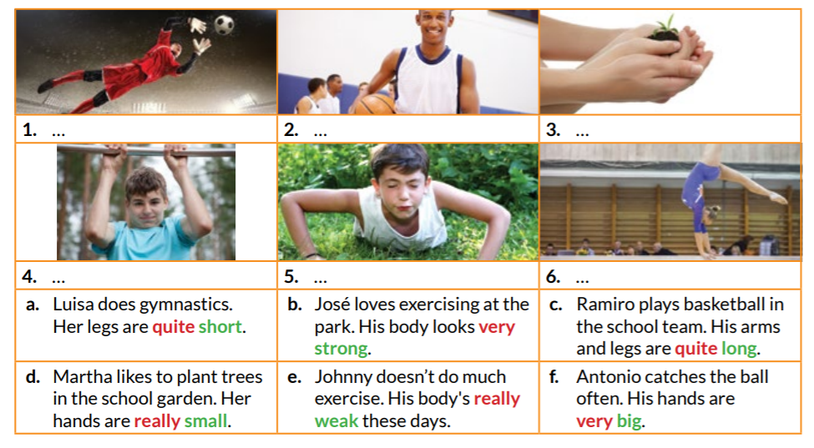  Taken from Way to Go 6  Then, T asks SS to look at the words that are highlighted in red and green colour. T explains to SS that the green colour words are adjectives. T says that adjectives are qualities or descriptions that are given to nouns. In addition, T explains that the red colour words are adverbs, T says that adverbs give more information about a verb, an adjective or another adverb. T also explains that the adverbs that are shown on exercise 5 on page 51 are intensifiers, which intensify the adjective.  Later, T explains to SS how to form plural nouns in English. T explains that we usually add -s (or -es) to the noun to make the plural form. However, there are some irregular plurals that do not follow this rule. T writes on the board:  Later, T reviews POSSESSIVE ADJECTIVES, where T reminds them of how possessive adjectives work. T tells SS that POSSSESSIVE ADJECTIVES are used with nouns and that they determine the relationship that one has with the object, person or place. Example:  - His arms are long.  - Her legs are very long.  Then, T gives SS a grammar workshop about Plural nouns to be solved in groups of three: https://www.grammar.cl/exercises/plural-nouns.pdf. In addition, T tells Ss to write 10 physical descriptions about their classmates using plural nouns, and possessive adjectives. T gives SS 15 minutes to solve the Grammar Workshop.  When SS finish the workshop, T asks SS to exchange worksheets with another group. Then T asks SS to share the answers using their classmates’ workshop and correct it with a bright colour pen if necessary. | 20 minutes  T  T – SS
  Regular plurals | Irregular plurals
  One Finger  Ten Fingers  One ear  Two ears | One foot  Two feet  One tooth  32 teeth
Production | T explains to Ss that they are going to create a song verse including parts of the body, regular and irregular plurals and adverbs of intensity. When SS present their songs, they have to sing it and dance in order to represent it. | 40 minutes  Group work
Production | Assessment: Rubric.  Before Ss perform their songs, they are given a rubric to assess their peers’ work. T may use the following sample to adapt the rubric according the context needs:  http://www.mswholeschools.org/files/Maharrey.WSI_Guide_and_Rubric_for_Song_Rap_as_PDF.pdf | 40 minutes  Group work
Wrap-up | Assessment: Feedback Sandwich  Once SS finish sharing their songs, T asks Ss to join their groups in order to give their partners some feedback about their classwork. Ss select one group to assess and T gives each group a piece of paper with a feedback sandwich for doing the peer assessment task. The sandwich has the following statements:  a. One thing I liked about your report was…  b. A suggestion I have for your report is…  c. Another thing I liked about your report was…  T may use the following link to adapt the sandwich:  http://2.bp.blogspot.com/-wHMjyhDBmAs/VDVBwoMWXvI/AAAAAAAAAfg/jBbiNIAkBVU/s1600/artsandwich.jpg | 30 minutes  Individual work

List a series of ideas of how this plan can be methodologically adapted so other teachers can implement it in their own educational context.
Implementation alternatives
- Teachers may use the following link to design vocabulary activities for free such as crosswords, bingo, board games, word search, dice, maze maker and dominoes: https://www.toolsforeducators.com/ You just need to click on the option you prefer, follow instructions and design ready-to-print material in 5 minutes.

- Teachers can devote more time to the song and ask SS to create two or three verses as homework.

- Teachers can also ask Ss to create an acrostic poem if they do want to do the song activity.

Write the key word for each category based on the content of this plan. For example:
Topic: environment Skill: reading Linguistic: should Vocabulary: animals, environment
Key words
topic | skill | linguistic | vocabulary | grade
Parts of the body | Reading and writing | Possessive Adjectives, adverbs of intensity | Parts of the body | 6th Grade

