INSPIRING TEACHERS
ELT PLAN TEMPLATE

Complete with the information about you
Author
Teacher´s name | Juan Carlos Sierra Villarraga
Email | juancarlossierravillarraga@hotmail.com
School | IE. INEM MANUEL MURILLO TORO

Select the type of plan
Lesson plan | Activity plan | Task plan | Project plan
 |  | X

Write a few lines about the usefulness of this plan for the Colombian English teachers
Example: This lesson plan gives the students a chance to know about you, their new teacher, and it also gives you a valuable opportunity to assess your students' level. It can also be a useful and productive class if you ever find yourself substituting a class at short notice.
Author’s remarks
This lesson plan provides students with the chance to talk about places of the neighbourhood and its corresponding location. Even though students are encouraged to develop the four skills, they need to pay special attention to a conversation in order to locate places and they are expected to describe their neighbourhood by creating a model scale made with disposable material. This lesson plan also gives students the opportunity to assess their peers and self-assess their own learning process.

Complete with the information about your students
Grade | Length of lesson | Number of students |  | Average age
6th | 4 hours | 40 |  | 11
Area |  | English level
Rural | Urban X | A1 X | A2 |  | B1

Select the curricular axe or focus
Curricular Focus / Axes
Environmental / Sustainability Education
Sexual / Health Education
Construction of Citizenship / Democracy / Teenagers | X
Globalization

Complete with information about the content and methodological approach of the plan
Topic | Places of the neighbourhood
Module / Unit | Module 3 Unit 2: Book: Way to go 6th grade, Page 100
Language focus | Language Function | Language skills | Vocabulary
Language focus | To locate places in town by using prepositions of place | All the skills are intertwined but there is an emphasis on listening and speaking | Places of the neighbourhood
Principles / approach | Task-based Learning, Transversality, Assessment

In “Aim”, state what the learning goal is, in other words, what you want your students to achieve by the end of the session.
In “Subsidiary aims”, relate the language skills (communicative and linguistic) students need to master in order to achieve the main aim of the lesson. Make sure the aims are learner-centred, specific, measurable, achievable, realistic, and action oriented.
Learning objectives
Aim | By the end of this lesson, students will be able to exchange information about places in town.
Subsidiary aims | By the end of this lesson, students will be able to:  - Talk about where places are (speaking).  - Identify specific information in a map of a neighbourhood (reading)  - Write simple sentences about neighbourhood places(writing).  - Understand information about different places (listening).

List all the materials needed for this plan. Please, do not include any picture or photograph.
Materials needed
- Text “Way to go 6”
http://aprende.colombiaaprende.edu.co/sites/default/files/naspublic/colombiabilingue/waytogo/Libros%20PDF/Grado%206/Way%20to%20Go%20Students%20book%20%206.pdf
- Computer / Video beam
- Sound system
- Maps of different neighbourhoods
- Markers
- Cardboard
- Evaluation rubric
- Self-assessment rubric

Write the name for each state of the plan. Then in the “Procedure”, write a detailed description of what the teacher and students do at each stage of the session.
Be sure to be thorough so any teacher can follow this plan. Write the procedure in third person and present tense.
Use these conventions: T= teacher S= students Ss= students

Stage | Procedure | Time and interaction
Warm up | T explains the purposes, class objectives and evaluation criteria.  T and Ss establish the Pedagogical agreements for the class development.  Ss get in groups of 4 or 5 and look at a map of a neighbourhood and try to answer the questions. SS may use dictionaries during the task.  Where can you buy groceries?  Where can you play basketball?  Where can you buy medicine?  Where can you get money?  Where can you buy books?  Where can you see a film?  Where can you buy bread?  The group that guesses the highest number of questions will be the winner. | 20 minutes  T-SS  SS-SS  Group work  T-SS
Engage Phase | After participating in the game and activating some vocabulary and places information, Ss return to their places and take out the book Way to Go 6th grade. Then, Ss refer to exercise 1 on page 100 and match the previous questions to the places shown in a map:  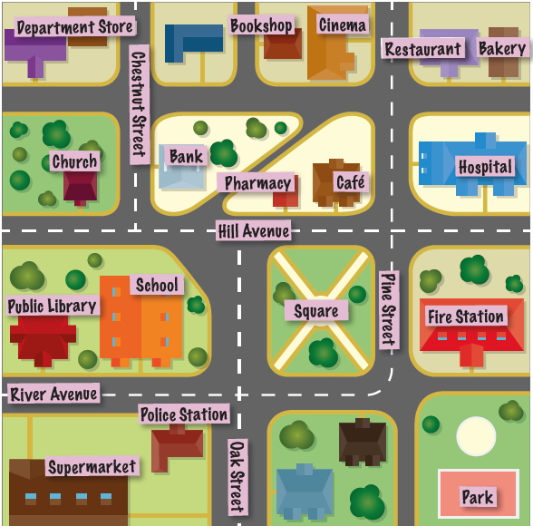  Taken from Way to Go 6  T asks some questions about the places.  Can they name some of the places?  Which places are there in your neighbourhoods?  Which places do you visit frequently?  T asks which places are key (important) in case of an emergency (the hospital, the police station, etc.). T locates emergency places on the map. (The police station’s on River Avenue / Oak Street. The fire station’s on Pine Street. The hospital’s on Hill Avenue.)  Ss go over the different names of the streets on the map.  T provides an example, such as Where’s the school? It’s on River Avenue.  T asks Ss other similar questions and write them on the board. Ss write the location of some places in their notebooks. For example: The pharmacy is on Hill Avenue. | 10 minutes  T-SS  Individual work  SS  T-SS  T-SS  10 minutes  T-SS
Study Phase  Context  Language Reflection  Language Guided Practice | Next, Students open the book on the page 101 and focus on the activity number 3:  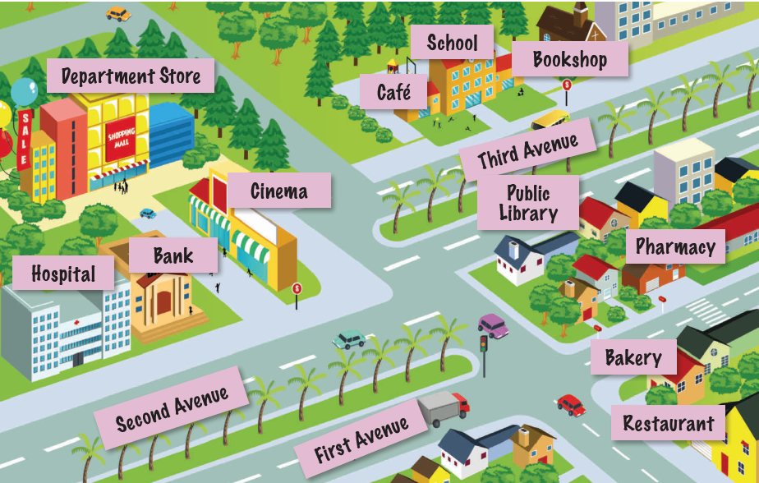  Taken from Way to Go 6  Ss check the vocabulary which appears on the map. Ss look at the map and name the places.  T asks: “On which street or avenue is the hospital/bank/bookshop?”  Ss read the directions and locate the places paying special attention to the words in red.  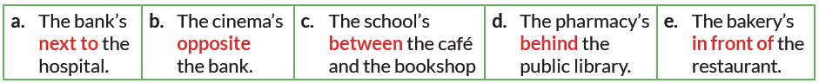  Taken from Way to Go 6  T uses objects in the classroom and place them in different locations to practise the different prepositions.  When students feel confident, T asks the following questions about the map in exercise 3:  What’s behind the cinema?  (The department store.)  What’s next to the school?  (The café.)  What’s opposite the café?  (The public library.)  What’s behind the cinema?  (The department store.)  T gives more practice by using the map from exercise 1 to locate the different places. T asks the following questions:  Where’s the café? (It’s between the pharmacy and the department store.)  Where’s the school? (It’s next to the public library.)  Where’s the park? (It’s in front of the fire station.)  Where’s the restaurant? (It’s behind the hospital / next to the bakery.)  Ss read and answer the questions individually; then, they check their answers in pairs.  T takes some answers from the previous activity to explain the Grammar Box: Prepositions of place  As SS have already studied the prepositions: at, in, on, T explains that there are other prepositions to describe where something is. These include: behind, between, in front of, opposite, next to.  T also explains the order of the words in a sentence with a preposition: subject + verb + preposition + object.  For example: The restaurant is in front of the bookshop.  Then, Ss listen to Michael talk to Kaitlin about his neighbourhood and point to the places on the map in exercise 3. Then, listen again and complete the sentences.  Ss listen to the track as many times as necessary to locate the places on the map. Ss complete the text by using the words in the Word Bank. Ss listen again and complete the script.  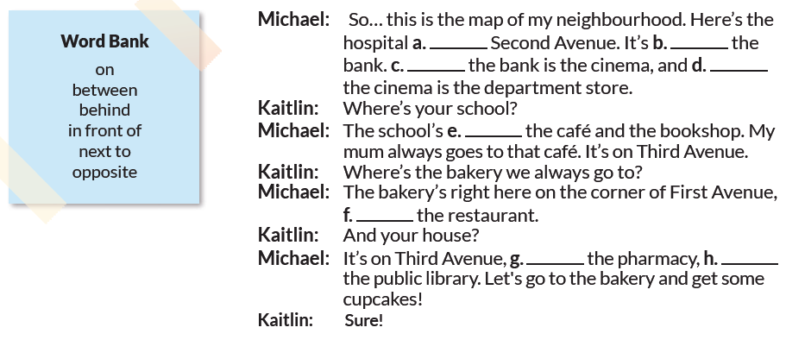  Taken from Way to Go 6  After that, Ss get in pairs and look at the photos on page 102. Ss look at the streets and name the places. T follows the model provided and have students say where the places are on each street.  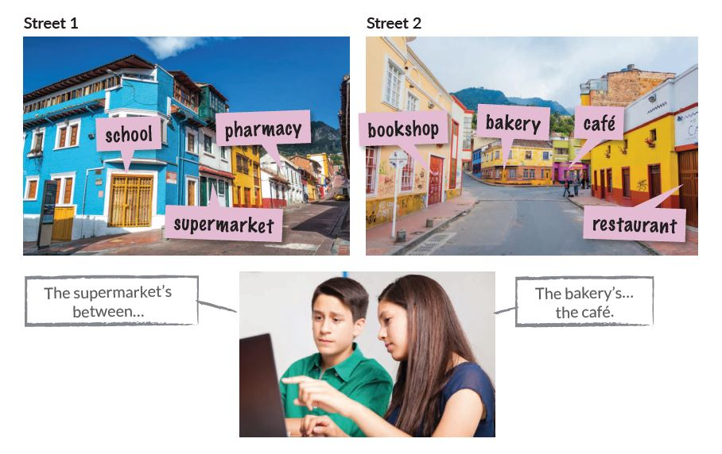  Taken from Way to Go 6 | 20 minutes  T-SS  T-SS  10 mins  T-SS  T-SS  10 mins  T-SS  10 mins  T-SS
Activate Phase (Free practice) | After Ss practice in controlled and semi-controlled practice, they do a free-practice task. Ss work in groups to create a scale model of their neighbourhood by using recycled items such as bottles, used boxes, etc. If T wants, he/she can have students paint the boxes and containers and write the names of the different places in town. T tells them to locate the places and describe where they are. T can have students from different groups say where a place is located in another group’s neighbourhood.  Note: the disposable materials are brought in advance. | 60 minutes  Group work  SS-SS
Wrap-up and Assessment | When Ss finish presenting the neighbourhood, Ss and T do the formative assessment task:  a) Peer-Assessment. Ss make some comments about their classmates’ neighbourhood using the strategy: Two stars and a wish.  Ss identify two positive aspects of the neighbourhoods of their peers and then express a wish about what the peers might do next time in order to improve another aspect of the neighbourhood. T may use the following link as a reference:  https://i.pinimg.com/originals/f8/ec/e9/f8ece9160b45e531f54d2bfe40169311.png  b) Ss do self-assessment by using the strategy “Three things”. At the end of the lesson, T asks Ss to make a list of two things they learned, and one thing they still need to learn.  T writes on the board these prompts…  1. Two things I learned today are…  2. One thing I still need to learn is...  Ss complete the prompts in their notebooks. | 20 mins  T-SS  10 mins  T-SS

List a series of ideas of how this plan can be methodologically adapted so other teachers can implement it in their own educational context.
Implementation alternatives
- For this class, T could use real pictures of Ss’ neighbourhood to contextualize the topic.
- T could ask Ss to make a map of their ideal neighbourhood out of disposable material.
- SS could also make a poster with real pictures of their neighbourhood or have a photography gallery.

Write the key word for each category based on the content of this plan. For example:
Topic: environment Skill: reading Linguistic: should Vocabulary: animals, environment
Key words
topic | skill | linguistic | vocabulary | grade
Places of the neighbourhood | Listening and speaking | Prepositions of place | Places of the neighbourhood | 6th

