INSPIRING TEACHERS
ELT PLAN TEMPLATE

Author
Teacher´s name | LUZ MILA PUENTES CAMARGO
Email | luzmilapc@hotmail.com
School | NORMAL SUPERIOR MARIA AUXILIADORA SCHOOL

Lesson plan | Activity plan | Task plan | Project plan
 |  | X

Author’s remarks
This lesson plan gives Ss the opportunity to talk about other people’s daily activities, and it gives them the chance to assess themselves on the use of the language. It can also be a useful and productive lesson to stimulate students’ production.

Grade | Length of lesson | Number of students |  | Average age
6th | 3 hours | 36 |  | 11-12
Area |  | English level
Rural | Urban X | A1 X | A2 |  | B1

Curricular Focus / Axes
Environmental / Sustainability Education
Sexual / Health Education
Construction of Citizenship / Democracy / Teenagers | X
Globalization

Topic | A famous person’s routine
Module / Unit | Way to go 6th Module 1 Unit 2 what do you do? book Pages 20, 21 and 22.
Language focus | Language Function | Language skills | Vocabulary
Language focus | Describe daily activities and time | All the skills are intertwined but there is an emphasis on reading and writing. | Daily activities verbs and connectors and / but
Principles / approach | Task-based Learning; Transversality, Assessment

Learning objectives
Aim | By the end of this lesson, students will be able to talk about someone’s daily activities.
Subsidiary aims | By the end of this lesson, students will be able to:  - Ask and answer questions about people’s routines,  - Add information and contrast ideas using and / but connectors.  - Write a composition about a favorite famous person to design a poster.  - Identify specific information in a spoken text.

Materials needed
A to Z game worksheet
Way to go book 6th grade. Pages 20, 21, 22.
http://aprende.colombiaaprende.edu.co/sites/default/files/naspublic/colombiabilingue/waytogo/Libros%20PDF/Grado%206/Way%20to%20Go%20Students%20book%20%206.pdf
Self-assessment Three things worksheet
E-chart graphic organizer. Taken from https://www.eduplace.com/graphicorganizer/ and adapted by LUZ MILA PUENTES CAMARGO.
Peer – assessment Two stars and a wish.
Poster Creation Rubric. Taken from https://www.uen.org/lessonplan/download/18725?lessonId=12365&segmentTypeId=2 and
http://www.gsiccharter.com/cms/lib011/GA01933819/Centricity/Domain/69/Cinco%20de%20Mayo%20Poster%20Grading%20Rubric.doc and adapted by Luz Mila Puentes Camargo.

Stage | Procedure | Time and Patterns of interaction
Warm up  Reinforcement about the vocabulary studied in the previous lesson | T asks SS to make groups of 4 students and gives them a piece of paper to play “the A to Z game” (Appendix No.1). Ss get in groups, the teacher explains the game to the students, they must race and write an appropriate word next to each letter, example:  Topic: Animals  Ss have 5 minutes to write on the paper and the first group who writes more words in the paper is the winner. Students can use the dictionary, their portfolios and notebooks. T gives Ss different opportunities to do it well, first with animals, second with school supplies and finally with the main topic of the lesson (Routines). T gives more opportunities to get points, if they write in English, they get 2 points for each word, but if they use Spanish, they get only 1 point for each word.  Topic: Daily activities. | 15 minutes  T-SS  Group work
  A | Ant | D | Dog
  B | Bee | E | Elephant
  C | Cat | F | Frog
  A | Arrive home | D | Do homework
  B | Brush my teeth | E
  C | Comb my hair | F | Finish school
Introducing language | When T sees, the students finish the activity, she says “No bees no honey” and the Ss respond, “no work no money” in order to catch students’ attention.  After that, T says “as we already have remembered some daily routines, now we are going to listen a girl talking about her sister! Please Ss go to the page 21 exercise #5 and copy it in your notebook”.  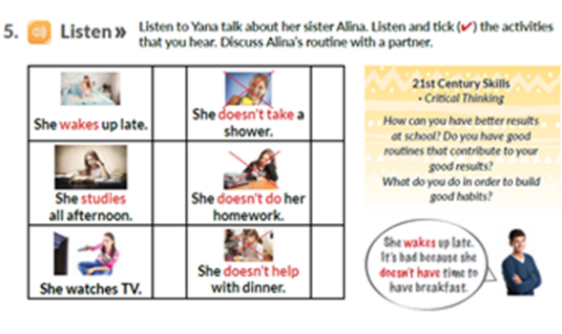  Taken from Way to Go 6th grade  T reads aloud the instruction of the activity they have to do. T checks students’ understanding asking about the names Yana and Alina and their relationship (sister). On the other hand, teacher asks about what and where Russia and Petrograd are. T helps them to locate it in a map. Then, T asks the students to look at the vocabulary before playing the track. After, T plays the track once, and asks the students about it. Then, T plays the track again and check the answers with the class. | 45 minutes  T – Ss  Individual work
  Answer Key
  She wakes up late, she doesn´t take a shower. She studies all the afternoon. She doesn´t do homework. She doesn’t help with dinner.
Controlled practice | Grammar presentation  T writes the sentences about Alina’s activities on the board and asks the students the difference between them and the way to say their routines with “I”. For instance:  T explains the affirmative form of the verbs and gives the students the Rules to the third person singular. Teacher explains verbs conjugations with a verb, and asks the students to do some others, for example:  T gives a prize or a 5, 0 to the students who conjugates the verb very well, and first, explaining again to the low proficiency students.  Teacher explains the use of connectors BUT to show contrast and, AND to add ideas.  Example: she wakes up early but she doesn´t go to bed early at night.  She does her homework and reads a book.  T asks the students to write some examples (at least 3) talking about their classmates in their notebooks; for example:  Maria does homework but she doesn´t have breakfast.  Jose participates in class and does homework.  T says again “no bees no honey” and Ss respond, “no work no money” to catch students’ attention, and T asks the Ss to copy exercise 6 on page 22 in the book:  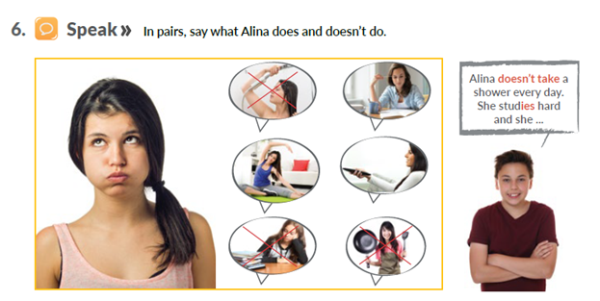  Taken from Way to Go 6th grade  T tells SS the exercise helps them to reinforce the grammar studied in the lesson. T reads the instructions aloud and students get their pair to work. T goes around monitoring the students´ work. At the end, T asks the students to say their answers aloud to the whole class.  Continuing the practice, T asks the students to copy the exercise 7 on page 22 in the book reads the instructions aloud, to check students understanding.  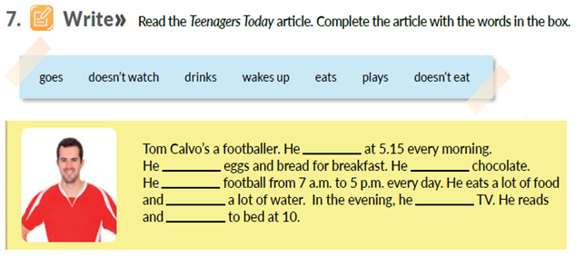  Taken from Way to Go 6th grade  Teacher asks the students about the vocabulary and they write the new one in their word-study book. T checks Ss´ answers aloud and collect Ss´ notebooks at the end of the class to grade them. | 45 minutes  Ss –Ss  Pair work
  I wake up early | I don’t make breakfast
  She wakes up late | She doesn’t do homework
  I take a shower  You take a shower  He takes a shower  She takes a shower  It takes a shower  We take a shower  You take a shower  They take a shower | I go to school  You go to school  He goes to school  She goes to school  It goes to school  We go to school  You go to school  They go to school
  Answer Key
  She doesn´t take a shower. She studies in the morning/afternoon. She does exercise. She watches TV. She doesn´t do homework. She doesn´t help with breakfast / lunch / dinner.
  Answer key
  Tom Calvo´s a footballer. He wakes up at 5:15 every morning. He eats eggs and bread for breakfast. He doesn´t eat chocolate. He plays football from 7 a.m. to 5 p.m. every day. He eats a lot of food and drinks a lot of water. In the evening, he doesn´t watch TV. He reads and goes to bed at 10.
Controlled practice | Self-assessment: THREE THINGS  T gives the student a piece of paper and asks them to make a list of 2 things they learned and 1 thing they need to learn or they need more explanation (Appendix No. 2). | 45 minutes  Ss –Ss  Pair work
Free practice  Post-Reading | Poster creation  T tells students that they are going to talk about their favourite famous person.” T asks the students to answer the following questions in their notebooks:  1. Who is your favourite famous person? Ex: My favourite famous person is Chayanne  2. What is his / her name? Real name? (if he /she uses an artistic name) Ex: His real name is Elmer Figueroa Arce  3. What does he / she do? (his / her occupation) Example: He is a singer, dancer and actor.  T gives the students a graphic organizer called E-Chart to help them to produce ideas and write about their favourite famous person. T may use the following link and sample as a reference:  https://www.eduplace.com/graphicorganizer/pdf/echart.pdf  They should write at least 6 sentences about each character. (T makes sure ss use both positive and negative forms). T helps the students with the new vocabulary they need.  Based on what the students have worked, they are going to make a poster about their favourite famous person, they must write affirmative and negative statements by using connectors and / but, in a piece of special paper (1/8 of cardboard). Ss must add some pictures about the famous person. | 30 minutes  T- Ss  Individual work
  Name: ___________________________ Date: ________________
  Sings pop music
  He / She dances salsa
  acts in movies
  Smoke cigarettes
  He / She doesn’t eat fast food
  drink beer
Wrap-up | Rubric  SS use the rubric provided to assess their peer’s presentation (Poster Assessment tool Appendix No. 3) | 30 minutes
Wrap-up | Peer assessment: 2 STARS AND A WISH  T tells students they are going to use the technique called “2 stars and a wish. SS write 2 good comments about their partners’ poster on the stars and they write something they have to improve within the cloud (Appendix No. 4). | 30 minutes

Implementation alternatives
I work at an urban area but if you are working at a rural area, I consider that this plan can be adapted. Students might not have information about famous people, so they can talk about their family members. On the other hand, if they don´t have photos about their relatives they can draw. Besides, T can model a conversation about routines and Ss can role-play the situation.

Key words
topic | skill | linguistic | vocabulary | grade
Daily Activities | Reading and Writing | Simple present tense:  Affirmative and negative form. Do / does + not.  Third person singular rules. | Daily activities verbs and connectors and / but | 6TH

Appendix No. 1
A to Z Game

TEAM: ________________________
A | B | C
D | E | F
G | H | I
J | K | L
M | N | O
P | Q | R
S | T | U
V | W | X
Y | Z

A TO Z GAME
TEAM: ________________________
A | B | C
D | E | F
G | H | I
J | K | L
M | N | O
P | Q | R
S | T | U
V | W | X
Y | Z

A TO Z GAME
TEAM: ________________________
A | B | C
D | E | F
G | H | I
J | K | L
M | N | O
P | Q | R
S | T | U
V | W | X
Y | Z

Appendix No. 2
Self- assessment

THREE THINGS  - ____________________________________  - ____________________________________  - ___________________________________ | THREE THINGS  1. _______________________________  2. _______________________________  3. _______________________________
THREE THINGS  1. ___________________________________  2. __________________________________  3. _____________________________________ | THREE THINGS  - _______________________________  - _______________________________  - _______________________________

Appendix No. 3
Poster Creation Rubric
Student name: _______________________________________ Grade: _______________________

CATEGORY | EXCELENT 5.0 | GOOD 4.0 | ACCEPTANCE 3.0 | FAIL 2.0 | SCORE
GRAPHICS | All graphics are related to the topic and make it easier to understand. All borrowed graphics have a source citation. | All graphics are related to the topic and most make it easier to understand. Some borrowed graphics have a source citation. | All graphics relate to the topic. One or two borrowed graphics have a source citation. | Graphics do not relate to the topic OR several borrowed graphics do not have a source citation.
GRAMMAR | There are no grammatical/mechanical mistakes on the poster. | There are 1-2 grammatical/mechanical mistakes on the poster. | There are 3-4 grammatical/mechanical mistakes on the poster. | There are more than 4 grammatical/mechanical mistakes on the poster
CONTENT | Content is accurate and all required information is presented in a logical order. | Content is accurate but some required information is missing and/or not presented in a logical order, but is still generally easy to follow. | Content is accurate but some required information is missing and/or not presented in a logical order, making it difficult to follow. | Content is inaccurate. Information is incomplete, inaccurate, or not presented in a logical order, making it difficult to follow.
PRESENTATION | Presentation is neat, clean, well- organized and presented in a creative way.  Presentation is colorful and creative. Information is interesting and accurate. | Presentation is mostly neat and clean. Information is organized in a logical manner and shows some degree of creativity. The overall presentation is interesting. | Presentation flows well. Some tools are used to show acceptable understanding.  Each member’s information is represented and identified with his or her name. | Presentation has no flow. Insufficient information and lacking some of the member’s information
FINAL SCORE
Comments:
Taken from https://www.uen.org/lessonplan/download/18725?lessonId=12365&segmentTypeId=2
http://www.gsiccharter.com/cms/lib011/GA01933819/Centricity/Domain/69/Cinco%20de%20Mayo%20Poster%20Grading%20Rubric.doc and adapted by Luz Mila Puentes Camargo
Appendix No. 4
Peer Assessment Tool: Two Stars and A Wish

