INSPIRING TEACHERS
ELT PLAN TEMPLATE

Complete with the information about you
Author
Teacher´s name | Liliana Patricia Vera
Email | lilianapatricia.vera@gmail.com
School | Institución Educativa Técnica Moreno y Escandón

Select the type of plan
Lesson plan | Activity plan | Task plan | Project plan
 |  | X

Write a few lines about the usefulness of this plan for the Colombian English teachers
Example: This lesson plan gives the students a chance to know about you, their new teacher, and it also gives you a valuable opportunity to assess your students' level. It can also be a useful and productive class if you ever find yourself substituting a class at short notice.
Author’s remarks
This plan will help you teach physical description adjectives and make students reflect upon the fact that all of us are different. It is a way to remark the importance of otherness and diminish bullying in our classrooms. If we teach something like that, we are contributing to our peace.

Complete with the information about your students
Grade | Length of lesson | Number of students |  | Average age
6 | Six hours | 40 |  | 11-12
Area |  | English level
Rural | Urban  X | A1  X | A2 |  | B1

Select the curricular axe or focus
Curricular Focus / Axes
Environmental / Sustainability Education
Sexual / Health Education
Construction of Citizenship / Democracy / Teenagers | Democracy
Globalization

Complete with information about the content and methodological approach of the plan
Topic | WE ARE ALL DIFFERENT!
Module / Unit | UNIT 1. English Way to go 1. Module 1. Pag. 33
Language focus | Language Function | Language skills | Vocabulary
Language focus | To describe their physical appearance and recognize differences by using the verb to be and the possessive adjective my/your and his/her | All the skills are intertwined but there is an emphasis on writing and speaking | Physical description adjectives
Principles / approach | Task Based Learning / Transversality / Assessment

In “Aim”, state what the learning goal is, in other words, what you want your students to achieve by the end of the session.
In “Subsidiary aims”, relate the language skills (communicative and linguistic) students need to master in order to achieve the main aim of the lesson. Make sure the aims are learner-centred, specific, measurable, achievable, realistic, and action oriented.
Learning objectives
Aim | By the end of this lesson, students will be able to describe their favorite sportsperson by means of a poster.
Subsidiary aims | By the end of this lesson, students will be able to:  - Identify specific information in a text related to a physical description.  - Listen to physical descriptions and recognize the vocabulary.  - Write sentences to express information about people and themselves.  - Describe their mates and sportspeople’s physical characteristics in an oral way.

List all the materials needed for this plan. Please, do not include any picture or photograph.

Materials needed
Pictures, soundtrack, copies, notebooks, computer, paper, markers, glue, scissors, balloons, ppt and video beam.
Way to Go 6th (pg.33).
http://aprende.colombiaaprende.edu.co/sites/default/files/naspublic/colombiabilingue/waytogo/Libros%20PDF/Grado%206/Way%20to%20Go%20Students%20book%20%206.pdf

Write the name for each state of the plan. Then in the “Procedure”, write a detailed description of what the teacher and students do at each stage of the session.
Be sure to be thorough so any teacher can follow this plan. Write the procedure in third person and present tense.

Use these conventions: T= teacher S= students Ss= students

Stage | Procedure | Time and Patterns of interaction
Warm up | A student reads the poster about classroom rules. In the poster, there are five rules to do in the Classroom: Respect your classmates and your teacher, participate in all activities, be ready to learn, believe in yourself and raise your hand to speak.  The teacher asks students about the vocabulary of the physical descriptions’ adjective. Students work in groups of eight to practice vocabulary.  The teacher gives students the category of the name of different sports. Students stand in a circle. One student calls out the sport and tosses the balloon in the air. Students already know the vocabulary about sports). The person who tosses the balloon must call out the name of one member of that vocabulary set (volleyball) and hit the balloon back into the air. They continue the task without repeating a sport already used. | 10 minutes  T-SS  SS-SS  Group work
Introduction | Transition: Teacher says: Talking about sports, let’s see some vocabulary related to sports. Teacher shows flashcards of a coach, a captain and, a libero (Appendix 1).  T asks the students:  - What is your favorite sport?  - Which sports are showing the flashcard?  - Do you participate in anyone?  Then, Teacher asks: How many students are in a sports team like Daka Volleyball Team, or Chacales Soccer Team or Skate Team?  After students answer the questions, teacher tells students that they are going to learn some vocabulary (adjectives) about physical descriptions through a PPT. The flashcards have been taken from https://en.islcollective.com/english-esl-powerpoints/grammar/adjectives-personality-character/physical-appearance-presentation/81031  Also, T gives Ss a copy of this vocabulary to be glued in their notebooks (Appendix 2). So, they only pay attention to the pronunciation, to the pictures and the T explanation.  Based on that, SS play a Memory Game about adjectives to describe physical appearance. T divides the class into four teams. T gives SS some pictures of physical descriptions adjectives. Each group takes the words and pictures and puts them into a correct order (Appendix 3).  Then, T and Ss socialize the exercise and put them in the correct order if there are some of them in an incorrect order. | 110 minutes.  To improve our fluency and pronunciation  Pair group  Whole group (at last)
Introduction | Assessment: Using Classroom Assessment Techniques (CATs)  The Muddiest Point. T shows to the Ss an image and explains that they are going to draw it in their notebooks and are going to answer: What was the muddiest point today? They find what is the least clear and reflect on the lesson and identify concepts needing further examination or study.  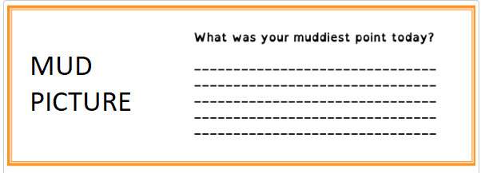
Practice | Transition: T says, “for reinforcing the physical appearance we have just studied in the introduction, now we are going to read a text and complete a chart with some information. We are going to work with the book Way to Go 6th on page 33 exercise 1.”  - T reads and explains the chart to the Ss.  - T reads a short paragraph about the Kansas School Newspaper (pg. 33 Way to go 6^{th.} Exercise 1).  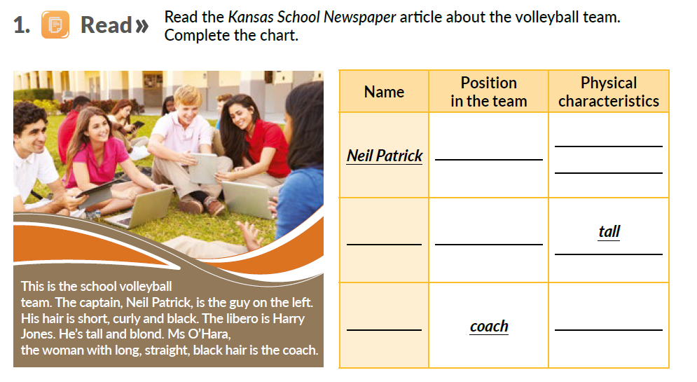  Taken from Way to Go 6th  - T reads again And Ss pronounce with him/her.  - At the last time, Ss in pairs read the text to each other.  - T presents the chart. According to the information in the reading, Ss complete the chart.  - They check the answers with the whole class.  - 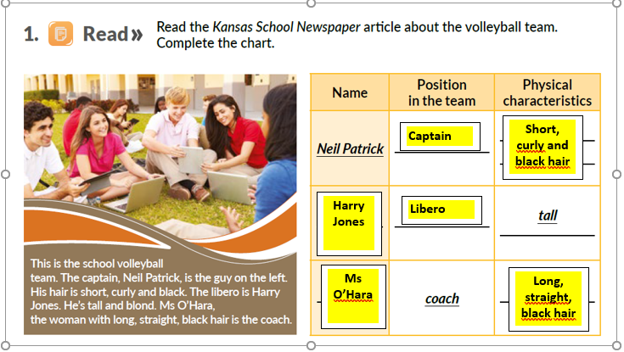They check the answers with the whole class.  Taken from Way to Go 6th  Ss and T socialize the activity about the reading and complete the chart. Then, Ss do a listening task from de English book Way to Go 6th on page 33. Exercise 2. T follows the following procedure:  ter,  - Ss listen to the audio track 22 about physical descriptions. (pg. 33 Way to go 6^{th.} Exercise 2).  - T plays the track again. Ss do not complete anything only when they’re reading and try to understand the audio.  - Then T asks the Ss which one in the photo corresponds to the physical description.  SS and T socialize the activity of the book. T presents an image and explains to the SS how to describe the physical appearance. T explains with examples that in a long description, we must use first length, style and color and the last one is the noun. T may use this material as a reference:  https://en.islcollective.com/english-esl-powerpoints/grammar/adjectives-personality-character/physical-appearance-presentation/81031  T and Ss try to describe an important soccer player (Lionel Messi). T starts with the physical description and some of them try to continue the description.  At the end, T corrects some mistakes about pronunciation or grammatical problems.  When Ss have corrected their grammatical problems or pronunciation problems, Ss form groups of 5 and start the next activity. Ss choose one of their classmates and they´re going to describe him/her. Each group presents their classmates that they choose in front of the class. | 120 minutes  To identify how to do a personal description with simple present.  Whole Ss  Pair Work
Practice | Assessment: Peer Assessment (Two Stars and a Wish). When Ss finish their presentation about the physical description of their classmates, T asks Ss to provide feedback about their mates’ work by using the technique called “Two stars and a wish”. The idea is that Ss write two positive comments about their peers’ work and something that can be improved.
Production | Transition: At the end of the last class, T asks Ss to bring some pictures of the most important sportspersons in Colombia. Now that Ss know how to describe somebody, they make a poster to present some sportspeople.  Note: Ss should have brought the pictures/images in advance.  - Ss present a photo of different sportspersons (men and women).  - T shows them a word bank with different adjectives.  - By pairs, they must choose a sportsperson (man or woman) to describe.  - They make a poster with the sportsperson they choose. This writing helps Ss improve listening since they need to understand what Ss are speaking.  - Each group presents their poster and describe the sportsman / woman they chose based on written ideas.  - T gives Ss a rubric to assess their classmate’s presentation. | 60 minutes  To provide speaking practice  Pair Ss
Wrap-up | After Ss give their presentations, T gives room for feedback; this means that SS socialize their rubric to assess the presentations. The rubric includes the following criteria: Vocabulary, grammar, content, writing, volume and speaking. The idea is that they use an emoji in each item: very well, quite well, with difficulty and unsatisfactory (see Appendix 4). | 60 minutes  T - SS
Wrap-up | Assessment: Then, T shows them an image of the Self-Assessment Exit Ticket 3, 2 and 1 and SS complete it by following these instructions (see Appendix 5):  - Write three things I learned with this lesson.  - Write two things I found interesting.  - Write one question I still have.  Homework: At home, they choose a picture of their family and describe the family members. | 60 minutes  T - SS

List a series of ideas of how this plan can be methodologically adapted so other teachers can implement it in their own educational context.
Implementation alternatives
- This lesson plan can be adapted to a rural or urban context. For example, when you talk about some teams students participate in. You can talk about some teams you know in your region.
- If you do not have a video beam or a computer in your context, you can print the images paste them on the board for teaching Ss the adjectives of physical descriptions.
- With the audio track, we can read the text and the Ss listen to what we say.
- You can ask Ss to draw in their notebook all the kinds of activities related to assessment: CATs, rubric, self-assessment or peer assessment.

Write the key word for each category based on the content of this plan. For example:
Topic: environment Skill: reading Linguistic: should Vocabulary: animals, environment
Key words
topic | skill | linguistic | vocabulary | grade
Physical description | Writing and speaking | Verb to be and  Possessive adjectives | Physical description adjectives | Sixth (6th )

Appendix 1

She is a libero

(Image that represents a libero)

He is a captain

(Image that represents a captain)

He is a coach

(Image that represents a coach)

Appendix 2

ADJECTIVES OF DESCRIPTIONS-ADJETIVOS DE DESCRIPCIÓN

AGE- EDAD

- - TEENS (10-19)
- - TWENTIES (20-29)
- - THIRTIES (30-39)
- - FORTIES (40-49)
- - FIFTIES (50-59)
- - SIXTIES (60-69)
- - SEVENTIES (70-79)

HEIGHT- ESTATURA

- SHORT- BAJO
- AVERAGE HEIGHT- ESTATURA PROMEDIO
- TALL-ALTO

BUILD- CONTEXTURA/PESO/FORMA DEL CUERPO

- SKINNY- ESQUELÉTICO
- THIN- WELL BUILT- ATHLETIC- DELGADO- CONTEXTURA DELGADA- ATLÉTICO
- FAT- GORDO
- CHUBBY- GORDITO
- STRONGLY BUILT-MUSCULAR- MUSCULOSO

HAIR- CABELLO LENGTH+ STYLE + COLOR

- LENGHT
- SHORT -CORTO
- SHOULDER-LENGHT- LARGO AL HOMBRO
- LONG– LARGO
- STYLE
- STRAIGHT- LISO
- WAVY- ONDULADO
- CURLY– CRESPO
- COLOR
- BLOND- RUBIO
- RED- ROJO
- BLACK- NEGRO
- BROWN- CAFÉ
- GRAY- GRIS
- BALD- CALVO
EYES
- BROWN EYES- OJOS CAFES
- BLUE EYES- OJOS AZULES
- GREEN EYES- OJOS VERDES
- BLACK EYES- OJOS NEGROS
- GRAY EYES- OJOS GRISES

Appendix 3

Memory Game

Fat
Insert image that represents fat

Curly hair
Insert image that represents curly hair

Tall
Insert image that represents tall

Blond
hair
Insert image that represents blond hair

Short
Insert image
that represents short

LONG BLACK STRAIGHT HAIR
Insert image that represents long black hair

BLUE EYES
Insert image
that represents blue eyes

Appendix 4

Rubric about the Sportsperson Presentation

 |  | Very Well  5 | Quite Well  4 | With difficulty  3 | Unsatisfactory  2
Vocabulary | Students can identify vocabulary related to physical descriptions
Grammar | Students can express the correct order in a long description.
Content | Students show understanding of the topic
Speaking | Students can talk about sportspersons physical descriptions.
Volume | Students can speak loud enough to be heard by all their classmates
Respect | Students show respect to describe his/her favourite sportspersons.

 |  | Very Well  5 | Quite Well  4 | With difficulty  3 | Unsatisfactory  2
Vocabulary | Students can identify vocabulary related to physical descriptions
Grammar | Students can express the correct order in a long description.
Content | Students show understanding of the topic
Speaking | Students can talk about sportspersons physical descriptions.
Volume | Students can speak loud enough to be heard by all their classmates
Respect | Students show respect to describe his/her favourite sportspersons.
Appendix 5
IET. MORENO Y ESCANDÓN
ENGLISH
Name: _______________________ Date: _______________
EXIT TICKET
How well did you understand this lesson?
3. Three things I learned with this lesson. | 1.
3. Three things I learned with this lesson. | 2.
3. Three things I learned with this lesson. | 3.
2. Two things I found interesting | 1.
2. Two things I found interesting | 2.
- One question I still have. | 1.

IET. MORENO Y ESCANDÓN
ENGLISH
Name: _______________________ Date: _______________
EXIT TICKET
How well did you understand this lesson?
3. Three things I learned with this lesson. | 1.
3. Three things I learned with this lesson. | 2.
3. Three things I learned with this lesson. | 3.
2. Two things I found interesting | 1.
2. Two things I found interesting | 2.
- One question I still have. | 1.

