INSPIRING TEACHERS
ELT PLAN TEMPLATE

Complete with the information about you
Author
Teacher´s name | Esteban Carvajal Ocampo
Email | estebancarva@hotmail.com
School | San Pablo school

Select the type of plan
Lesson plan | Activity plan | Task plan | Project plan
x

Write a few lines about the usefulness of this plan for the Colombian English teachers
Example: This lesson plan gives the students a chance to know about you, their new teacher, and it also gives you a valuable opportunity to assess your students' level. It can also be a useful and productive class if you ever find yourself substituting a class at short notice.
Author’s remarks
- This plan is a good way to assess ss level while they think which professions they like the most and which ones are not appealing for them.
- This is a good strategy to connect and anchor new vocabulary and language skills with their daily life, motivations, vocations, expectations, likes and dislikes
- Ss are able to express and communicate their likes and dislikes regarding professions to their classmates.
Complete with the information about your students
Grade | Length of lesson | Number of students |  | Average age
6th | Six Hours | 39 |  | 11
Area |  | English level
Rural | Urban x | A1 x | A2 |  | B1

Select the curricular axe or focus
Curricular Focus / Axes
Environmental / Sustainability Education
Sexual / Health Education
Construction of Citizenship / Democracy / Teenagers | x
Globalization

Complete with information about the content and methodological approach of the plan
Topic | Professions, occupations, vocations and my life plan
Module / Unit | Module 2 - way to go
Language focus | Language Function | Language skills | Vocabulary
Language focus | Expressing likes and dislikes about future professions. | Listening, speaking and writing | Likes and dislikes, jobs, professions, future activities and plans.
Principles / approach | Task Based Learning

In “Aim”, state what the learning goal is, in other words, what you want your students to achieve by the end of the session.
In “Subsidiary aims”, relate the language skills (communicative and linguistic) students need to master in order to achieve the main aim of the lesson. Make sure the aims are learner-centred, specific, measurable, achievable, realistic, and action oriented.
Learning objectives
Aim | By the end of the Project students will be able to describe the activities and professions they like and dislike.
Subsidiary aims | By the end of this lesson, students will be able to …  - Express ideas about their future professional choices  - Compare and contrast different professions. (advantages and disadvantages)

List all the materials needed for this plan. Please, do not include any picture or photograph.
Materials needed
- Video about responsibility, discipline and life plan. Sources below
- Second video about professions and occupation. Sources below
- Examples of videos and billboards for ss to develop their own life project (to be made by Ss) (Example of previous activities)
- Vocabulary Flashcards (to be made by Ss)

Write the name for each state of the plan. Then in the “Procedure”, write a detailed description of what the teacher and students do at each stage of the session.
Be sure to be thorough so any teacher can follow this plan. Write the procedure in third person and present tense.
Use these conventions: T= teacher S= students Ss= students
Stage | Procedure | Time and Patterns of interaction
Warm up:  Pre-Task: Presenting the topic | Questioning: T. will start the class by asking ss about what they would like to study at the university. He will encourage learners to say it in English and will help with the correct way of saying in case ss don’t know. For example: Engineering, Medicine, Languages, etc. As students mention their favorite careers T will encourage them to explain why.  Some flashcards will be needed to help ss understand some other professions.  Acronym: up next, T will show ss a poster with the words RESPONSIBILITY and DISCIPLINE and will incite ss to write words with each letter.  Brainstorming: T. will play a video about responsibility, discipline and life purpose. Then he will ask ss to write on the board key words from the video. Then a second video about professions will be displayed and ss will have to complete the following chart in their notebooks based on it:  Write as many aspects as you can understand and of course that call your attention about: | 20 minutes  T-SS  Group work  Time: 50 minutes  Interaction: T – SS  Ss – Ss (Whole class)  Aim: To familiarize students with the topic and the vocabulary.
  Vocation and life plan reflection and conversation. (the importance of professions and our contribution to society) | Storytelling about personal experiences and fictional stories about people and their experiences
Warm up:  Pre-Task: Presenting the topic | Assessment: Describe here the assessment practice the T implements in this stage if applicable. For example, self-assessment, peer-assessment, classroom assessment technique, test, etc. Also, describe how the T provides feedback.
While Task | T hands in a copy with some words related to a girls ‘description of what she does and likes, Ana. Then Students get in pairs and try to organize Anna´s paragraph in which she describes her wishes, likes and dislikes about jobs and professions, Ss have to shape the paragraph so it makes sense.  After that, some couples will read the paragraph aloud and T will be checking coherence and cohesion, then T will explain the use of logic connectors to support their ideas, likes, dislikes and choices. Finally, T will display the original paragraph so all ss can assess their group work.  Up next, T will ask ss to work with another person (different from the one in the previous activity) and following Ana’s description format, they will talk for about 5 minutes about their vocation, what they like to do and what they don’t like to do. | Time: 50 minutes  Interaction:  Ss – Ss (Whole class)  Aim: To encourage Ss to communicate their ideas, feelings, likes, dislikes and choices
While Task | Assessment: Reflection tree.  T project the reflection tree on the screen and ask ss to place themselves in the number they consider represents their advancement in the writing process, considering their performance in the previous activity.
Post task | RAFT Technique, Writing. T will provide ss with an example of Billboard and his own design of what he wants to do in his future. In a round table, T will introduce his billboard so students can ask questions and exchange ideas. Finally, he will project the video he made about a profession he likes. Then, Ss will create their own billboard and video to present it to their classmates, finally they will paste them around the school hall.  RAFT  Homework: groups of 3. For next class, ss will have to record a short video clip in which they explain one of his classmates’ job preferences and including what he likes and doesn’t like. | Time: 60 minutes  Interaction: T – SS  Ss – Ss (Whole class)  Aim: To promote interaction by sharing with classmates choices and preferences to build a life project
Post task | Assessment: Rubric. The following rubric will be given to ss so they get to know what T will check in their paragraph.  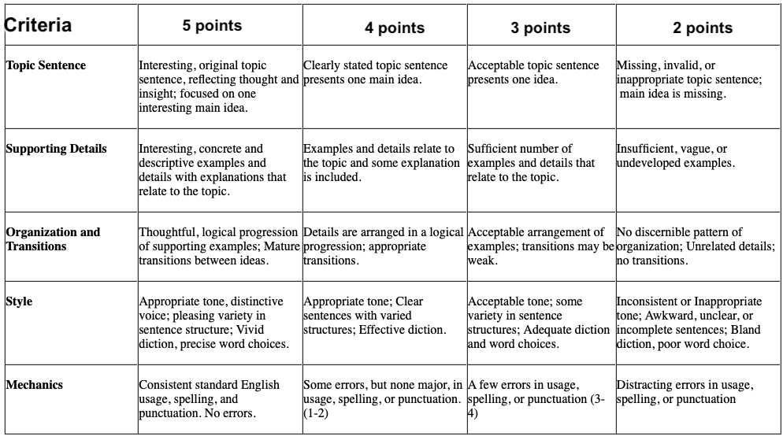
Wrap up | T will start the class by presenting one more video about future jobs and the importance of being responsible and discipline at any job.  Then every group will project their video clips describing the different jobs.  Peer assessment. During this video clips presentation T will implement the “2 stars and a wish” technique in order to promote peer assessment:  _______________________________  _______________________________  _______________________________  Through a round table T will provide general feedback and will continue promoting interaction in the classroom by asking ss general questions about the oral activity. | Aim: to promote oral interaction, independent and collaborative work.
Wrap up | Group work: Ss will post their billboards around the classroom and will get ready to present it to their guest. The first presentation will be conducted among classmates so the class will be divided into 2. Half of the class will present to the other half and then swap. Every listener will have the following peer assessment document to be completed whilst listening to a classmate:  Collaborative work. The objective of this activity is to provide as much insight as possible about the presentation so ss can feel more prepared to present their billboard to the school.  Final presentation. After all the feedback provided by the T in the written text and classmates and teacher in the oral production, ss will paste their billboards around the school hall and will present them to the guests who are from the other 6th grade.

List a series of ideas of how this plan can be methodologically adapted so other teachers can implement it in their own educational context.
Implementation alternatives
This task plan is aimed at being transversal through Ethics subject matter with values like discipline, responsibility and emotional intelligence.

Write the key word for each category based on the content of this plan. For example:
Topic: environment Skill: reading Linguistic: should Vocabulary: animals, environment
Key words
topic | skill | linguistic | vocabulary | grade
Professions occupation, vocation and life plan | Listening, speaking and writing | Simple present  Logic connectors | Likes and dislikes, jobs, professions, future activities and plans. | 6th

The following rubric will be implemented for the T all over the task development in order to assess ss’ process in the oral component.
Criteria | Superior | High | Basic | low
Knowledge of the topic | Communicates easily and evidences comprehension of the topic | Communicates and evidences comprehension of the topic | Communicates and evidences basic comprehension of the topic | Needs Improvement in the comprehension of the topic
Explanation: argumentative and descriptive skills | Provides excellent arguments and descriptions of his/her choices | Provides strong arguments and descriptions of his/her choices | Provides fair arguments and descriptions of his/her choices | Does not provide arguments and descriptions of his/her choices
Accuracy:  Use of the language | Conveys the message clearly and with excellent pronunciation | Conveys the message clearly and with outstanding pronunciation | Conveys the message with some difficulties and with fair pronunciation | The message is not clearly conveyed, needs improvement in pronunciation
Use of materials | Excellent use of the billboard and the video casts the message clearly | Uses efficiently the billboard and the video casts the message clearly | The billboard and the video casts the message with some mistakes | The billboard and the video does not casts the message
Performance: Connection with the audience | Accomplished to establish positive connection with audience needs, interests and expectations | Accomplished to establish positive connection with audience | Establishes fair connection with audience | Needs to develop positive connection with audience

Video sources
https://www.youtube.com/watch?v=so2QHzbU_Eg
https://www.youtube.com/watch?v=v_p9JdeiJfo&t=2s

