INSPIRING TEACHERS
ELT PLAN TEMPLATE

Complete with the information about you
Author
Teacher´s name | María Alejandra Mosquera Ledezma
Email | mandracollege@gmail.com
School | Oreste Sindici

Select the type of plan
Lesson plan | Activity plan | Task plan | Project plan
x

Author’s remarks
With this lesson plan you can learn how to give directions, Identify the places of a town, use the prepositions of place appropriately, to know your community.

Complete with the information about your students
Grade | Length of lesson | Number of students |  | Average age
6° | 8 hours | 50 |  | 10-14
Area |  | English level
Rural | Urban x | A1 x | A2 |  | B1

Select the curricular axe or focus
Curricular Focus / Axes
Environmental / Sustainability Education
Sexual / Health Education
Construction of Citizenship / Democracy / Teenagers | x
Globalization

Topic | This is My neighbourhood
Module / Unit | Unit 2: I belong to a community
Language focus | Language Function | Language skills | Vocabulary
Language focus | Ask for and give information about directions to get to places. | Writing  Listening | City Places  Prepositions of place  Objects of the classroom
Principles / approach | Task based learning

Learning objectives
Aim | By the end of this lesson, students will be able to ask for and give directions to get one’s bearings in a place.
Subsidiary aims | By the end of this lesson, students will be able to …  - Identify places in town  - Use prepositions of place appropriately at the moment of giving directions  - Use There is/ There are to describe places

Materials needed
Dictionary, cardboard or paper, markers, photocopy, pencil, marker, board, a box and two objects.

Stage | Procedure | Time and interaction
Pre task | T starts the class by asking ss to look around the classroom and identify different objects like the Tv, board, desk, etc. T writes the list of objects on the board as ss mention them. That day, T will place different objects that she will bring from her house all around the classroom, like a picture, some glasses, dishes, frames, among others. Finally, T will ask ss about their position in order to see how much ss know about the use of prepositions of place.  Questions like “where is the pen?” will be asked and then if they cannot reply properly T will guide them to say “The pen is ON the table. ”  Some flashcards are used in order to enrich the activity. Example:  (Add a picture about the prepositions of place)  Later, T asks ss questions about famous places in Medellin like El Pueblito Paisa, Parque Explora, etc. T tries to help ss to use some prepositions like in front of and next to. | 30 minutes  T-SS
Task 1 | T plays a video of famous places in Antioquia in order to provide ss with vocabulary and help them understand their location. After the video, T shows ss a map of Antioquia and ask them to identify where those places in the video are.  https://www.desktodirtbag.com/things-to-do-in-medellin-colombia/  Pair work: Every pair will receive the map and together they will have to locate the 9 famous places mentioned in the video. The first couple to complete the map will go to the front and describe it to the class. If it is correct, they will receive a candy.  Consolidation of vocabulary: T will give one card to each student with a word about the vocabulary of the lesson plan (city places, prepositions of place). Ss look for the meaning in the dictionary.  When the T says: “start” each student gives the card to the other student and says the meaning, the student that receives it, ha to write the word and the meaning in his/her notebook in thirty seconds. When the time finishes they repeat the procedure until they write all words.  Note: T shows the time to ss using a TV. or a cloc’k. | 30 minutes  SS-T  Individual work  20 minutes  SS-T  Group work
Task 2 | Dictogloss  T shows to ss a little text for a few minutes, he reads it aloud and display it again, later in groups of 3 ss have to write as many words as they can remember, then they compare their text with the one the T shows them.  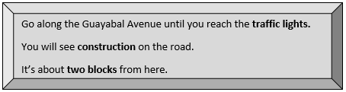  Every group will have to show the class what they wrote and the group with fewer mistakes will be awarded with some extra points  Individually, SS will develop the page 35 of the workbook “way to go”.  And they will have to make labels or pictures with names of the different places around the school and place them around the classroom, then SS have to identify the position of the place that the T says respect to school.  E.g. Where is the church? It’s next to school | 20 minutes  T-SS  SS-SS  Individual work  30 minutes  SS- SS  Individual work  20 minutes  SS- SS  SS- T  Group work
Task 3 | SS has to give an address to other SS who have to say what the place is.  E.g. Walk straight ahead to St. Mary street and turn left there, turn right on Carmelo street, the place is opposite the bakery. Then T will show ss a big map of a city and will play de audio so ss can follow the instructions and reach the places mentioned in the audio:  Map:  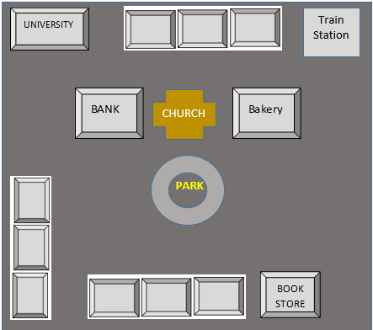  Listening:  http://www.elllo.org/english/Games/G012-Directions.html  Scrambled sentences  In pairs, T prints a text on a paper and then she/he cuts it into strips with one sentence per strep. T gives ss the sentences belonging to text and the ss have to assemble the sentences into coherent text or dialogue.  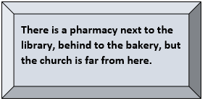  The first pair to finish will have to yell BINGO so T can check and give the points. | 30 minutes  SS-SS  Pair work  40 minutes  SS-SS  Pair work
Task 4  Assessment  Peer assessment  Self-assessment | T gives SS a map of the municipality of Itagüí without names with a list of instructions that they have to follow to put the names of the places.  E.g. There is a school in front of the park, the church is between the school and the supermarket on Guayabal Avenue Etc.  HAND SIGNAL  T tells students She/he will asks “Is there a church next to school? They will answer yes or no, with their hands  A thumbs up means “Yes, There is”  A Thumb down means “No, There isn’t”  T asks a crazy question such “Is there a sea under school?  T asks students to close their eyes, and use their thumbs to answer the questions:  A thumbs up means “Yes, There is”  A Thumb down means “No, There isn’t”  Clines  Finally, students draw emojis to show how they felt in each activity, or if they like it or not  Traffic lights  T asks students create a traffic light in their notebooks. Using colors. Then T tells ss to:  - Write aspects from the lesson they understand this very well in the green light.  - Write aspects from the lesson they need a bit of support but understand the basics in the yellow light.  - Write aspects from the lesson they don´t understand and need help in the red light.  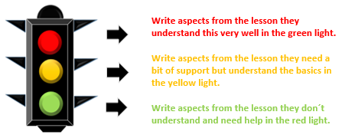 | 40 minutes  T-SS  Group work  15 minutes  T-SS  Individual work  20 minutes  SS-T  Individual work  15 minutes  SS-T  Individual work
Post task | Group work: designing a town.  Finally, Ss will create their own town following the patters given by teacher (the places it must have like a fire station, a mall, etc) in a poster. Once they finish the poster, they must name it and prepare a short presentation in which they will present it to the whole class.  Rubric. T will use this rubric to assess Ss oral production  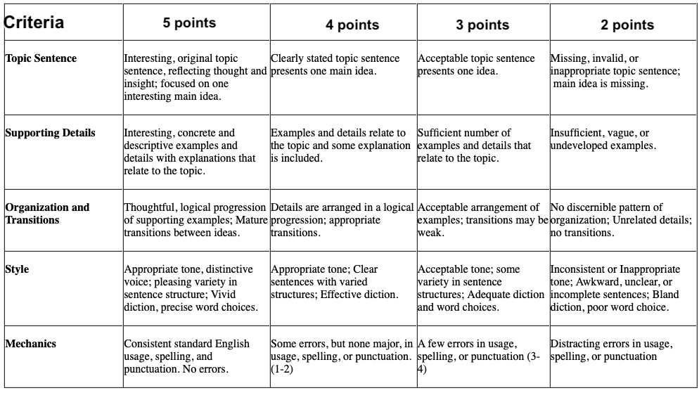 | 50 minutes  SS-SS  Whole class interaction

Implementation alternatives
This lesson plan can be used in any context, the teacher can use the T.V and show to the students songs related with the topic in the warm up.
https://www.youtube.com/watch?v=DHb4-CCif7U

Key words
topic | skill | linguistic | vocabulary | grade
This is My neighbourhood | Writing  Listening | There Is/ There are | City Places  Prepositions of place  Objects of the classroom | 6°

