INSPIRING TEACHERS
ELT PLAN TEMPLATE

Author
Teacher´s name | Yarima del Carmen Prens Lara
Email | alicialaradeprens@hotmail.com
School | Institución Educativa Escuela Normal Superior de Montería

Lesson plan | Activity plan | Task plan | Project plan
 |  | X

Author’s remarks
This plan is focused on the Construction of Citizenship Democracy; this lesson planning is fundamental in the learning process for 6th grade, this lesson plan gives the students a chance to know about the topic family members.

Grade | Length of lesson | Number of students |  | Average age
6 | 2 hours | 35 |  | 11-12
Area |  | English level
Rural | Urban x | A1 x | A2 |  | B1

Curricular Focus / Axes
Environmental / Sustainability Education
Sexual / Health Education
Construction of Citizenship / Democracy / Teenagers | X
Globalization

Topic | Family Members And Relationship
Module / Unit | Module 1 // Unit 3
Language focus | Language Function | Language skills | Vocabulary
Language focus | - Describing family relationships | Listening  Writing  Speaking  reading | Mother/father/brother/sister/grandmother, grandfather/aunt/uncle/cousin.
Principles / approach | Task

Learning objectives
Aim | By the end of this lesson, students will be able to talk about their family members doing an album with pictures of them, writing short descriptions under the photos.
Subsidiary aims | By the end of this lesson, students will be able to …  - By the end of this lesson, students will be able to identify words and phrases related to the family using simple present in oral and written texts.  - By the end of this lesson, students will be able to ask and answer yes / no questions about the family and their relations between their members.

Materials needed
Posters, flash cards, power point presentations, pictures, photos, projector, audio, photocopies. Album.

Stage | Procedure | Time and Patterns of interaction
Warm up: | T asks Ss to …. Actively participate in a conversation to talk about the family.  https://www.youtube.com/watch?v=FHaObkHEkHQ  -- Title: Family –  Hello! Let me introduce my family.  It’s me. He is my father. She is my mother. They are my parents. He is my brother. She is my sister. He is my grandfather. She is my grandmother.  They are my grandparents. He is my uncle. She is my aunt. She is my cousin, my family They are my family members. I love them!  Ss get in pairs and answer questions related to the video.  Who are they?  Who is she? Who is he? | 5 minutes  5 minutes  T-SS  SS-SS  Pair work  20 minutes  Individual work  T-SS  10 minutes  T
Introduction: | T tells the SS that they are going to study the family members and their relationship.  - Present the task to carry out: family album.  - Present the samples of the family album.  Ask questions to explore the vocabulary and knowledge of the students using the family album presented.  The teacher Ask questions to explore the vocabulary and knowledge of the students using the projector with a power point presentation.  The teacher ask students questions related to the power point presentation. | 5 minutes  T-SS
Introduction: | Assessment: writing the vocabulary | 5 minutes  T-SS
Vocabulary focus | Activate vocabulary with a poster, illustrating the family members, questions to verify the understanding of the vocabulary.  https://en.islcollective.com/english-esl-worksheets/grammar/questions-interrogative/lets-talk-about-family/1988  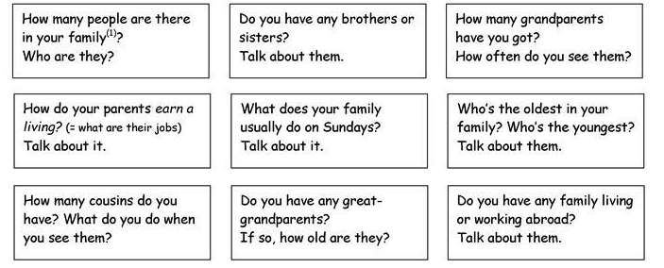 | 10 minutes  T-SS
practice | Practice the vocabulary and grammar learned through exercises using book and copy.  Book: Way to Go Grade 6 Page 30 activity 1 to 4 http://aprende.colombiaaprende.edu.co/es/node/94010 | 10 minuts  T-SS
Production | - The teacher divides the students into groups of 4; creatively using images they do an album. SS share their ideas.  - The students exchange information and answer questions with the help of the teacher.  - Actively participate in a conversation to talk about family members.  - The students will have the necessary space and time to plan and make the album.  - There will be a dialogue to exchange information about the activities and moments that they share.  - They will arrange the presentation of their albums.  Assign each group’s time for explain their album in the next class. | 20 minuts  T-SS  20 minutes  SS
Production | Assessment: Trainer can ask participants to have a look at the album and pay attention to the sections. students are asked to grade themselves once they have completed the task given. | 20 minuts  T-SS  20 minutes  SS
Wrap up | Paper Slide: On paper, small groups sketch and write what they learned. Then team representatives line up and, one at a time, slide their work under a video camera while quickly summarizing what was learned. The camera doesn’t stop recording until each representative has completed his or her summary.

Implementation alternatives
We can do oral presentations and role-play if it is possible to invite the family of one student for share with them during the class.

Key words
topic | Skill | linguistic | vocabulary | grade
FAMILY MEMBERS | Listening  Writing  Speaking  reading | •SIMPLE PRESENT  use vocabulary related to family members.  • use vocabulary related to people’s physical appearance.  • use vocabulary related to people’s feelings. | -Wh questions.  What, where, when,  Why.  -Family members  Mother, father, brother, sister, aunt, uncle, grandmother grandfather…  -Adjectives.  Tall, short, fat, strong, happy, long, blue… | 6°

