INSPIRING TEACHERS
ELT PLAN TEMPLATE
Author
Teacher´s name | Fernando Casanova Caicedo
Email | ufofer02@yahoo.es
School | IE Bachillerato

Lesson plan | Activity plan | Task plan | Project plan
 |  | X

Author’s remarks
This plan can be used in urban & rural areas since I consider every human being has habits as animals as plants. The images of routines are quite useful in order to connect students’ prior knowledge in this way they can associate it with their realities. I use modern music and with the mimic actions acted out by students might emerge dance steps in this way they can enjoy and remember this class forever.

Grade | Length of lesson | Number of students |  | Average age
6th | 2 lessons of 60 minutes | 31 |  | 10 -13
Area |  | English level
Rural X | Urban | A1 X | A2 |  | B1

Curricular Focus / Axes
Environmental / Sustainability Education
Sexual / Health Education
Construction of Citizenship / Democracy / Teenagers | x
Globalization

Topic | My Daily Routine
Module / Unit | 1
Language focus | Functional language | Language skills | Vocabulary
Language focus | Expressing and describing  daily activities | Speaking and writing | NA
Principles / approach | Task based learning

Learning objectives
Aim | By the end of the lesson, learners will be able to present their daily habits through videos.
Subsidiary aims | By the end of this lesson,  - Students will be able to use the simple present to express actions and time expressions to express frequency

Materials needed
Poster paper, computer, cell phones, markers and colored pencils

Stage | Procedure | Time and interaction
Warm up | The teacher asks Students to get into groups of 3 and write as many daily activities they can do in one day. The group with the longest list, wins. | 5 minutes  Group work
Pre-task | Then ss draw a big clock on a poster paper. They must write the daily activities round the clock according to the time of day they do each activity  T monitors and helps with language | 15 minutes  T-SS  SS-SS
task | After completing the clock, the group gets together with another group and practices describing their daily actions. The teacher writes a sentence on the board to help with language: e.g.  “I wake up at 5:30 A.M”  T monitors and helps with language.  Then, Teachers gives Students some tips showing do’s and don’ts to record a video in their houses by using a smartphone and record it in a USB with the file name “My daily routine”. They must record themselves doing the activity and describing it. | 15 minutes  T-SS  SS-SS  15 minutes
Post task | The teacher uses the laptop and TV to project students’ videos recorded in their USB’s.  The teacher takes notes about strengths & weaknesses of each video presented by learners.  The teacher highlights students’ relevant mistakes.  The teacher asks students to select the 2 best videos of each gender. | 50 minutes  T-SS
Assessment | 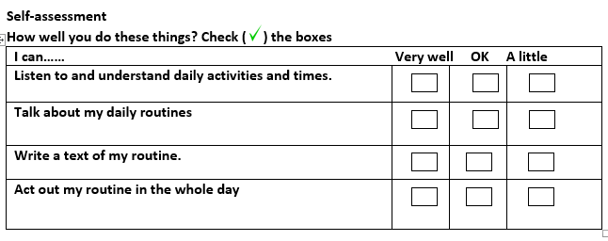 | 15 minutes  T-SS

Inspiring tips for other teachers who want to implement this plan
If students don’t have devices to record the videos, they can prepare 5-minute presentations to show in class.

Key words
topic | skill | linguistic | vocabulary | grade
My Daily Routine | Speaking and writing | NA | NA | 6th

