INSPIRING TEACHERS ELT PLAN TEMPLATE

Complete with the information about you
Author
Teacher´s name | Arturo Echenique
Email | arturoecheniquegomez@gmail.com
School | Liceo Samario

Select the type of plan
Lesson plan | Activity plan | Task plan | Project plan
 | x

Write a few lines about the usefulness of this plan for the Colombian English teachers
Example: This lesson plan gives the students a chance to know about you, their new teacher, and it also gives you a valuable opportunity to assess your students' level. It can also be a useful and productive class if you ever find yourself substituting a class at short notice.
Author’s remarks
This activity plan can be used for introducing vocabulary about either landscapes or eco-parks in Colombia while allowing the students to practice their productive skills.

Complete with the information about your students
Grade | Length of lesson | Number of students |  | Average age
7th | 65 minutes | 35 |  | 15
Area |  | English level
Rural | Urban X | A1 | A2 X |  | B1

Select the curricular axe or focus
Curricular Focus / Axes
Environmental / Sustainability Education | X
Sexual / Health Education
Construction of Citizenship / Democracy / Teenagers
Globalization

Complete with information about the content and methodological approach of the plan
Topic | Eco-tourism
Module / Unit | Module 4. Globalization
Language focus | Language Function | Language skills | Vocabulary
Language focus | Describing eco-parks and activities | Writing  speaking
Principles / approach | Communicative approach

In “Aim”, state what the learning goal is, in other words, what you want your students to achieve by the end of the session.
In “Subsidiary aims”, relate the language skills (communicative and linguistic) students need to master in order to achieve the main aim of the lesson. Make sure the aims are learner-centred, specific, measurable, achievable, realistic, and action oriented.
Learning objectives
Aim | By the end of this lesson, students will be able describe eco-parks they have visited in Colombia and the activities they did.
Subsidiary aims | By the end of this lesson, students will be able to …  - Identify eco-national parks and their characteristics.  - Exchange information about Colombian eco-parks in simple past and present perfect.

List all the materials needed for this plan. Please, do not include any picture or photograph.
Materials needed
Markers, board, KWL form copies for each student, paper or notebooks, printed flashcards, pencil and eraser.

Write the name for each state of the plan. Then in the “Procedure”, write a detailed description of what the teacher and students do at each stage of the session.
Be sure to be thorough so any teacher can follow this plan. Write the procedure in third person and present tense.
Use these conventions: T= teacher S= students Ss= students
Stage | Procedure | Time and Patterns of  interaction
Warm up | T writes on the board “ECO-PARKS” and below “what are THEY?” T asks SS about what they know about eco-parks. After, giving some answers, T gives them a copy with the KWL (Know, Want to learn, Learnt) chart.  While SS write their answers on the Know, Want to learn columns, T writes on the board: “HAVE YOU EVER…?” Then T draws a line dividing the board in two: on the left T writes “YES, I HAVE”. On the other side T writes “NO, I HAVEN`T”. | 10 minutes  Individual work  T-SS  SS-T

have you ever ?

yes, I have! No, I haven`t
Introduction | T asks SS to write on a piece of paper or in their notebooks what is written on the board.  T explains SS the activity: T shows two flashcards in order to help SS to understand the questions. Then, T writes examples in each column based on his/her experiences (verbs shown only). It is important for SS to understand they write the verbs in each column according to their own experiences and that for this activity there are no wrong answers.  have you ever ?  yes, I have! No, I haven`t  CROSS MAGDALENA LOOK AT THE PACIFIC RIVER OCEAN | 15 minutes  Individual work T-SS

 | T shows the rest of the experiences through flashcards giving enough time so SS can classify them into the columns.  T shows the flashcards again and has SS practice the pronunciation of the verbs written. If necessary, T corrects the pronunciation. | 10 minutes Group work  T-SS
Practice | T asks SS to write complete sentences about 3 experiences related to eco-parks they have visited and other 3 they have not visited yet. T provides two examples.  have you ever ?  yes, I have! No, I haven`t  CROSS MAGDALENA LOOK AT THE PACIFIC RIVER OCEAN  “I`VE CROSSED MAGDALENA RIVER” “I HAVEN`T LOOKED AT THE PACIFIC OCEAN”  After writing the sentences, T asks SS to make groups of four students (maximum) in order to compare their sentences. T asks SS to discuss and correct grammar or spelling mistakes if necessary. T monitors works and helps when necessary. | 5 minutes Individual work  T-SS  5 minutes  Group work  SS-SS
Production | T asks SS to stand up and go around the classroom interviewing three other students (minimum) asking and answering questions about experiences.  T encourages SS to share any other extra information about eco-parks they have been to before. | 10 minutes  Pair work  SS-SS
Wrap-up | T asks three SS to stand up and share what they found out about their classmates’ experiences  Classroom Assessment technique: One-minute paper: T asks SS to write on a piece of paper what they learnt in this class. For this, T gives them 1 minute. Answers can be key words or phrases.  T collects the papers for later analysis.  T asks SS to complete the last column in the KWL. When SS finish, T collects the KWL papers for analysis. | 10 minutes  Individual work  T-SS

List a series of ideas of how this plan can be methodologically adapted so other teachers can implement it in their own educational context.
Implementation alternatives
Below you will find the KWL and the FEEDBACK forms: be sure to make enough copies for each of your students. You can also draw KWL or the FEEDBACK forms on the board so S can have these assessments in a paper.
The flashcards are ready for you to paste the pictures and print. Other options for the flashcards is to use a projector or to write the activities on the board and act them out (some activities are hard to act). You can add or change flashcards in order to adapt them to your context.

Write the key word for each category based on the content of this plan. For example:
Topic: environment Skill: reading Linguistic: should Vocabulary: animals, environment
Key words
topic | skill | linguistic | vocabulary | grade
Eco-tourism | Writing  speaking | Present perfect  Simple past  Adjectives | Landscapes  Free time activities | 7th

KWLCHART
Topic:
WHAT I KNOW | WHAT I WANT TO KNOW | WHAT I LEARNED

KWLCHART
Topic:
WHAT I KNOW | WHAT I WANT TO KNOW | WHAT I LEARNED

KWLCHART
Topic:
WHAT I KNOW | WHAT I WANT TO KNOW | WHAT I LEARNED

FEEDBACK
Activity:
DID YOU LIKE THE ACTIVITY?  COLOR THE FACE | WHAT DID YOU LIKE THE MOST?  WHY? | WHAT DIDN´T YOU LIKE?  WHAT CAN BE IMPROVED AND HOW?
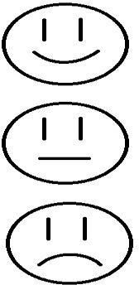

FEEDBACK
Activity:
DID YOU LIKE THE ACTIVITY?  COLOR THE FACE | WHAT DID YOU LIKE THE MOST?  WHY? | WHAT DIDN´T YOU LIKE?  WHAT CAN BE IMPROVED AND HOW?

FEEDBACK
Activity:
DID YOU LIKE THE ACTIVITY?  COLOR THE FACE | WHAT DID YOU LIKE THE MOST?  WHY? | WHAT DIDN´T YOU LIKE?  WHAT CAN BE IMPROVED AND HOW?

PASTE PICTURE HERE
LOOK AT THE
PACIFIC OCEAN

PASTE PICTURE HERE

CROSS MAGDALENA
RIVER

PASTE PICTURE HERE

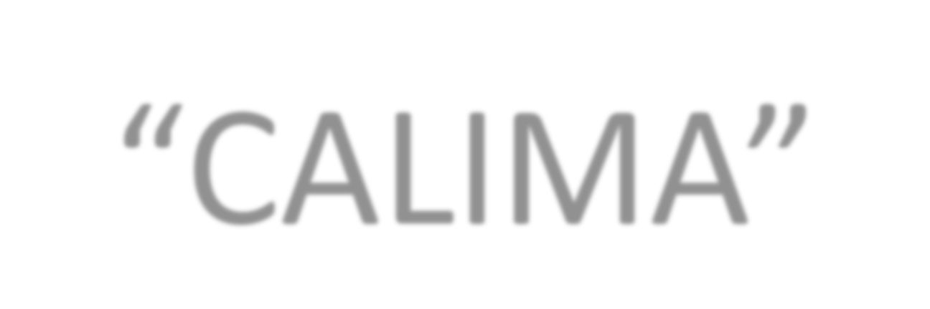SWIM IN LAKE
“CALIMA”

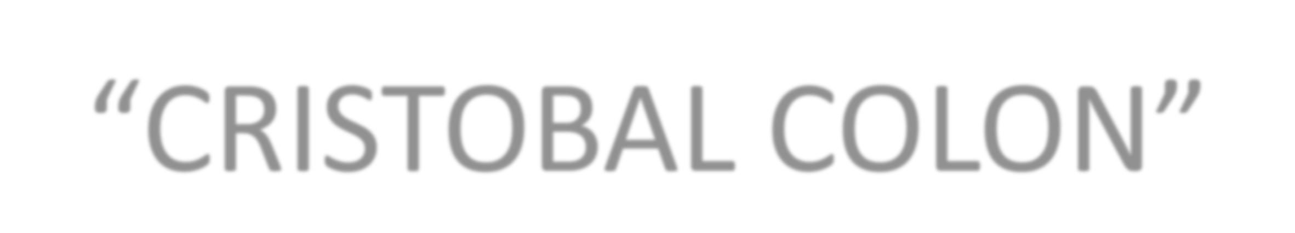

PASTE PICTURE HERE

CLIMB MOUNTAIN
“CRISTOBAL COLON”



PASTE PICTURE HERE

SUNBATHE AT THE
BEACH “EL MORRO”

PASTE PICTURE HERE

VISIT A SUGARCANE PLANT
IN “VALLE DEL CAUCA”

PASTE PICTURE HERE

BE IN “LA GUAJIRA”
DESERT

PASTE PICTURE HERE

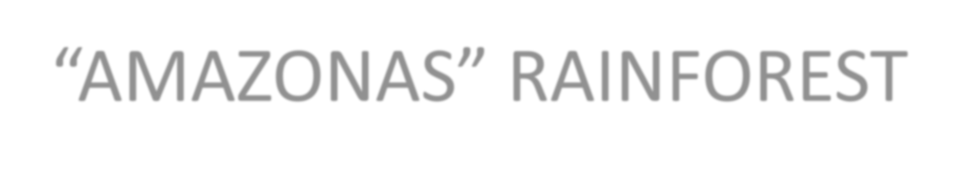TAKE PICTURES IN THE
“AMAZONAS” RAINFOREST



PASTE PICTURE HERE

DO RAPPEL IN “LA
CHORRERA” WATERFALL

