INSPIRING TEACHERS
ELT PLAN TEMPLATE

Complete with the information about you
Author
Teacher´s name | Rocío Camelo Silva
Email | rocasil_2007@hotmail.com
School | I.E. Técnica Atanasio Girardot

Select the type of plan
Lesson plan | Activity plan | Task plan | Project plan
 | X

Write a few lines about the usefulness of this plan for the Colombian English teachers
Example: This lesson plan gives the students a chance to know about you, their new teacher, and it also gives you a valuable opportunity to assess your students' level. It can also be a useful and productive class if you ever find yourself substituting a class at short notice.
Author’s remarks
This lesson plan provides students with the chance to talk about different ways of recycling. Even though students are encouraged to develop the four skills, they need to pay special attention to a reading in order to identify recycling tips and they are expected to do a recycling campaign by means of a poster. This lesson plan also gives students the opportunity to assess their peers and self-assess their own learning process.

Complete with the information about your students
Grade | Length of lesson | Number of students |  | Average age
7th | 150 minutes | 35 |  | 14
Area |  | English level
Rural | Urban X | A1 X | A2 |  | B1

Select the curricular axe or focus
Curricular Focus / Axes
Environmental / Sustainability Education | X
Sexual / Health Education
Construction of Citizenship / Democracy / Teenagers
Globalization

Complete with information about the content and methodological approach of the plan
Topic | Recycling
Module / Unit | Way to Go 7, Module 3- Unit 2-Lesson 1
Language focus | Language Function | Language skills | Vocabulary
Language focus | To give recommendations and suggestions by using “should” | All the language skills are intertwined abut there is an emphasis on reading and writing | Reduce, Reuse, Recycle, Water, Plastic, Wood, Paper, environmental issues and conservation
Principles / approach | Task-based Learning, Transversality, Assessment

In “Aim”, state what the learning goal is, in other words, what you want your students to achieve by the end of the session.
In “Subsidiary aims”, relate the language skills (communicative and linguistic) students need to master in order to achieve the main aim of the lesson. Make sure the aims are learner-centred, specific, measurable, achievable, realistic, and action oriented.
Learning objectives
Aim | By the end of this lesson, students will be able to give suggestions for taking care of the environment.
Subsidiary aims | By the end of this lesson, students will be able to:  - Write suggestions to protect natural resources (writing).  - Describe ways to protect natural resources (speaking).  - Classify specific information given in a written text (reading).  - Identify the environmental conservation strategies mostly used in the community (listening).

List all the materials needed for this plan. Please, do not include any picture or photograph.
Materials needed
Markers, board, colours, cardboard, photos, video beam.
Book “Way to go” 7
http://aprende.colombiaaprende.edu.co/sites/default/files/naspublic/colombiabilingue/waytogo/Libros%20PDF/Grado%207/Way%20to%20Go%20Students%20book%20%207.pdf

Write the name for each state of the plan. Then in the “Procedure”, write a detailed description of what the teacher and students do at each stage of the session.
Be sure to be thorough so any teacher can follow this plan. Write the procedure in third person and present tense.
Use these conventions: T= teacher S= students Ss= students
Stage | Procedure | Time and Patterns of interaction
Warm up | T shows the recycling logo to Ss and asks them: Do you know this logo? What do you know about it?  T writes recycling in the middle of the board and does a mind map with SS’ answers. T may use the following image since it includes the three Rs: recycle, reuse and reduce:  https://www.pinclipart.com/picdir/middle/149-1496039_e-waste-singapore-recycling-symbol-reduce-reuse-recycle.png  Then, T gives Ss examples about the Three Rs (Reduce, Reuse, and Recycle), writes the following ideas on the board and asks Ss to match them:  1. Reduce a. Separate rubbish and use it to make other things  2. Reuse b. Use less of something  3. Recycle c. Use something again  After, T writes different items on the board and asks ss to classify them into the correct “R”: paper towels, paper, eggs boxes, plastic bottles, magazine, newspapers, etc. T explains to Ss how words are formed to help them to learn new vocabulary, for instance: re means again, so rewrite means to write again, and redo means to do again. | 10 minutes  T-SS  10 minutes  T-SS
Warm up | Assessment: Hand signal  T uses a Classroom Assessment Techniques (thumbs up - thumbs down) in order that Ss indicate if they understood the differences between Reuse, Recycle and Reduce. | 10 minutes  T-SS  10 minutes  T-SS
Introduction | T shows SS some flashcards in order to get them familiar with the vocabulary used in a leaflet (brochure) they will read in the following section. The suggested words are: wood, rubbish, oil, fossil fuel, pollution, throw away, save, find out, make into. | 10 minutes  T-SS  Group work
Practice | Ss work in pairs and read the text to find unknown vocabulary (Exercise 4 on page 111). Then, T ask ss to do choral reading to correct pronunciation and some volunteers read out loud. Then, Ss classify some information from the reading according to the category, T checks their answers and corrects the chart with the class:  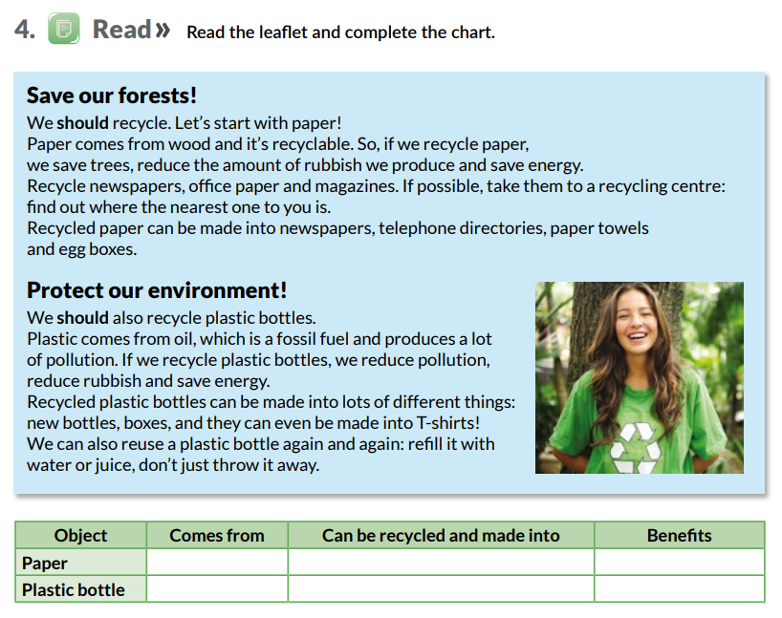  Taken from Way to Go 7th grade  Ss copy the first sentence of each paragraph in their notebook:  We should recycle. Let´s start with paper  We should also recycle plastic bottles  Now, T explains grammar, the use of the modal should and shouldn´t use because they need to make a poster by end of the class.  Then, SS do exercise 2 on page 110 where they listen to some people talking about the three Rs and complete the sentences with should / shouldn’t (Track 49, Way to Go 7th grade).  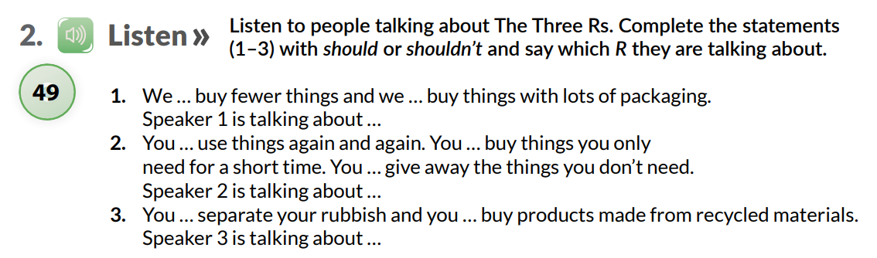  T corrects answer with the whole class and plays the track as many times as necessary to assure Ss understand the text. | 20 minutes  T-SS  Pair work  10 minutes  T-SS  Pair work
Production | Ss make a poster where they give the community some tips or recommendations (using should-shouldn´t) to save the water or protect the environment in order to do a campaign at school.  Before making the poster, Ss write an outline to brainstorm ideas and T makes corrections. T may use one of the following graphic organizers to help SS structure ideas (cluster webs are suggested):  https://www.eduplace.com/graphicorganizer/ | 60 minutes  Group work
Wrap-up | Peer assessment  When they finish their task, they assess each other by using the technique “Two Stars and a Wish”. The idea is that they write two positive ideas about the poster and one wish to improve it next time. T may use the following link as a reference: https://i.pinimg.com/originals/f8/ec/e9/f8ece9160b45e531f54d2bfe40169311.png  Ss paste their posters around the school to begin their campaign. Finally, T asks Ss about their feelings in understanding the topic and their purposes to protect the environment. T shows Ss a self-reflection tree and asks “Who are you in the picture? Why? The following tree may be used as a reference:  https://pbs.twimg.com/media/C3_wyuHWcAEoWgt.jpg | 20 minutes  SS-SS  Group work  10 minutes  SS-SS  Individual work

List a series of ideas of how this plan can be methodologically adapted so other teachers can implement it in their own educational context.
Implementation alternatives
- For introducing the reading vocabulary, Ts may use the following link in case they want to create a crossword: https://www.toolsforeducators.com/crossword/ or T may create a contest for SS to play a memory game. In this case, T has to print both the images and the words and paste them face down on the board.
- Ss can bring material for decorating the poster from the previous class.

Write the key word for each category based on the content of this plan. For example:
Topic: environment Skill: reading Linguistic: should Vocabulary: animals, environment
Key words
topic | skill | linguistic | vocabulary | grade
Recycling | Reading and Writing | Should / shouldn’t | Environmental issues and conservation | 7th

