INSPIRING TEACHERS
ELT PLAN TEMPLATE

Complete with the information about you
Author
Teacher´s name | Libia Marina Morales Ortega
Email | livianita_52@hotmail.com
School | I.E Macajan

Select the type of plan
Lesson plan | Activity plan | Task plan | Project plan
x

Write a few lines about the usefulness of this plan for the Colombian English teachers
Example: This lesson plan gives the students a chance to know about you, their new teacher, and it also gives you a valuable opportunity to assess your students' level. It can also be a useful and productive class if you ever find yourself substituting a class at short notice.
Author’s remarks
I have had the opportunity students through this lesson become aware of English language learning because a globalized word requires it, also I can assess some skills to my students such as: Reading, Listening, Writing.

Complete with the information about your students
Grade | Length of lesson | Number of students |  | Average age
7th | 6 hours | 37 |  | 14
Area |  | English level
Rural X | Urban | A1 X | A2 |  | B1

Select the curricular axe or focus
Curricular Focus / Axes
Globalization | x

Complete with information about the content and methodological approach of the plan
Topic | Let’s See The World (WTG 7-Unit 1-pages 130-131)
Module / Unit | 4/ GLOBALIZATION: INTERNATIONAL CULTURES
Language focus | Language Function | Language skills | Vocabulary
Language focus | - Identifying the characteristics of different countries  - Asking for and giving information about typical characteristics of different countries.  - Producing short and descriptive texts with simple tenses. | - Listening  - Reading  - writing | Countries and Nationalities:  Colombia/Colombian  United States of America/American  Japan/Japanese  China/Chinese  Biodiversity:  - Animal-and plant-ocean-rivers-mountains.  Season:  - Winter-summer-spring-fall.  Qualities:  - Fast- slow-big-small-old-new-mountains-modern-far-near.
Principles / approach | Noticing appraoch

In “Aim”, state what the learning goal is, in other words, what you want your students to achieve by the end of the session.
In “Subsidiary aims”, relate the language skills (communicative and linguistic) students need to master in order to achieve the main aim of the lesson. Make sure the aims are learner-centred, specific, measurable, achievable, realistic, and action oriented.
Learning objectives
Aim | By the end of this lesson, students will be able to talk about the typical characteristics of different countries.
Subsidiary aims | By the end of this lesson, students will be able to  - Develop vocabulary relating to typical characteristics of some countries around the world.  - ask for and give information about typical characteristics of different countries using the present simple and past  - build simple, short and written texts about typical characteristics of some countries around the world.

List all the materials needed for this plan. Please, do not include any picture or photograph.
Materials needed
10 cards that contain 5 flags of countries and other 5 cards with their own names, such as: Colombia-Japan-France -United States-England.
- a set of cards that contain 10 images and 10 words that are related to the song “One small world”
- 9 sheets of long paper (1/8) to make the collage poster.
- A video of the song: One small world: https://learnenglishkids.britishcouncil.org/es/songs/one-small-world
-6 paper slips of the names of the countries related to the song. “One small world”
- 1 grid poster with 6 columns
- 1 picture of China
-9 handouts that contains 5 texts which they have to complete with an information related to with the words or images from the collage poster
-1 poster with the lyrics of the song One small world: https://learnenglishkids.britishcouncil.org/sites/kids/files/attachment/songs-one-small-world-lyrics.pdf
1- political world map
-18 paper slips which contain the names of the countries and nationalities
-9 happy stars as reward system.
-9 jigsaw puzzles of a picture of the Forbidden City, China
-9 cards of 9 countries such as: Japan-Italy-France-Colombia-Australia- United States-Russia- Egypt-England and some key information about them, like: the capital city-weather-population- official language- famous
landmarks- rivers or oceans and area covered
- 1 poster evaluation rubric
- 1 bag and 3 pieces of paper that contains 3 paragraphs of a reading about China.
-3 exit tickets for student assessment
-markers
- glue

Write the name for each state of the plan. Then in the “Procedure”, write a detailed description of what the teacher and students do at each stage of the session.
Be sure to be thorough so any teacher can follow this plan. Write the procedure in third person and present tense.
Use these conventions: T= teacher S= students Ss= students
Stage | Procedure | Time and Patterns of interaction
Warm up: | • T asks Ss to play the game “scavenger hunts which consists of finding around the classroom 10 cards that contain 5 flags of countries and other 5 cards with their own names, such as: Colombia-Japan-France -United States-England. T should hide countries’ cards around the classroom previously.  • T arranges the classroom in a circle and asks 10 students to look for these cards taking into account some clues to find them within the classroom, such as:  -The place where you sit down  -The place where your teacher puts her books.  -The object you open or close to get in the classroom.  -The part of the classroom where you put some pictures.  -The part you use to write with erasable markers  - T sets the time with a countdown phone clock to control students’ participation during the game.  - When the 10 students find all the cards, T requests them to show them to the rest of the class and asks these 10 SS to match the flags with the correct countries’ names and paste on the board. | 20 minutes  T-SS  SS-SS
Warm up: | - Assessment: T asks the rest of SS to tick the cards that have the flags and the names of the countries with the correct order by using some CCQ, such as:  -Have you watched these flags in any soccer team before? Or Do you remember if these flags belong to any soccer team that you know or like? | 20 minutes  T-SS  SS-SS
Introduction:  Introducing language  Pre-? | - T presents SS a video named: “One small world” in order to identify the vocabulary related to some continents, countries, capital cities, actions, landmarks and weather events, such as: New York : the Hudson river; Paris: the Eiffel Tower; the Chimes of Big Ben; Moscow: the Kremlin, Cairo: The home of the Sphinx, the land of the Pharaohs; Australia: the capital city Canberra; Cambodia: The capital city Phnom Penh; Bogota is in South America, Europe, Asia; Africa, Rome, Beijing, Nairobi, Paris, Calcutta and Tripoli; live; likes; winter; snow.  https://learnenglishkids.britishcouncil.org/es/songs/one-small-world  - In order to check for comprehension, T asks SS questions about the song:  -Can you name some cities from the song?  -Can you name some famous places or landmarks from the song?  - T motivates SS to make 9 groups of 4 and gives them a set of cards that contain 10 images and 10 words that are related to the song “One small world”, such as: winter-capital city-South America-Australia-Beijing- live-listen-Africa-planet earth-the Statue of Liberty-Bogotá-people-snow- the Eiffel Tower-river-North America- The Home of the Sphinx which they should paste on a piece of paperboard in order to make a collage poster. There will be some intruders like: summer-heart-elephant.  - T tells SS they should work collaboratively and try to remember what they watched and understood from the video of the song. T says SS that they will keep working together the whole task long.  - T asks student groups to paste their collage posters on the walls of the classroom and encourages them to walk around and check if the images and words from the posters are or not related to the vocabulary of the song studied.  - In order to check out the vocabulary identified from the song, T gives each 9-student group a handout that contains 5 texts which they have to complete with an information related to with the words or images from the collage poster, such as:  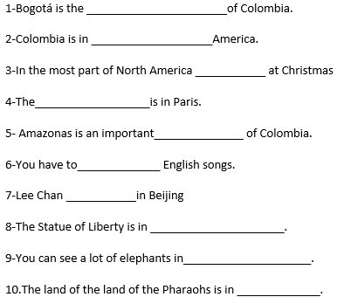  Reward System  - T gives each 9- student group a happy Star if they complete the text in a correct way.  - Then, T presents student groups a grid poster with 6 columns which they should complete with the rest of the information from the song studied taking into account the names of the characters -actions -cities and landmarks.  - In order to help SS to complete the grid, T pastes the poster with the lyrics of the song on a wall of the classroom. https://learnenglishkids.britishcouncil.org/sites/kids/files/attachment/songs-one-small-world-lyrics.pdf  - T models student groups how to complete the grid with the information from the song. T starts to complete it taking into account the first character from the song and then, asks them to fill in the rest columns taking into account the place where the other characters live and the most representative landmarks are in each city, such as:  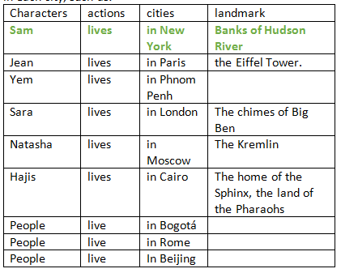 | 20 minutes  T-SS  group work  15 minutes  T-SS  Group work  25 minutes  T-SS  15 minutes  T-SS  group work
Introduction:  Introducing language  Pre-? | - Assessment:  - In order to check for understanding, T encourages SS to compare the information from the grid with the poster of the song and tick it if the information is correct.  - Then, T encourages student groups to add the grid another information related to countries and nationalities about where these characters live.  - T gives each student group 18 paper slips which contain the names of the countries and nationalities where the other characters live. SS should paste them in the grid taking into account the modelling given, such as:  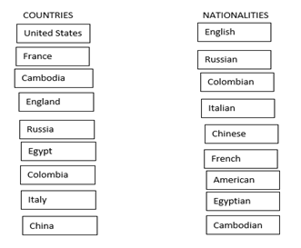  - In order to help student groups to complete the grid with this information, T presents them a political world map and asks them to point out the position of these countries firstly.
Practice:  Controlled practice | - T starts modelling with two paper slips about the country: UNITED STATES and the nationality AMERICAN. T reads aloud student groups this information and says to them: Sam lives in New York. New York is the United States. He is American.  - T also asks SS to demonstrate what they understood with a famous character from Colombia, such as: Amparo Grisales.  - T asks students groups to discuss and work collaboratively completing the grid with the information given.  - After, T asks a student from each group to read aloud or mime the information from the grid.  Reading skill  Pre-Reading:  - T presents each student groups a jigsaw puzzle of a picture of the Forbidden City, China https://www.jigsawexplorer.com/puzzles/forbidden-city-jigsaw-puzzle/ and asks them to put the pieces together as quick as they can. The first group that finishes will receive a happy start  - T asks student groups some questions what they know about this country, such as:  1-In what continent is China?  2-What famous landmark is important in China?  3-What other things do you know about China?  - Then, T gives each 9-student group a bag that has 3 pieces of paper that contains 3 paragraphs of a reading about China.  China`s capital is Beijing,where more than 21 million people live! In Beijing, there are many beautiful places to visit, for example, the Forbidden City, which is actually a museum, not a city.  In general, the weather in China is wet and warm, but because the country is so enormous, temperatures vary a lot depending on where you are. China has the largest population in the word: there are about 1,4 billion people! The official language is Mandarin and around 850million people speak it, which means that more people speak Mandarin than any other language in the world.  China is the fourth largest country in the word! It covers an area of about 9.6 million km2. Its longest river is the Yangtze, which is 6.300 kilometres long and is the third longest river in the world!  - T asks SS to read them and organise them with coherence taking into account 3 clues which writes on the board, such as:  1-The first paragraph is about the Capital city and landmarks.  2-The second paragraph is about weather, population and official language  3-the third paragraph is about Area covered and the most important river. | 20 minutes  T-SS  Group work  25 minutes  T-SS  Group work  20 minutes  T-SS  Group work  25 minutes  T-SS  Group work  SS-SS
Practice:  Controlled practice | - Assessment: T reads aloud and mimes SS the full text in order to check for understanding.  While reading  - T encourages student groups to read the whole text about China and gives them a handout that contains a chart which they should complete with information about the text CHINA.  - Assessment: T asks student groups to exchange their own charts with other group in order to check the information given by them.  Post reading  - T requests student groups to make a poster with words and drawings taking into account the information about China.  - T asks them to describe their pictures in front of the class taking into account this poster evaluation rubric.  Yes No
  - Images are relevant to purpose
  - States objectives
  - Uses correct grammar and punctuation
  - Provides motivation
  - Use informative little heading
Production:  Freer practice | Writing  Brainstorming:  - T asks each student groups to make a leaflet or brochure in which they have to describe a country taking into account some key information about it and the structure of the descriptive texts.  - T presents student groups a brochure model of the capital city of Philippines, Manila and asks them take into account only the most important issues they have already studied, such as the capital city-weather-population- official language- famous landmarks- rivers or oceans and area covered.  - https://itsmorefuninthephilippines.co.uk/wp-content/uploads/Manila__UK-%EF%BF%BD-English__A5-Brochure__August-2019__Web-1.pdf | 25 minutes  T-SS  SS-SS  group work  35 minutes  T-SS  Group work  45 minutes  T-SS  Group work
Production:  Freer practice | Assessment: T asks student groups some questions based on the brochure about MANILA, such as:  1-What issues do you need to know if you want to describe a country?  2-Which adjectives can you use to describe a place or a country?  3- How many subtitles or paragraphs can you take into account to write your descriptive text?  First draft  - T asks student groups to choose a card that contains the names of 9 countries such as: Japan-Italy-France-Colombia-Australia- United States-Russia- Egypt-England and some key information about them, like: the capital city-weather-population- official language- famous landmarks- rivers or oceans and area covered.  - T asks student groups to play a game named: My imaginary place which consists of creating a magic site and tell some issues about it based on their own imagination.  - T starts modelling their own magic place, such as: My magic place is Libialand. The capital city is Libin- Weather here is coldylin. There a lot of pink people. The official language is Libinguish. The most important place is a big blue tree and has pink and yellow rivers. It has only 1.000 kilometers because it’s an island.  - T requests student groups to make a drawing of their magic site and start to describe it.  - Assessment: Then, T presents student groups a writing rubric in which defines the categories to take into account in their descriptive text, such as:  -Main title: Name of the country in capital and bold letters  -Subtitles like: the capital city-weather-population- official language- famous landmarks- rivers or oceans and area covered.  -Use of adjectives of fact and opinion related to length -colours-height-width- ancient-location.  - T gives student groups a sheet of paper and asks them to write some ideas about their country based on the key information given.  Editing  - T asks student groups to present their first draft and checks it together taking into account the writing rubric.  Final paper  - T asks student groups to check the connectors, the punctuation and the coherence of ideas and gives student groups a long sheet of paper to write their final descriptive text.  - T gives student groups instructions to make a leaflet and asks them to choose the appropriate drawings or pictures related to the information given.  Assessment: When the student groups finish of making their leaflet, T asks them to paste them around the classroom and share with the rest of groups.
Wrap-up | - T asks students to make a drawing of the place where they live, whether rural or urban area and write some key information about it.  - T asks SS to present their drawings and share what they feel about the place where they live with prompts, such as:  -I live in the _____________________zone (Rural/ urban)  -My favorite place to play is__________________  -I love to rest near____________________  -I really enjoy to see_____________________ | 20 minutes  T-SS  SS-SS  group work  Oral presentation rubric
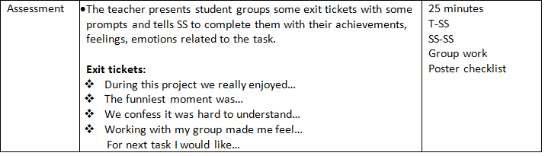
List a series of ideas of how this plan can be methodologically adapted so other teachers can implement it in their own educational context.

Write the key word for each category based on the content of this plan. For example:
Topic: environment Skill: reading Linguistic: should Vocabulary: animals, environment
Key words
topic | skill | linguistic | vocabulary | grade
Characteristics of different countries | Reading, writing, listing. | Simple tenses | Countries and Nationalities:  Colombia/Colombian  United States of America/American  Japan/Japanese  China/Chinese  Biodiversity:  - Animal-and plant-ocean-rivers-mountains.  Season:  - Winter-summer-spring-fall.  Qualities:  - Fast- slow-big-small-old-new-mountains-modern-far-near. | 7th

