INSPIRING TEACHERS
ELT PLAN TEMPLATE

Complete with the information about you
Author
Teacher´s name | Adalberto Delgado Claro
Email | cristocentricoforever@gmail.com
School | El Rodeo

Select the type of plan
Lesson plan | Activity plan | Task plan | Project plan
 |  |  | x

Write a few lines about the usefulness of this plan for the Colombian English teachers
Example: This lesson plan gives the students a chance to know about you, their new teacher, and it also gives you a valuable opportunity to assess your students' level. It can also be a useful and productive class if you ever find yourself substituting a class at short notice.
Author’s remarks
The present Project aims to reinforce the four English foreign language skills, which are reading, writing, oral comprehension and speaking. Through each step, you will find some activities or tasks that focus on the communicative approach.
This project will empower the students to have good eating habits and healthy gastronomic customs to develop mind and body. It also leads the learner to understand the importance of having healthy diets and share it with others. In this Planning teachers can find many relevant and important tasks which let participants understand the language and manage a classroom in order to be a truthful leader.

Complete with the information about your students
Grade | Length of lesson | Number of students |  | Average age
8 | 4 hours | 44 |  | 15
Area |  | English level
Rural | Urban x | A1 | A2 x |  | B1

Select the curricular axe or focus
Curricular Focus / Axes
Environmental / Sustainability Education
Sexual / Health Education | x
Construction of Citizenship / Democracy / Teenagers
Globalization

Complete with information about the content and methodological approach of the plan
Topic | What we eat
Module / Unit | Module 3 unit 1 EP1
Language focus | Language Function | Language skills | Vocabulary
Language focus | Giving instructions | Writing, Speaking, Reading and listening | Healthy Food, vegetables, fruits, recipe ingredients, kitchen utensils, verbs of cooking, modal verbs, healthy diets, verbs.
Principles / approach | Project based approach

In “Aim”, state what the learning goal is, in other words, what you want your students to achieve by the end of the session.
In “Subsidiary aims”, relate the language skills (communicative and linguistic) students need to master in order to achieve the main aim of the lesson. Make sure the aims are learner-centred, specific, measurable, achievable, realistic, and action oriented.
Learning objectives
Aim | By the end of this lesson, students will be able to describe the process of a recipe in a video tutorial
Subsidiary aims | By the end of this lesson, students will be able to …  - Introduce the steps of a recipe using the quantifiers and countable and uncountable nouns.  - List verbs and nouns used to prepare a recipe.  - Focus on pronunciation of each step to elaborate the recipe  - Give clear and accurate instructions to cook a recipe.  - Produce a text about healthy food.  - Understand the importance to have a healthy diet.  - Communicate the benefits of a healthy food

List all the materials needed for this plan. Please, do not include any picture or photograph.
Materials needed
Box with vocabulary pictures, video beam, grammar worksheets, video editor software, Visual Aids, list of ingredients, pictures for Reward System, sticker paper, videos, speakers,
https://drive.google.com/drive/folders/1CIMiAL8CMrXskgk_dQ9YGrDwG1qpPM-1

Write the name for each state of the plan. Then in the “Procedure”, write a detailed description of what the teacher and students do at each stage of the session.
Be sure to be thorough so any teacher can follow this plan. Write the procedure in third person and present tense.
Use these conventions: T= teacher S= students Ss= students
Stage | Procedure | Time and Patterns of interaction
Warm up: | Competition in groups:  - T pastes on the board cooking ingredients, kitchen utensils, and verbs for cooking (choose the vocabulary appropriate for the region and students’ level.)  - Under the board, the T places one red and one green basket. The red basket is labeled “uncountable” and the green basket is labeled “countable.”  - T divides the SS in groups, and asks them to complete the activity by placing the images on the board in to the correct basket.  - SS Select one representative at a time to go to the board and place on item in the basket.  - T controls the time and says when to start, explains that each competitor has 15 seconds for the activity.  - T places two leaders in front of the board, 4 meters of distance.  - When the T says ‘start’ the leaders run, as fast as possible, and classify the most nouns related to cooking and putting them in the two different baskets, (countable basket and uncountable basket.) T controls the time.  - The groups obtains 5 points classifying the most words during the 15 seconds.  - T repeats the challenge with two other leaders.  - T counts the quantity of points obtained by each group and names the champion group with most points. | -55 minutes  -T-SS  -Group work
Introduction:  Introducing language | - T introduces SS the project  This project will empower the students to have good eating habits and healthy gastronomic customs to develop mind and body. It also leads the learner to understand the importance of having healthy diets and share it with others.  - T divides into groups.  - T explains the Reward System to promote the work in group and motivate the learning. When SS finish an activity, they receive a ticket as a reward (of your choice).  - T explains the objectives of the project and what L2 skills they will develop.  - T delivers a guide with the vocabulary needed for this project. | -25 minutes  -Set the context  -T – SS
Introduction:  Introducing language | Assessment: SS express their expectations about the project and write in wall of wishes what they want to learn from classmates and teachers.  T gives some ideas like, collaborative work, mentoring, vocabulary, fluency, management, leadership. And facilitate a wall to become the creative Wall of Wishes. | -25 minutes  -Set the context  -T – SS
Development Lesson 1  Listening Task | Pre listening activities  - T mimes part of the scene of the conversation in order to arouse students’ interest  - T shows the vocabulary used in the conversation  https://learnenglishteens.britishcouncil.org/skills/listening/beginner-a1-listening/ordering-food-cafe  Listening  - T plays the conversation and SS do the exercises to practise and improve listening skills.  https://learnenglishteens.britishcouncil.org/skills/listening/beginner-a1-listening/ordering-food-cafe  While listening  - SS listen to the audio again for listening to the gist answering the following questions:  a. What’s the subject of the passage?  b. what’s the purpose of the conversation?  C. what is each speaker talking about?  d. what’s the role of the characters in the audio?  Post listening  - SS discuss what is their favourite food and why.  https://learnenglishteens.britishcouncil.org/sites/teens/files/ordering_food_in_a_cafe_-_exercises_4.pdf | -To Reinforce listening skill  -To Review vocabulary  -55 minutes  -Team work
Development 2  My menu Learning | - T provides SS a menu to select one activity from each dish:  Starters (you can create these materials using your own puzzle makers)  - Make a crossword with the verbs for cooking  - Make a Word-search with the Kitchen Utensils  - Create a Pictionary with all the vocabulary  Main course  - Write questions using ‘How much’ and ‘How many’  - Create a dialogue about the most common ingredients used by their families’ chickens  - Create a short Recipe step by step.  Additions  - Play a taboo cards about countable and uncountable nouns  - Play a hangman using countable and uncountable nouns  - Play a stop game using countable and uncountable nouns  Desserts  - Make a cartoon of a favourite dish  - Make a mandala of your favourite fruit | -55 minutes  -Vocabulary use  -T – SS  -Individual work
Development 2  My menu Learning | Assessment:  Students get in groups based on the same activities they did with their partners. SS check each other’s products and discuss what they liked or what they could do better. If SS do not have partners, SS pair up with the teacher. | -55 minutes  -Vocabulary use  -T – SS  -Individual work
Development  Lesson 3  Speaking Task | Speaking  - T delivers a menu of a restaurant from their town. Then, in groups SS chose their favourite plate  - SS write a short conversation between a waitress and a client ordering food in a café.  - SS act out a role play ordering food in a café  - T uses the following questions to guide de activity:  Is the food from other countries similar to the food of your city?  Do you like eating out?  Do you like your home food?  Is this a healthy menu? | -10 minutes to write a dialogue.  -2 minutes for each group make an oral presentation (54 minutes).  -Enhance oral skills  -T – SS  -Group work
Development  Lesson 3  Speaking Task | Assessment:  T designs a rubric to evaluate the SS presentation taking into account seven aspects: student name, language use, pronunciation, body expression, interaction with the others, score and observation. The standard is ranked in three levels: high, medium and low.  T evaluates the pronunciation during each presentation, ticks on the appropriate rank, and then gives the feedback to correct the pronunciation and grammar mistakes or errors.  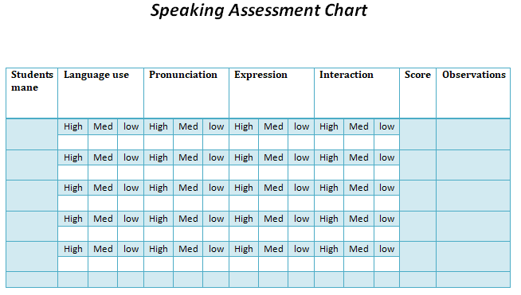
Development  Lesson 4  Writing  Task | Writing  - T designs and delivers a worksheet in which SS write the name of their recipe, ingredients and steps as following:  - Name of the dish: (SS are motivated to be original and make up a healthy name)  - Ingredients: SS list the ingredients and quantities.  - Cooking tools: SS write the cooking utensils needed.  - Level of difficulty: SS mark the level of difficulty of the dish: easy, medium, difficult, expert.  - Time: SS show how much time is needed.  - Special features: SS explain how healthy will be their dish.  - Preparation: SS write the instructions for making their recipe step by step. SS use the imperative and some modal verbs to give instructions.  - Picture: SS draw a picture of their recipe.  - T gives some time linkers like first, next, then, after five minutes…and recommends using the simple present tense, imperative and modal verbs. | -SS – T  -55 minutes  To work in writing production  -To Reinforce grammar
Development  Lesson 4  Writing  Task | Assessment: T and SS play a game called Simon says, SS acts when they listen to the key sentence …Simon says... They obey. The objective of this game is to evaluate the imperative used in the redaction of the steps of the recipe. T gives the feedback to SS in a plenary.
Development  Lesson 5  Listening and speaking  Task | Listening and speaking  - T presents a video clip about How to describe a recipe step by step.  https://www.youtube.com/watch?v=hzJFnu_T4Us  - SS, in groups, take note and write some questions about the video, then ask the questions to other groups.  1. What is the main ingredient?  2. What are the utensils?  3. Tell us some steps  4. Mention all the ingredients  5. Is this a healthy recipe? Why?  - T explains SS how to make and record a video presenting the description of their recipe.  - SS make their Recipe stronger adding the information seen in the video.  - SS ask their technology teacher at school about a video editor and take note in order to be prepared to present the product of the project. | 110 minutes  SS- SS  T-SS  To enhance listening and oral production  Group work
Development  Lesson 5  Listening and speaking  Task | Assessment: T asks SS about a Video Editor to edit the video their videos, then SS check their descriptions recipes and improve the vocabulary used.  In a round table SS explain why their recipes are healthy and what things they have added or changed.
Development 6  Reading Task | Reading  - T delivers a reading worksheet about health and fitness.  - SS in group answer the questions in 8 reading skills:  - Skimming: look quickly the text (25 seconds) what is it about?  - Scanning: look at the text again. Underline the countable and uncountable nouns you find.  - Identifying the target: who is the text written for and how do you know that?  - Guessing meaning: what do you think the expression, in the text, ‘prevent diseases, too’ means?  - Recognising links: in the last paragraph, what does ‘so’ refer to?  - Inferring: do you agree with the theory ‘many people love to eat fruits, but don’t much care for vegetables’ give reasons for your answer.  - Identifying the main message: what is the main point that the writer wants to convey? How do you know that?  - Predicting: what do you think the next text by the same author will be about?  Text:  https://www.comprehension-worksheets.com/reading-comprehension/second-grade-reading-comprehension-worksheets/fruits-and-veggies/  - SS draw some conclusions about the text.  a. What do these fruits have in common?  b. Would you like to eat more fruits and vegetables?  c. Do you agree with the following statement: ‘a rainbow of vegetables and fruits can help you your body’?  d. Which group of fruit and vegetables do you eat much and which less?  - After answering the question below, SS. In groups, interview five classmates about Eating Healthy and complete the following survey.  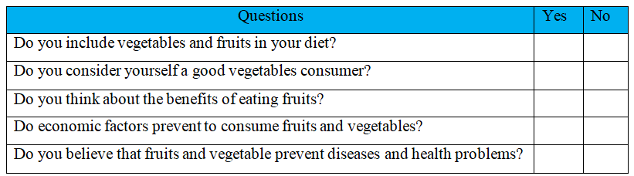 | 110 minutes  T – SS  SS-SS  To reinforce Reading Comprehension Skill  Group work
Development 6  Reading Task | Assessment:  - SS share with the class what they learned about healthy habits  - SS create a slogan giving advice to classmates about how to become a good vegetables and/or fruits consumer.  - SS debate the best Slogan and T gives the feedback taking into account the SS experiences and opinions.
Development 7  Writing Task | Writing  T stars the class with a management strategy consisting in:  - SS write an article expressing their opinion about having a healthy diet.  Paragraph 1: describe your favourite food and explain why you enjoy it.  Paragraph 2: say what’s the point in favour or what’s the point against your favourite food.  Paragraph 3. Write some advice to eat this food or if it is necessary to change to improve health.  Paragraph 4: write a short conclusion about your favourite food and give an opinion about it.  T explains some useful linking words like: ‘also and too’ for similar ideas; ‘because’ to give reasons, ‘however’ and ‘even though’ to contrast ideas; ‘for example’ to give examples. | 110 minutes  SS-SS  To express their groups opinions and to reinforce Writing skills  SS – SS
Development 7  Writing Task | Assessment: SS write about what they learnt during this activity, the most difficult aspects: language aspects, team work. Finally T gives some advice on how to manage the problematics situations.
Consolidation | - SS record a video explaining step by step the recipe selected.  - T organizes a Food Stands Campaign in which each group will expose the recipe.  - All the school visits the stands and listen to the exposition of each group.  - SS organise the courses by turns in order to visit the stands and eat a sample of the recipe  - SS hand out a pamphlet giving advice about How to Eat Healthy  - SS deliver a report about the campaign. | To consolidate the knowledge  110 minutes  T – SS  Group work  Individual work
Consolidation | Assessment: SS from others courses write a comment about what they think about the stand and the exposition of the participants. And give a value of each stand and presentation.  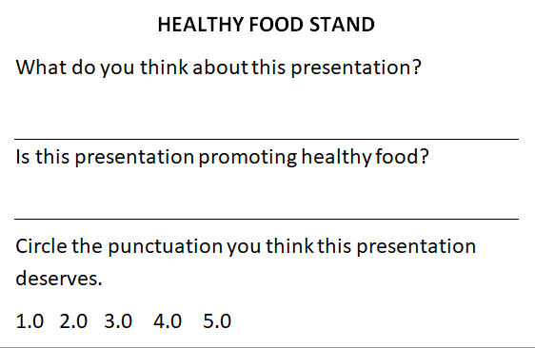  SS organize the information gathered and discuss the result with the classmates. Then write a plan to improve if it necessary
Wrap-up | - SS self-assess their participation and collaborative work in the project  - T pastes in a wall the icons or vector of the four skills developed during the project. SS walk around and paste under the icon a green paper if they felt confident and achieved some goal, yellow paper if they felt less confident, orange paper if they did not feel confident and red paper if they did not achieve any goal.  - T asks SS to work in pairs to discuss what they can do with what they learnt in this project  - T reinforces concepts  - SS write what they change or improve in the project. | To assess their work  SS – T  SS –SS  40 minutes

List a series of ideas of how this plan can be methodologically adapted so other teachers can implement it in their own educational context.

Implementation alternatives
- Use a videos and audio and all the material according to the SS L2 level.
- Let students be creative during the different developments.
- Be attentive of student’s doubts and opinions during each stage.
- Apply Reward System to promote the participation of the SS and give a bill of paper for each good answer or performance.

Write the key word for each category based on the content of this plan. For example:
Topic: environment Skill: reading Linguistic: should Vocabulary: animals, environment
Key words
topic | skill | linguistic | vocabulary | grade
Health | Listening  Writing  Listening  Speaking | Imperative  Modal verbs | Food, fruits, vegetables, kitchen utensils | 8

