INSPIRING TEACHERS
ELT PLAN TEMPLATE

Complete with the information about you
Author
Teacher´s name | Diego Alejandro Ariza Devia
Email | diegoariza71@gmail.com
School | Institución Educativa Juan Bautista La Salle

Select the type of plan
Lesson plan | Activity plan | Task plan | Project plan
 | x

Write a few lines about the usefulness of this plan for the Colombian English teachers
Example: This lesson plan gives the students a chance to know about you, their new teacher, and it also gives you a valuable opportunity to assess your students' level. It can also be a useful and productive class if you ever find yourself substituting a class at short notice.
Author’s remarks
This activity plan gives students the opportunity to learn new vocabulary about shopping by playing a board game. Also, this activity gives the opportunity to the teacher to implement Formative Assessment techniques and involve students in their learning process.

Complete with the information about your students
Grade | Length of lesson | Number of students |  | Average age
8th | 60 minutes | 38 |  | 14
Area |  | English level
Rural | Urban x | A1 x | A2 |  | B1

Select the curricular axe or focus
Curricular Focus / Axes
Environmental / Sustainability Education
Sexual / Health Education
Construction of Citizenship / Democracy / Teenagers
Globalization | x

Complete with information about the content and methodological approach of the plan
Topic | Sensible Shopping
Module / Unit | Globalisation
Language focus | Language Function | Language skills | Vocabulary
Language focus | Expressing opinions about shopping practices. | Speaking  Listening | Shopping  Useful items
Principles / approach | Communicative Approach

In “Aim”, state what the learning goal is, in other words, what you want your students to achieve by the end of the session.
In “Subsidiary aims”, relate the language skills (communicative and linguistic) students need to master in order to achieve the main aim of the lesson. Make sure the aims are learner-centred, specific, measurable, achievable, realistic, and action oriented.
Learning objectives
Aim | By the end of this activity plan students will be able to express points of view about useful shopping.
Subsidiary aims | By the end of this activity, students will be able to …  - Identify and use vocabulary about shopping.  - Identify useful shopping items for their lives.

List all the materials needed for this plan. Please, do not include any picture or photograph.
Materials needed
3 Fly swatters
Images (sweater, fruits and vegetables, sweets, pencils and erasers, medicine)
Board game worksheet (Annex 1)
board game pieces and dices.

Write the name for each state of the plan. Then in the “Procedure”, write a detailed description of what the teacher and students do at each stage of the session.
Be sure to be thorough so any teacher can follow this plan. Write the procedure in third person and present tense.
Use these conventions: T= teacher S= students Ss= students
Stage | Procedure | Time and interaction
Input | Board Dash:  Teacher (T) asks students (Ss) to get in three big groups.  T tells Ss that they should be standing on a line, back at the board.  The first Ss in each group have a fly swatter.  T says a statement that describes one of the images pasted on the board.  Ss listen to the teacher, turn around, run to the board and touch with the fly swatter the image that is described in the statement.  The first Ss in each group go to the back, give the fly swatter to the second S; and so on and so forth.  Some statements can be (the words in bold are replaced by images on the board)  - I wear this when it is cold (sweater).  - We can buy these food in the supermarket (fruits and vegetables).  - These are unhealthy food (sweets).  - We can find these objects at school. (pencils and erasers).  - We take this when we are sick (medicine).  Tip: T can provide more statements that help Ss do the board game easily.  List of images: sweater, fruits and vegetables, sweets, pencils and erasers, medicine. | 10 minutes  Whole class.
Game | Board Game: (Annex 1)  T explains SS the activity:  - SS get in groups of three people.  - T provides each group with a board game about useful shopping, 3 board game pieces and dices to be used. The board game has pictures of different things, some questions to answer and some penalties during the game.  - In the group SS take turns to roll the dices.  - SS begin the game in the starting box. The first S rolls the dices and moves his/her game piece forward that number of spaces.  - S reads the box and answers the question or does suggested activity (penalty) in order to identify shopping for useful items.  - SS roll dices as many times as necessary until a S wins.  - T passes using stop and go activity to the different groups in order to solve difficulties.  - SS try to use English language all the time but in unknown vocabulary SS can use mother tongue.  - SS use dictionary during the boardgame activity plan. | 30 minutes  T-SS  5 minutes  Individual work  10 minutes  Ss-Ss  5 minutes  T-Ss
Game | Assessment: Focused Listing  After playing the game, T gives Ss the “Focused Listing” template and asks them to write individually as many words as they remember about Shopping.  Then, T asks Ss to stand up and walk around while some music is played.  When the music stops, Ss stop and find another classmate.  Ss say to each other:  - “Tell me a word you learnt about shopping”.  Ss create more circles if their classmates tell them new words they had not included before.  Then, T elicits from Ss the words they have got in their Focused Listing.

List a series of ideas of how this plan can be methodologically adapted so other teachers can implement it in their own educational context.
Implementation alternatives
Teachers can provide fun to students with the Board Dash activity. If teachers don’t have fly swatters, they can create darts with paper that is rolled to have the shape of a dart.
T could print the board game in a big size to play with the whole group and check students’ understanding. Additionally, if teachers have access to internet, they can put the board game template on a slide in Power Point, display it so that all the students see it.
The last activity can be done orally to

Write the key word for each category based on the content of this plan. For example:
Topic: environment Skill: reading Linguistic: should Vocabulary: animals, environment
Key words
topic | skill | linguistic | vocabulary | grade
Sensible Shopping | Grammar  Speaking  Listening | Present simple | Shopping  Things for useful items | 8°

ANNEX 1

Board Game template

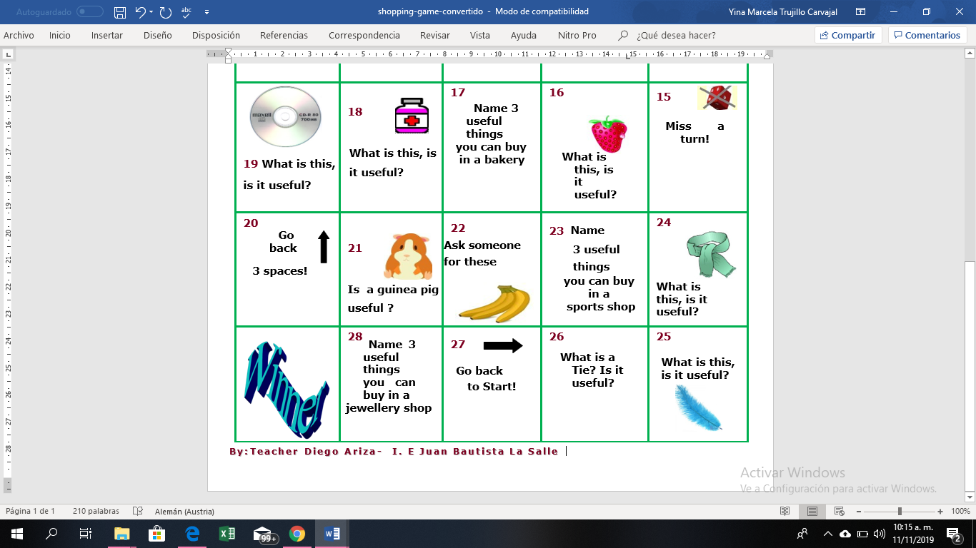
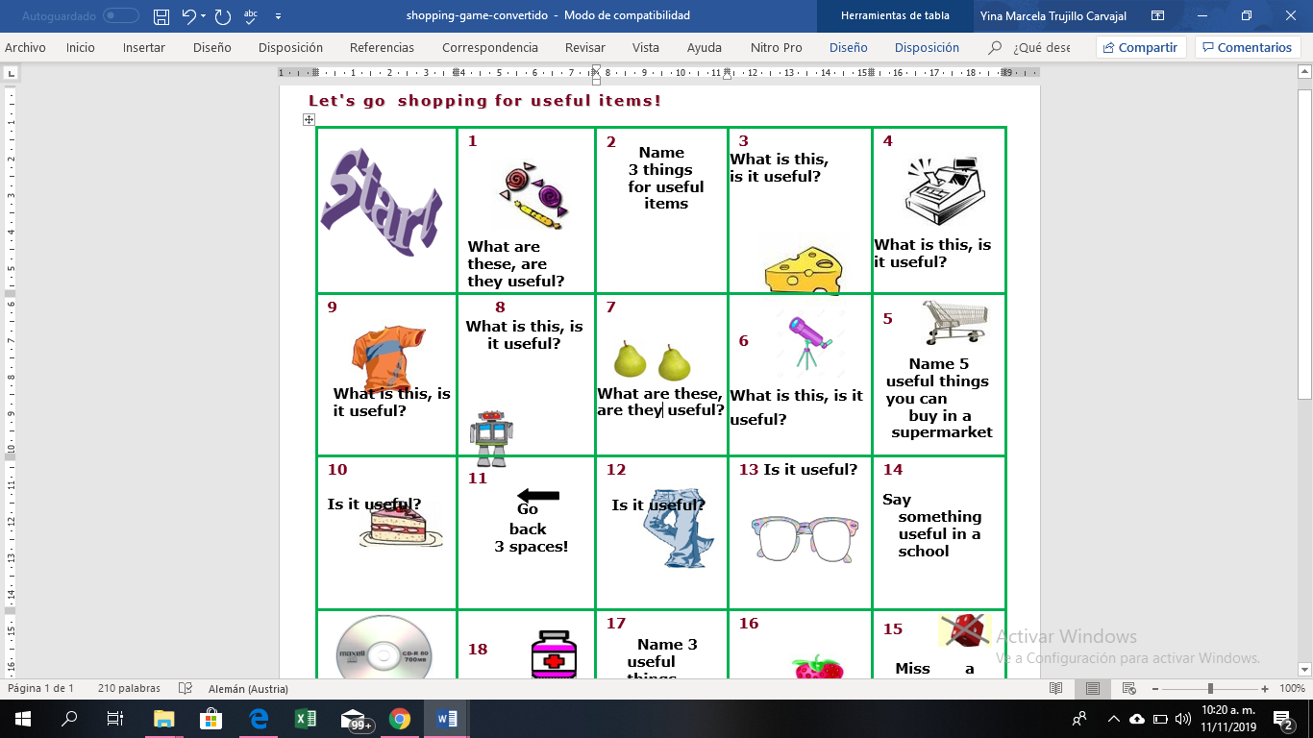

Annex 2:
Focused Listing

Complete the Focused Listing template with information about shopping. You can include words, statements, pieces of advice, etc.

