INSPIRING TEACHERS
ELT PLAN TEMPLATE

Author
Teacher´s name | EMILCE LAMPREA MOOR
Email | emilamor77@hotmail.com
School | ESCUELA NORMAL SUPERIOR MARIA AUXLIADORA DE GIRARDOT

Lesson plan | Activity plan | Task plan | Project plan
 |  | X

Author’s remarks
This lesson plan gives students the opportunity to talk about personal interests such as their favourite dish and to ask for suggestions and recommendations about eating habits.

Grade | Length of lesson | Number of students |  | Average age
Eighth | 2 Hours | 40 students |  | 13-14
Area |  | English level
Rural | Urban X | A1 X | A2 |  | B1

Curricular Focus / Axes
Environmental / Sustainability Education
Sexual / Health Education | X
Construction of Citizenship / Democracy / Teenagers
Globalization

Topic | NUTRITION AND HEALTH
Module / Unit | MODULE 2 –UNIT 2 Lesson 1 WAY TO GO! 8°th Grade
Language focus | Language Function | Language skills | Vocabulary
Language focus | To give suggestions about food by using “should” | All the skills are intertwined but there is an emphasis on reading and writing | Food: cooking methods; Nutrients
Principles / approach | Task-based Learning, Transversality (Health), Assessment

Learning objectives
Aim | By the end of this lesson, students will be able to talk about their favourite food and describe traditional cuisines and its nutritional components.
Subsidiary aims | By the end of this lesson, students will be able to …  - Recognize vocabulary about food.  - Ask for and give information about the ingredients of a dish. (speaking)  - Understand information about typical dishes (Listening)  - Ask and answer simple questions in present simple.  - Elaborate a poster about their favourite dish including suggestions and recommendations. (writing)

Materials needed
- Book Way to Go! 8th
- http://aprende.colombiaaprende.edu.co/sites/default/files/naspublic/colombiabilingue/waytogo/Libros%20PDF/Grado%208/Way%20to%20Go%20Students%20book%208.pdf
- Audio and PPT slides with Colombian food
- Dictionary, board and markers
- Evaluation rubric, Self-assessment rubric

Stage | Procedure | Time and Patterns of interaction
Warm up | - T explains the purposes, class objectives and evaluation criteria.  - T and Ss establish the Pedagogical agreements for class development.  Stop Game: The teacher splits the class into 8 groups, selects a letter to start and writes the words of six different categories (occupation, fruit or food, things, animals, colours and clothing). As the teacher says an alphabet letter, the students have to write a word that starts with that letter under each category. The group that gets more correct words wins. | 15 minutes  T  T-SS  SS-SS  Group work
Introduction | After participating in the game and activate the students’ knowledge, they return to their places and take out the book Way to Go 8th grade.  After that, the teacher emphasizes the words about food and fruits and ask other questions: What other fruits and foods do you know? What is your favourite food? Which foods are healthy or unhealthy?  The teacher writes food words on the board and elaborate a word bank by classifying student’s ideas into healthy and unhealthy food. Then, the students open their book on page 60 (Way to Go 8) and look at the pictures relating to dishes from Australia, Japan and Colombia. After, the students, Label the ingredients with the words in the Word Bank.  The teacher checks answers with the class. After that, the teacher checks the answers with students and explains the following activity.  Listening Activity: The teacher tells the students that the next activity is about an audio and they open their books on page 60 Exc.6. Students read the food descriptions and focus their attention on the red words. T checks if students understand.  Student work in pairs, listen and complete the sentences. The teacher plays the audio again if necessary. Students check their answers in pairs. (Track 27-Page 60, Exercise 2).  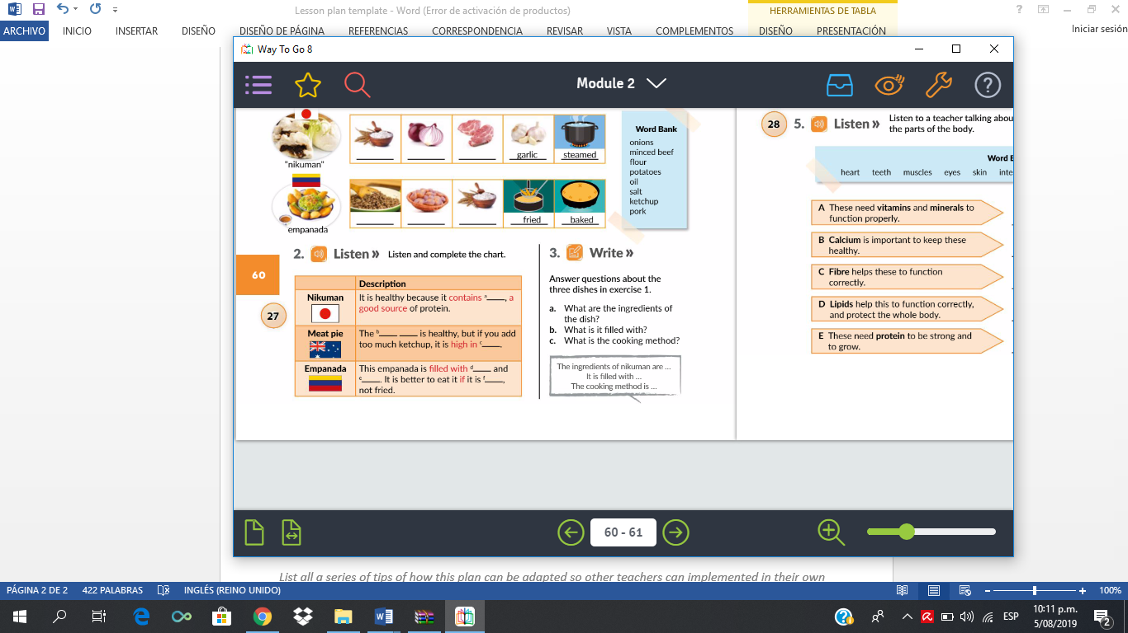  Taken from Way to Go 8  Answer Key: a. Pork b. cooking method c. salt d. meat e. onions f. baked.  Then, T asks some comprehension questions:  a. What are the ingredients of the dish?  b. What is it filled with?  c. What is the cooking method?  T explains the following activity, which is a short reading about the Five Food Groups. SS go over page 61, read a nutrition piece of advice and complete the text with some words.  Ss work individually answering the questions and writing the answers. Then, they check answers in pairs. T tells SS to close their books and asks the students: Which food contains proteins? Which food contains carbohydrates? Etc. | 15 minutes  T-SS  Individual  Work  10 minutes  T-SS  15 minutes  T-SS  Individual  Work
Practice | T shows some slides about different types of typical Colombian food: the paisa platter, Empanada, Tamal, Lechona, sancocho and arroz atollado. Then, T writes useful expressions on the board for SS to answer questions about the dishes (page 63):  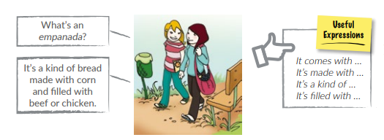  Taken from Way to Go 8  Questions  - What are ingredients of the Tamal, Lechona, sancocho and arroz atollado?  - What is your favourite one?  - What is the cooking method?  Then, SS open the book on the page 64 and focus on the activity number 6:  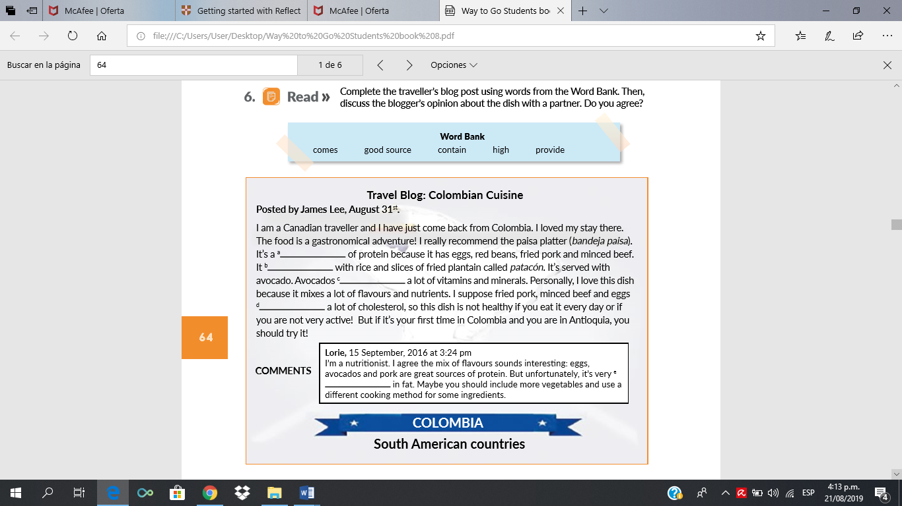  Taken from Way to Go 8  T asks: What kind of text is this? (travel Blog) and writes the word bank on the board to explain the meaning and how to complete the text. T writes other words (Work Bank) that students don't know.  Ss read the text individually and check their answers in pairs. T asks some follow-up comprehension questions: Where is James Lee from? What’s his opinion about Colombian food? T takes some answers from the previous activity and reminds SS of the correct form to ask about factual information:  T takes advantage of the reading to explain to use of “should” to give suggestions and recommendation. | 10 minutes  T-SS  Individual  Work  15 minutes  T-SS  Individual  Work
  1. What is your favourite dish?
  2. What does it come with?
Production | Once Ss do controlled and semi-controlled practice, they are asked to do a free practice task. They get in groups of four to elaborate a poster about their favourite dish including suggestions and recommendations. SS follow the blog as a writing model and use a graphic organizer to brainstorm ideas: https://www.eduplace.com/graphicorganizer/pdf/timeorder.pdf  Example:  Arroz atollado:  1. EVENT: Ingredients: rice, chicken, pork, carrots, chickpeas, american sausages, peppers, oil and salt.  2. EVENT: Cooking method:  3. EVENT: Classify the ingredients: Vegetables, meat, cereal and flours  4. EVENT: Nutritionist: recommendations to make your dish healthier.  Each group elaborate their poster using a graphic organizer. | 30 minutes  T-SS  Individual  Work
Wrap up | When Ss finish presenting the poster, Ss and teacher do the formative assessment:  - Peer-Assessment. Ss make some comments about their classmates’ poster using the strategy: Two stars and a wish. T tells the students they are going to write 2 good comments about their partners’ poster on the stars and write something they have to improve in the wish. T may use the following link as a reference:  https://ecdn.teacherspayteachers.com/thumbitem/Two-Stars-and-a-Wish-1183454-1500876148/original-1183454-1.jpg  - SS do a self-assessment task by using the strategy “Can do statements” (Appendix 1). | 20 minutes  T-SS  Work individually

Implementation alternatives
I work at an urban area but if you are working at a rural area, I consider that this plan can adapted in such a way that they talk about the typical dishes of their region. Use different assessment strategies, I suggest using a rubric to assess the poster (see Appendix 2).

Key words
Topic | Skill | Linguistic | Vocabulary | Grade
Health Education | Reading and Writing | Should | Food: cooking methods; Nutrients | Eighth

Appendix 1
Self -assessment tool

NUTRITION AND HEALTH
NAME: _________________________________________
DATE: GRADE:
STAMENTS | I can do this | I can do this with help | I need to work on this
Respect classroom rules.
Recognize vocabulary about food

Ask for and give information about the ingredients of a dish
Understand information about typical dishes.
Elaborate a poster about your favourite dish making specific information.

Appendix No. 2
Poster rubric

Student name: _______________________________________ Grade: _______________________
CATEGORY | EXCELENT 5.0 | GOOD 4.0 | ACCEPTANCE 3.0 | FAIL 2.0 | SCORE
GRAPHICS | All graphics are related to the topic and make it easier to understand. All borrowed graphics have a source citation. | All graphics are related to the topic and most make it easier to understand. Some borrowed graphics have a source citation. | All graphics relate to the topic. One or two borrowed graphics have a source citation. | Graphics do not relate to the topic OR several borrowed graphics do not have a source citation.
GRAMMAR | There are no grammatical/mechanical mistakes on the poster. | There are 1-2 grammatical/mechanical mistakes on the poster. | There are 3-4 grammatical/mechanical mistakes on the poster. | There are more than 4 grammatical/mechanical mistakes on the poster
CONTENT | Content is accurate and all required information is presented in a logical order. | Content is accurate but some required information is missing and/or not presented in a logical order, but is still generally easy to follow. | Content is accurate but some required information is missing and/or not presented in a logical order, making it difficult to follow. | Content is inaccurate. Information is incomplete, inaccurate, or not presented in a logical order, making it difficult to follow.
PRESENTATION | Presentation is neat, clean, well- organized and presented in a creative way.  Presentation is colorful and creative. Information is interesting and accurate. | Presentation is mostly neat and clean. Information is organized in a logical manner and shows some degree of creativity. The overall presentation is interesting. | Presentation flows well. Some tools are used to show acceptable understanding.  Each member’s information is represented and identified with his or her name. | Presentation has no flow. Insufficient information and lacking some of the member’s information
FINAL SCORE
Comments:
Adapted from https://www.uen.org/lessonplan/download/18725?lessonId=12365&segmentTypeId=2
http://www.gsiccharter.com/cms/lib011/GA01933819/Centricity/Domain/69/Cinco%20de%20Mayo%20Poster%20Grading%20Rubric.doc

