INSPIRING TEACHERS
ELT PLAN TEMPLATE

Complete with the information about you
Author
Teacher´s name | LYDA SUGEY NUÑEZ FUENTES
Email | Lydasugey1@hotmail.com
School | IE Manuel Elkin Patarroyo

Select the type of plan
Lesson plan | Activity plan | Task plan | Project plan
 |  | X

Write a few lines about the usefulness of this plan for the Colombian English teachers
Example: This lesson plan gives the students a chance to know about you, their new teacher, and it also gives you a valuable opportunity to assess your students' level. It can also be a useful and productive class if you ever find yourself substituting a class at short notice.
Author’s remarks
This lesson plan allows students to give information about the nutritional value and health benefits of food. It also gives the opportunity to integrate the four communicative skills and use different assessment strategies (self-assessment/peer-assessment and classroom assessment techniques CATs).

Complete with the information about your students
Grade | Length of lesson | Number of students |  | Average age
8TH | 215 minutes | 30 |  | 13
Area |  | English level
Rural | Urban X | A1 X | A2 |  | B1

Select the curricular axe or focus
Curricular Focus / Axes
Environmental / Sustainability Education
Sexual / Health Education | X
Construction of Citizenship / Democracy / Teenagers
Globalization

Complete with information about the content and methodological approach of the plan
Topic | Eating Habits
Module / Unit | Book: Way to go 8th grade. Module 2 Unit 2: Pages 61-62-64
Language focus | Language Function | Language skills | Vocabulary
Language focus | To make recommendations about eating habits. | All the skills are intertwined but there is an emphasis on reading and writing. | Eating habits  Healthy food  Unhealthy food  Nutrients
Principles / approach | Task Based Learning, Transversality (Health), Assessment.

In “Aim”, state what the learning goal is, in other words, what you want your students to achieve by the end of the session.
In “Subsidiary aims”, relate the language skills (communicative and linguistic) students need to master in order to achieve the main aim of the lesson. Make sure the aims are learner-centred, specific, measurable, achievable, realistic, and action oriented.
Learning objectives
Aim | By the end of this lesson, students will be able to give information about the nutritional value and health benefits of food.
Subsidiary aims | By the end of this lesson, students will be able to …  - Give information about eating habits. (speaking)  - Identify specific information in a blog (reading)  - Write a poster about a typical dish making suggestions and recommendations (writing).  - Identify specific information about nutrients and parts of the body (listening).  - Give and ask for suggestions about eating habits by using the modal “should” (Grammar).

List all the materials needed for this plan. Please, do not include any picture or photograph.
Materials needed
Computer, Video beam, Sound system.
Markers and cardboard.
Evaluation rubric and self-assessment rubric.
Text “Way to go 8”
http://aprende.colombiaaprende.edu.co/sites/default/files/naspublic/colombiabilingue/waytogo/Libros%20PDF/Grado%208/Way%20to%20Go%20Students%20book%208.pdf

Write the name for each state of the plan. Then in the “Procedure”, write a detailed description of what the teacher and students do at each stage of the session.
Be sure to be thorough so any teacher can follow this plan. Write the procedure in third person and present tense.
Use these conventions: T= teacher S= students Ss= students
Stage | Procedure | Time and Patterns of interaction
Warm up | - T explains the class objectives and establish the pedagogical agreements for the class development along with Ss.  - T activates students’ prior knowledge by participating in the game “guessing the food”. For doing this, some previously selected real foods are placed on a table.  - Ss get in groups of 5 or 6. Teacher says the characteristics of some foods and Ss try to guess what food is described. Some prompts are:  - This food provides vitamins and minerals (lettuce).  - Girardot´s people like to eat this food on weekends (tamal).  - This fruit helps our digestive tract (papaya).  - The students prefer eating this food during the break (empanada).  - It is good for our bones and teeth (milk).  - This food is a source of vitamins, specially vitamin C (pineapple).  - You need this food to be strong and to grow (beef).  - Each group has to select the food that corresponds to the nutritional characteristics that the teacher mentions. The group that guesses the highest number of foods will be the winner.  After that, Ss listen to an audio to activate some information about nutrition. This activity is taken from the book Way to Go 8th grade: exercise 5- track 28 -page 61.  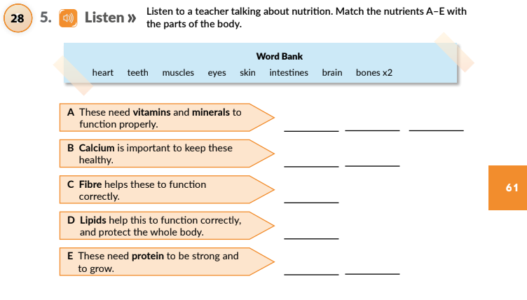  Taken from Way to Go 8th grade  - T explains the vocabulary from the word bank. T says a part of the body and asks some students to point at it.  - T makes sure Ss understand the highlighted words in the text.  - T asks Ss to listen to the audio and match the parts of the body with the nutrients.  - T plays the audio two or three times if necessary.  - T checks the answers with the whole class. | 20 minutes  T  T-Ss  T-Ss  Group work  20 minutes  Group work  25 minutes  Individual work  T-Ss  T-Ss  T-Ss  T-Ss
Engage phase | After checking prior knowledge about food vocabulary and nutritional information, Ss return to their seats.  - Ss read the guidelines 1-4 that are shown on page 62 exercise 7 and check the unknown vocabulary.  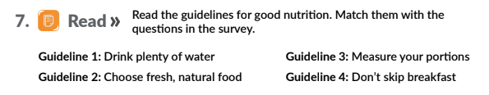  Taken from Way to Go 8th grade  - T asks some questions about the guidelines.  - Why is water good for health?  - Why is skipping breakfast not a good habit?  - What fresh and natural foods do you consume frequently?  - Do you measure your portions? Do you consider this important?  - Ss read the following survey and label the questions with the guidelines (page 62 exercise 7):  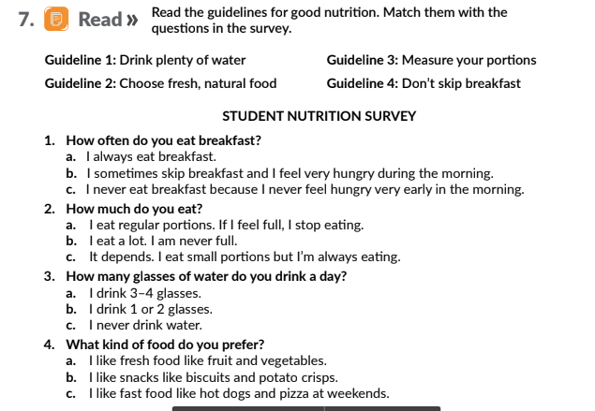  Taken from Way to Go 8th grade  Answers:  Question 1= Guideline 4: Don´t skip the breakfast  Question 2= Guideline 3: Measure your portions  Question 3= Guideline 1: Drink plenty of water  Question 4= Guideline 2: Choose natural and fresh food  - Ss answer the previous survey individually and socialize their answers. T encourages Ss to reflect and recognize if they have good or bad eating habits. T may use the following questions  - What do you think about your eating habits?  - What habits do you have to improve?  - What is one your family’s eating habits?  - Are they good or bad? Why? | 20 minutes  Individual work  T-Ss  15 minutes  Individual work  T-Ss
Practice  Language reflection  Semi-controlled practice | After talking about good and bad eating habits, Ss close the book and observe some images presented on the board. The idea is that SS get familiar with some vocabulary they need to understand a reading (Blog, page 64).  - T shows some images of foods that make up a famous typical Colombian dish: the paisa platter. These pictures are pasted on the board.  - T presents the name of these foods on small cards (eggs, red beans, fried pork, minced beef, rice, slices of fried plantain, avocado). So, Ss participate by placing the names under the corresponding flashcard.  - T elicits the name of the typical dish (paisa platter).  - Next, Students open the book on page 64 and do the following reading (activity number 6):  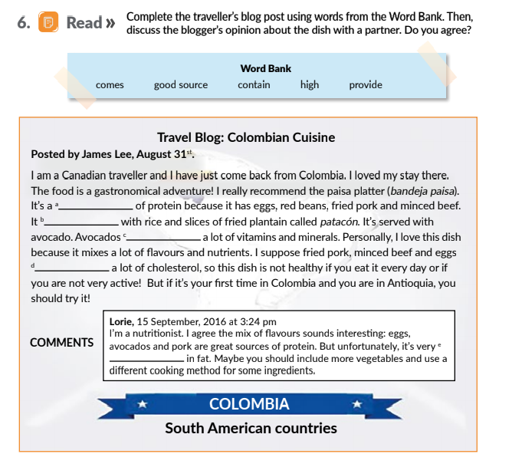  Taken from Way to Go 8th grade  - Ss check the vocabulary which appears in the Word bank.  - T asks some questions to set the reading in context:  What kind of text is it?  What is a blog?  Do you have a blog? Do your teachers have a blog? Who?  What is a blog for?  - Ss read, complete the text and check their answers in pairs.  - After, T asks some follow-up questions to contextualize the use and form of the modal should:  - Where is James from?  - What is his opinion about the paisa dish (bandeja paisa)?  - Why does he recommend this Colombian dish?  - What foods does he say may be unhealthy?  - What does Lorie think about the paisa dish?  - T takes some answers from the previous activity to explain the use of “should” through concept questions. T writes on the board what James Lee says about paisa dish: You should eat paisa dish because it is a good source of protein.  - T asks the following Concept Questions to Ss:  - What is James Lee doing?  - Expressing necessities.  - Giving some recommendations.  - Expressing obligation.  - What word is used to express recommendation?  - Because  - Good source  - Should  - What is the form of the verb?  - Base form  - Past  - Past participle  Now, T shows the negative form. T writes the following sentence on the board.  You shouldn´t eat the paisa dish if you are not active.  - Ss write other sentences in negative form, taking information from the blog.  T presents more examples about Ss’ real context.  - T asks Lorie’s recommendations about paisa dish. Ss complete the sentence using the model. Some answers could be:  - You should include more vegetables  - You should use a different cooking method for some ingredients.  - Ss complete the model:  - You _______________ include more ______________.  - You should ____________ a different cooking method for some ingredients.  - T elicits students to make another recommendation about this typical dish.  - You should __________________________________.  - You shouldn´t _______________________________.  - Once Ss identify the use and form of should, a mingle activity is carried out to gather information about the students’ eating habits and practice the use of the modal should. T gives each student a chart to participate in a round table (Appendix 1).  T plays music for students to dance in the center of the room. When the music stops, they should ask and answer the questions about their eating habits. This activity is done three times.  - After carrying out the activity, Ss get in groups of 3.T asks who has good or bad habits according to the information collected. Only bad habits are written on the board. Some eating habits could be:  - Skip the breakfast  - Drink little water  - Eat a lot of fast food  - Drink enough sodas.  - Don’t eat vegetables or fruits  - In each group, Ss give suggestions to each other depending on their eating habits.  - Ss select the best suggestions and the group with the highest number of sentences is the winner.  - Some of these suggestions are written on the board. T and Ss correct possible construction mistakes in the sentences. | 10 minutes  T-Ss  Individual work  20 minutes  Individual work  T-Ss  Pair-work  Ss-T  10 minutes  Individual work  Ss-T  Individual work  Ss-T  10 minutes  Ss-Ss  10 minutes  Group work
Free practice | After Ss practice in a controlled and semi-controlled way, they do a free-practice task. They get in groups of five people to create a blog entry by using the blog on page 64 (activity 6) as a model.  Writing process approach  - Ss identify the following reading categories in the blog and underlined them with different colors:  Traveler:  - Introductory idea (yellow color)  - Dish and ingredients (green color)  - Why you recommend (blue color)  - Closing idea (red color)  Nutritionist:  - Introductory idea (orange color)  - Recommendations (purple color)  T and peers check and correct the categories.  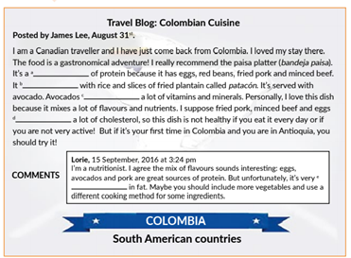  - Ss works in groups. Ss have to choose one typical dish from our city (tamal, chicken sancocho, lechona) to create a blog.  - Ss use the graphic organizer below to write the outline according to the role: Travellers. They recommend this dish to people from another country or city. Nutritionists: Recommend how to make the dish healthier.  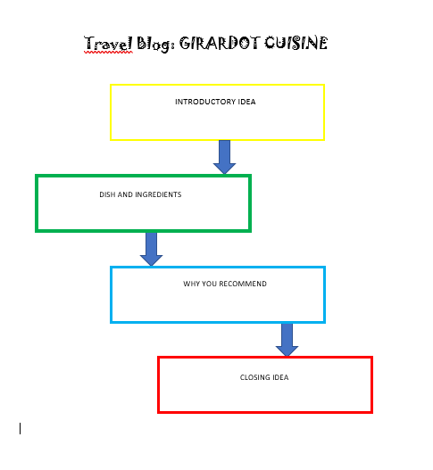  c) Based on the outline, each group writes a draft for the teacher and peers to correct it.  - With the new version, students present the blog in a poster. | 35 minutes  Individual work  T-Ss  Ss-Ss  Group work
Wrap up and assessment | - When Ss finish presenting the poster, Ss and T do the formative assessment task.  - Peer-Assessment. Ss make some comments about their classmates’ poster using the strategy: Two stars and a wish.  Ss identify two positive aspects of the posters of their peers and then express a wish; it means what their peers might do next time in order to improve an aspect of the poster. T may use the following link as a reference: https://ecdn.teacherspayteachers.com/thumbitem/Two-Stars-and-a-Wish-1183454-1500876148/original-1183454-1.jpg  - Ss do a self-assessment task by using the strategy “Can do statements” (See Appendix 2).  - The poster is assessed with a rubric (See Appendix 3).  - At the end, T implements the muddiest point technique in order to check the teaching- learning process. T hands out cards to Ss. T asks Ss not to write their names on the cards.  T ask Ss to answer the following questions on the cards:  What was the most important thing you learned during this class?  What important question remains unanswered? | 20 minutes  Ss- Ss  SS  Individual work  Ss- Ss  SS Individual work
Homework | - Finally, T takes the posters to identify possible construction errors. These will be indicated on the posters and the students will correct the errors in their notebooks. The corrections will be presented the following class.  - Ss conduct surveys on eating habits to 3 members of their family and 3 students of the school, taking the nutrition survey as a model (Way to Go 8, page 62 exercise 7.)  - T suggests to the students some links on eating habits to expand the topic studied in class:  http://www.webmd.com/children/kids-healthy-eating-habits#1  http://www.health.com/health/gallery/0,,20934662,00.html  https://en.islcollective.com/resources/printables/worksheets_doc_docx/eating_healthy_habits/food  - Ss socialize some bad habits identified in their surveys.

List a series of ideas of how this plan can be methodologically adapted so other teachers can implement it in their own educational context.
Implementation alternatives
- At the Warm-up stage, you can include specific foods from your city or department. If you have difficulty to carry real food, you can use flashcards as a good alternative to show such food.
- In the controlled practice stage, the reading is about a blog. if your students do not know about this, it is essential that you design one or explain what it is and what its main characteristics are.
- In the mingle activity, you can change or include more questions according to the healthy habits you know about your students.
- In the writing process, you should assure that students know aspects of the text structure specifically the introductory idea, the development and the closing idea. You can use other shorter readings, but with the same theme where the student identifies these three categories. According to this, keep in mind that the length of this stage may be longer.
- The theme of the blog made by SS can also be adapted based on a typical dish of SS’ region.
- You can implement other self-assessment techniques. For example, “Three things”: Students reflect on a lesson by answering the following- 3 things they learned, 2 things they want to know more about, and 1 question they have. Another could be “Traffic lights”: SS color with green-light where the success criteria have been achieved, amber-light where improvement is needed and red where they need help.
- In peer-assessment, you can implement “Feedback sandwich” which states that whenever you offer a corrective comment, sandwich it between two positive comments. “Learning wall” is another interesting strategy by which SS can post comments about their peers’ work.
- For CATs techniques, you can use “One-minute paper”: SS answer 2 questions in one minute which may be similar to those worked in the “Muddiest point” proposed in this lesson plan.

Write the key word for each category based on the content of this plan. For example:
Topic: environment Skill: reading Linguistic: should Vocabulary: animals, environment
Key words
topic | skill | linguistic | vocabulary | grade
Eating habits | Reading and writing | Modal “should” | Eating habits  Healthy food  Unhealthy food  Nutrients | 8th

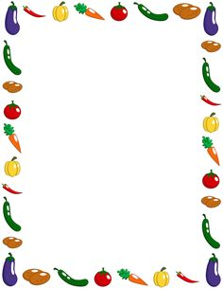
Appendix 1

Name | Do you eat breakfast? | Do you drink more or less than 8 glasses of water a day? | What is your favourite food? | What is your favourite drink? | Do you often eat fresh fruit and vegetables?

FINDING OUT INFORMATION ABOUT SOME EATING HABITS
Name. _________________________________

Find a classmate, ask some questions for a while, and then move on to speak to another classmate.

Name | Do you eat breakfast? | Do you drink more or less than 8 glasses of water a day? | What is your favourite food? | What is your favourite drink? | Do you often eat fresh fruit and vegetables?

FINDING OUT INFORMATION ABOUT SOME EATING HABITS
Name. _________________________________

Find a classmate, ask some questions for a while, and then move on to speak to another classmate.

Appendix 2

EATING HABITS
NAME: _________________________________________
DATE: GRADE:
I CAN… | Very well | well | With difficulty
Ask for and give information about eating habits
Make suggestions about eating habits
Identify suggestions and comments in a written text.
Create a poster where I make suggestions and recommendations
Respect classroom rules

Appendix 3

POSTER RUBRIC

NAME: ________________________________ DATE:_______________

 | EXCELLENT | GOOD | FAIR | POOR
Content | The poster includes all required categories:  - Introductory idea  - Dish and ingredients  - Why you recommend  - Closing idea | Some required categories are included on the poster. | Only 2 required categories are included on the poster. | The required categories were missing.
Graphics | All graphics are related to the topic and make it easier to understand. | Some graphics are related to the topic and most make it easier to understand. | Few graphics are related to the topic. | Graphics do not relate to the topic
Presentation | The poster is very attractive in terms of design, layout, and neatness. | The poster is attractive in terms of design, layout, and neatness. | The poster is acceptably attractive in terms of design, layout, and neatness. | The poster is very poorly designed. It is not attractive.
Grammar | There are no spelling, grammar or punctuation mistakes on the poster. | There are few spelling, grammar or punctuation mistakes on the poster. | There are some spelling, grammar or punctuation mistakes on the poster. | There are many grammatical mistakes on the poster

