INSPIRING TEACHERS
ELT PLAN TEMPLATE

Complete with the information about you
Author
Teacher´s name | CARLOS EDUARDO MARIN OROZCO
Email | carlosemarin@hotmail.com
School | La Asunción

Select the type of plan
Lesson plan | Activity plan | Task plan | Project plan
 |  |  | X

Write a few lines about the usefulness of this plan for the Colombian English teachers
Example: This lesson plan gives the students a chance to know about you, their new teacher, and it also gives you a valuable opportunity to assess your students' level. It can also be a useful and productive class if you ever find yourself substituting a class at short notice.
Author’s remarks
This plan helps students to use the integrated skills (speaking, reading, listening and writing) as well as new vocabulary related to the construction of democracy and peace through positive facts. It also allows students to improve their self-esteem, to see other´s qualities and values, and to reinforce their knowledge about previous topics already taught in class.

Complete with the information about your students
Grade | Length of lesson | Number of students |  | Average age
8th | 4 h 20 min | 39 |  | 13-15
Area |  | English level
Rural | Urban X | A1 X | A2 |  | B1

Select the curricular axe or focus
Curricular Focus / Axes
Environmental / Sustainability Education
Sexual / Health Education
Construction of Citizenship / Democracy / Teenagers | X
Globalization

Complete with information about the content and methodological approach of the plan
Topic | LANGUAGE IN THE CONSTRUCTION OF PEACE
Module / Unit | Module 3: DEMOCRACY AND PEACE
Language focus | Language Function | Language skills | Vocabulary
Language focus | Expressing positive language to promote the construction of peace at school. | Listening, speaking, reading and writing. | Qualities about people (kind, responsible, respectful, honest, tolerant, etc.).
Principles / approach | Project-based learning.

In “Aim”, state what the learning goal is, in other words, what you want your students to achieve by the end of the session.
In “Subsidiary aims”, relate the language skills (communicative and linguistic) students need to master in order to achieve the main aim of the lesson. Make sure the aims are learner-centred, specific, measurable, achievable, realistic, and action oriented.
Learning objectives
Aim | By the end of this lesson, students will be able to recognize and to use the role of language (positive and negative) in the construction of peace in the thorough integrated skills.
Subsidiary aims | By the end of this lesson, students will be able to …  - Describe in an oral and written way the role of language in the construction of peace by using meaningful and grateful experiences.  - Identify facts and opinions in medium length simple oral and written texts related to topics of general interest.  - Exchange information on topics of the role of language in the construction of peace through meaningful and grateful experiences by using role-playing.

List all the materials needed for this plan. Please, do not include any picture or photograph.
Materials needed
Downloaded pictures about student’s life moments, computers, cell phones, target shooting game toy, paper, markers, and pencils.

Write the name for each state of the plan. Then in the “Procedure”, write a detailed description of what the teacher and students do at each stage of the session.
Be sure to be thorough so any teacher can follow this plan. Write the procedure in third person and present tense.
Use these conventions: T= teacher S= students Ss= students
Stage | Procedure | Time and interaction
Warm up | T shows SS some cartoon stories about attitude adjustment with positive and negative attitudes.  Students get in pairs, they sort and discuss the kind of attitudes they should have to be successful in life, and what kind of attitudes they need to improve by acting out the cartoon pictures they have.  T randomly selects cartoons from the internet.  Self-assessment: Hand signal:  T asks SS to show thumbs up or down. Thumbs up means everything is clear; thumbs down mean SS need clarification/reinforcement. | 20 minutes  T-SS  SS-SS  Pair work
Introduction of the Project | SS watch the video: Think positively cartoon https://www.youtube.com/watch?v=An2OaIbPSII Then, SS will give some facts and opinions about it.  SS brainstorm main ideas and vocabulary about peace, success, solving conflicts, positive attitudes, such as kindness, happiness, honesty, caring, friendship, courage, responsibility, and perseverance.  SS talk about past experiences where they showed positive attitudes through a target shooting game toy (Target Games are activities in which players send an object toward a target board table while avoiding any obstacles, Participants learn about and practise aim and accuracy as they send an object toward targets different distances away) when SS get the target, they will talk about their experiences that construct peace by using the vocabulary given.  T tells SS that by this is a project they will be doing together. At the end, SS will have a virtual album + a brochure based on the project development and class topic. | 20 minutes  T-SS  SS-SS
Development 1 | SS answer some questions about grateful and positive moments in their lives by pointing on the expression: the language that construct peace. During the school SS will participate in some debates and in a show and tell activity that encourage them to use basic vocabulary and concepts about their meaningful moments that construct peace in the family, school, friends and the surrounding community.  A reading comprehension worksheet about the topic what makes people successful will be developed during classes. This worksheet pretends to inspire students to improve their reading skills through the use of simple questions, and vocabulary that help them to be better people who are able to construct peace.  Taken from: https://en.islcollective.com/download/english-esl-worksheets/grammar/present-simple-vs-continuous-progressive-tense/reading-comprehension-what-makes-people-succesful/37343  Self-assessment: Hand signal:  T asks SS to show thumbs up or down. Thumbs up means everything is clear; thumbs down mean SS need clarification/reinforcement. | 60 minutes  SS – SS
Development 2 | A worksheet: Good vibes, Motivation and Inspiration Will be developed. A set of cards that bring students the possibility to express their feelings and ideas about meaningful moment in life will be carried out. This worksheet is intended to bring positive vibes in the classroom and at the same time, practice conversation among your students. The activity could be done in groups or pairs.  TAKEN FROM: https://en.islcollective.com/english-esl-worksheets/material-type/fun-activities-and-games/good-vibes-motivation-and-inspiration/95816  Self-assessment: Learning Journal:  SS’ notes will be fully appreciated, they will complete in their notebooks the most important experiences, and positive activities that help them to solve conflicts and to construct peace in their immediate environment.  After participating in the show and tell activity, SS will pick up at least five meaningful moments.  Finally, SS illustrate their moments by making a brochure (A brochure is an informative paper document for advertising, which can be folded into a template, pamphlet or leaflet). | 60 minutes  SS
Development 3 | SS find out pictures about their meaningful moments, and positive aspects that construct peace to create a virtual album; the images could be personal pictures or downloaded images from their personal ‘albums or cell phones, also clipart images about caring, honesty, solving problems, reconciliation, peace, friendship are allowed too. (If they don’t have printing tools access they can use images related to the topics from magazines and newspaper.) | 40 minutes  SS
Consolidation | SS present their virtual album and the brochure in front of the class, by reflecting the importance to highlight memorable moments in life that encourage them to improve their relationships, bearing in mind the situations that construct peace in their surroundings. (SS neighbourhoods are places with many social issues, that’s why the importance to inspire a positive relationship among them).  Assessment:  When the whole class presents their albums, by groups of four, SS talk about their classmates’ works by using positive vocabulary, and they express each other how happy they feel by sharing moments at school. A check list chart will be designed for the students to verify the aims of the topic and their progress.  Rubrics charts are an important tool to see students’ progress.  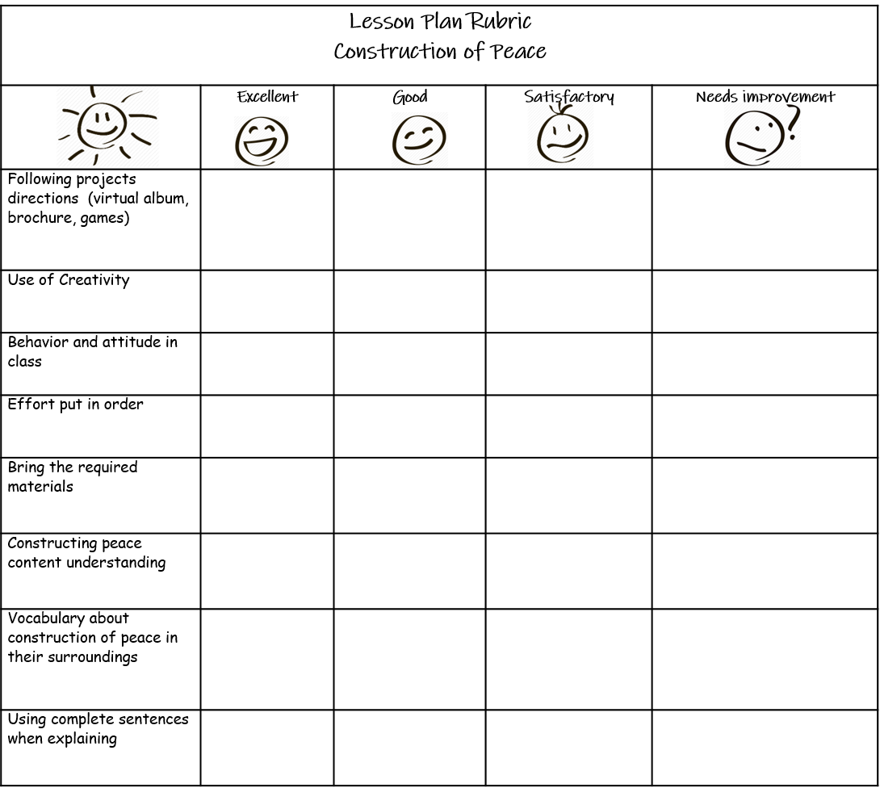  Peer assessment will be carried out at the end of the activities proposed in the lesson plan.  Self-assessment: Exit ticket.  SS are asked to answer 2 questions before class ends.  - What kind of language should I use to avoid conflicts within my neighbourhood, school, etc.?  - What compromise can I make today to avoid any kind of conflict? | 40 minutes  SS- SS  20 minutes  SS

List a series of ideas of how this plan can be methodologically adapted so other teachers can implement it in their own educational context.

Implementation alternatives
This project plan will help other teachers to create a peaceful environment in their school, by providing the students tools for believing in their dreams and to highlight the positive attitude they should have to create and inspire peaceful environment in their nearby community. Most of the activities require the use of technology, students are plenty involved, and that is why any teacher who would like to apply this lesson can do it.

The suggested activities could be developed with recycled materials and reused papers, taking into account that many of our schools, and some of the students don’t have enough technology support and access.

Different strategies to learn the topic could be role plays performances, art projects, music creations and homemade videos where kids could show their abilities and preferences, taking into account that is a social topic that promotes peace and good relationships in life.

It is important to have a critical thinking about how the teaching strategies will help in the class development.
Journals, diaries and checklists can be useful tools for improving methodological strategies in this lesson.

(Teacher tips: bingo board games could be used instead the target shooting game toy).

Write the key word for each category based on the content of this plan. For example:
Topic: environment Skill: reading Linguistic: should Vocabulary: animals, environment
Key words
topic | skill | linguistic | vocabulary | grade
Construction of peace | Reading, writing, listening and speaking. | Present tense | Personal Qualities | 8th

Appendix Section

Worksheet 1

What makes people successful?

Who do you think is the most successful? Who do you think is the least successful?

In order to answer these questions, we first need to define success. Everyone has a different definition. Many of us place great value on performance, on achievements, or on reaching various goals. Others associate success with material goods, measuring it by how much one can acquire. Others measure success by how much they can contribute to the well-being of their families, or to the community and society in general there are many other definitions, but mostly success is associated with becoming rich, famous, and respected at work.
Yet, it doesn’t have to be that way.

Being successful could mean simply being satisfied with oneself and one’s career. For many people, a successful person is someone who feels that his or her work and life in general offer an exceptionally high degree of satisfactions.
But how does one get from here to there? How does one reach this feeling of satisfaction with life and career? It seems that successful people consistently do two things:

- They use their natural abilities in their work.
- They set career and life goals.

In other words, successful people choose careers where they can use their natural abilities, or do what comes naturally to them. For example, successful teachers are people who instinctively know how to help people learn, and the best doctors are those who know how to listen to people. Successful people know where they are starting from, and what direction they want to give their lives and careers, even if it is something as simple and wonderful as raising a happy family.
What are your natural abilities? What are your career and life goals? If you can answer these questions, you are on your way to having a successful career and life.

1. According to the previous reading, answer the following questions:

A. __________ there is a general consensus on the definition of success.
B. __________ a lot of people think that you are successful if you are rich and famous.
C. __________ Successful people choose careers that match their skills.
D. __________ Successful people don’t plan their lives.
E. __________ doing what comes naturally to you helps make you successful.
F. __________ raising a happy family is not enough to be considered successful.

2. Choose the most accurate summary of the corresponding answer from the following questions:

2.1. What kind of other definitions can be found about how to succeed?

a) People can define success as having material goods and raising a family.

B) Success is measured only by being rich and famous. However, other people consider that it is defined when others reach their goals in life.

c) The definitions of success can vary from one individual to another. Thus, some people can measure it by having material goods, reaching their life goals or simply giving their best to their families or community.

2.2. How can a successful person be defined?

a) It can be defined when someone is enjoying what he/she does. Nevertheless, he/she can encounter ups and downs in their lives in a regular basis. For this reason, it cannot have an exact definition at all.

b) Human beings as a whole can feel the pleasure of being successful by his or her job, and lives in general making sure that they are entirely pleased with them.

c) A successful person is someone who presents an exceptionally high degree by having material goods and have lived happily with their families.



Taken from: https://en.islcollective.com/download/english-esl-worksheets/grammar/present-simple-vs-continuous-progressive-tense/reading-comprehension-what-makes-people-succesful/37343

Worksheet 2


Good vibes, Motivation and Inspiration
Think about 3 things that you are grateful for today
Who are your role models and inspiration in life?
What motivates you to study English?





What is your ‘go-to-song’ whenever you need motivation?
Name 3 things that you appreciate about your partner.
Share your favourite inspirational or motivational quote.



What is the nicest thing that someone has done for you recently?
Name 3 things that make you smile.
Think of a goal. How do plan to achieve it?




What lifts you up when life gets you down?
What little thing could you do to make someone’s day better?
Compliment 3 things about your partner!





It’s up to you whether to take this challenge or not.
Every morning when you wake up or before you go to sleep, think about something you are grateful for.
Do this for 30 days
Trust me; it will change your life ^_~

TAKEN FROM: https://en.islcollective.com/english-esl-worksheets/material-type/fun-activities-and-games/good-vibes-motivation-and-inspiration/95816

