INSPIRING TEACHERS
ELT PLAN TEMPLATE

Complete with the information about you
Author
Teacher´s name | Ricardo Consuegra Martínez
Email | Ricoma67@hotmail.com
School | I.E.Noroccidental de Soledad

Select the type of plan
Lesson plan | Activity plan | Task plan | Project plan
 | X

Write a few lines about the usefulness of this plan for the Colombian English teachers
Example: This lesson plan gives the students a chance to know about you, their new teacher, and it also gives you a valuable opportunity to assess your students' level. It can also be a useful and productive class if you ever find yourself substituting a class at short notice.
Author’s remarks
This plan enhances the use of adverbs of frequency at the moment of describing different activities like going to the supermarket. In other words, it helps ss enrich their expressions related to daily activities by adding the frequency with which they develop such activities.

Complete with the information about your students
Grade | Length of lesson | Number of students |  | Average age
9th | 1 hour | 42 |  | 14 years old
Area |  | English level
Rural | Urban X | A1 X | A2 |  | B1

Select the curricular axe or focus
Curricular Focus / Axes
Environmental / Sustainability Education
Sexual / Health Education
Construction of Citizenship / Democracy / Teenagers | X
Globalization

Complete with information about the content and methodological approach of the plan
Topic | My personal activities
Module / Unit | Module 2. Unit 2
Language focus | Language Function | Language skills | Vocabulary
Language focus | Reporting the most common activities practiced in their free time. | Speaking | Go shopping, paying videogames, swimming, meeting friends.
Principles / approach | Noticing approach

In “Aim”, state what the learning goal is, in other words, what you want your students to achieve by the end of the session.
In “Subsidiary aims”, relate the language skills (communicative and linguistic) students need to master in order to achieve the main aim of the lesson. Make sure the aims are learner-centred, specific, measurable, achievable, realistic, and action oriented.
Learning objectives
Aim | By the end of this lesson, students will be able to describe how frequently they develop certain activities in their daily lives
Subsidiary aims | By the end of this lesson, students will be able to …  - Ask for and give the frequency in which activities are carried out.  - Classify different exercises depending on how often are developed.

List all the materials needed for this plan. Please, do not include any picture or photograph.
Materials needed
Ball, any colour. Adverbs of frequency cards. Markers and board.
https://www.eslkidstuff.com/lesson-plans/adverbs-of-frequency.html#print-outs
worksheets from this website.

Write the name for each state of the plan. Then in the “Procedure”, write a detailed description of what the teacher and students do at each stage of the session.
Be sure to be thorough so any teacher can follow this plan. Write the procedure in third person and present tense.
Use these conventions: T= teacher S= students Ss= students
Stage | Procedure | Time and Patterns of interaction
Ice-breaker | T asks SS to play a game to review days of the week and play ball toss  To begin, T gets everybody standing up and tosses a ball to a student who tosses it to another student and so on around the class – T lets everyone have fun for a minute throwing the ball around the class and trying not to let it drop on the floor.  Next, T has a student toss the ball to him and as he catches it, shouts “Monday”. T tosses the ball to another student and encourages him/her to shout “Tuesday” as they catch it. It continues with the days of the week being shouted out in the correct order, going around the class. If the ball is dropped or the wrong day is said T must start again with Monday.  T Sets a target of 3 or 4 fast rounds without mistakes or dropping the ball. | 10 minutes  T-SS
Pre-activity | T encourages a s to choose one of the activities on the board, such as “I go shopping with friends”. In the space on the right-side of the board write “On Saturdays, I _________ go shopping with friends”.  Then under this, T draws a vertical line with 0% at the bottom and 100% at the top to make a frequency chart, as follows:  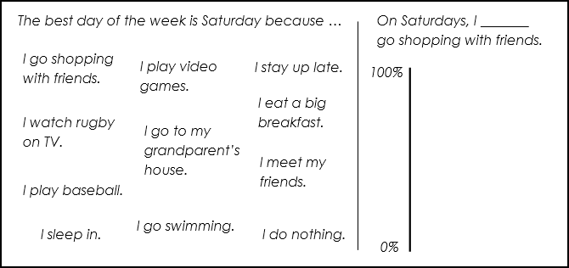  Then T points to himself and at the 0% and shakes his head to indicate that he never goes shopping with friends on Saturdays.  Next, T gets a few volunteers to come up to the board and point on the vertical line where their answers would be (e.g. around 50% for sometimes, 70% for often, etc.). | 15 minutes  T-ss
While-activity | At this point T will add the frequency adverbs to the chart. Before class, T prepares cards with the adverbs of frequency written on them (always, almost always, often, usually, sometimes, rarely, hardly ever, almost never, never) attachment 1. T puts the “never” card at 0% on the board. Say “I never go shopping with friends on Saturdays”.  T gives the rest of the cards to different students and asks them, one-by-one, to come to the board and place them where they think they would go on the chart. As each student guesses, T gets everyone to help by saying “higher!” or “lower!”. T keeps having students come up to the board with their cards until he has a completed chart:  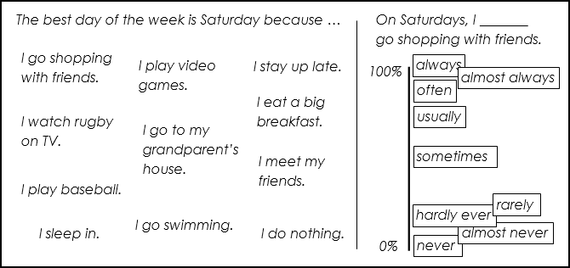  T goes around the class asking everyone to say how often they go shopping using the full structure (e.g. “On Saturdays, I often go shopping with friends.”)  T puts students into small groups of 3 or 4 and gets them to say how often they do all the activities written on the board. T walks around and helps out with mistakes. | 15 minutes  SS- SS
While-activity | Assessment: T implements the learning logs strategy to help ss assess their own process so right at the end of this activity, ss must respond to no more than three of the following prompts in their notebooks.  • with the adverbs of frequency, I learned that...  • The most useful adverb of frequency that I will take from this lesson is . . .  • I really liked the. . .  • What I liked most about this lesson was. . .  • Adverbs of frequency are mainly used for… | 15 minutes  SS- SS
Post-activity | Chat, writing activity:  Students are asked to simulate a chart conversation with a person from England with whom they are exchanging information about their daily activities. So, they will start by writing the script:  Me: Frank, how often do you go swimming on Saturdays?  English man: On Saturdays, I hardly ever go swimming.  Me: interesting! And Frank how often do you sleep in on Saturdays?  English man: On Saturdays, I always sleep in.  etc.  The idea is to motivate students to write different questions and then change the role to the reader. | 10 minutes  SS – SS
Post-activity | Assessment: feedback sandwich technique  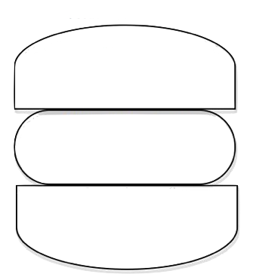  Every student will assess some of their classmates with this technique this way  Something I like about your  presentation was…  I suggest you to…  I encourage you next time to… | 10 minutes  SS – SS
Wrap-up | Do the "Adverbs of frequency questionnaire"  https://www.eslkidstuff.com/lesson-plans/adverbs-of-frequency.html#print-outs  The worksheets are in this link.  T puts students in pairs, gives out the A/B pair worksheets and allows a couple of minutes for everyone to check for vocabulary issues. Then start the activity - everyone asks their partners the questions from the questionnaire and records their answers. At the end, T has students tell the class about their partners. | 10 MINUTES  T – SS

List a series of ideas of how this plan can be methodologically adapted so other teachers can implement it in their own educational context.
Implementation alternatives
This amazing activity can also be implemented with a HOW OFTEN questionnaire which encourages ss to ask and answer a wider range of topics and not only the daily activities. You can contextualise it with sports, tv shows and visiting family.

Write the key word for each category based on the content of this plan. For example:
Topic: environment Skill: reading Linguistic: should Vocabulary: animals, environment
Key words
topic | skill | linguistic | vocabulary | grade
Frequent activities | Speaking | Adverbs of frequency | Go shopping, paying videogames, swimming, meeting friends. | 9th

Attachment 1
Adverbs of frequency cards
always, almost always, often, usually, sometimes, rarely, hardly ever, almost never, never

Always | Almost always | Often
Usually | Sometimes | Rarely
Hardly ever | Almost never | Never

