INSPIRING TEACHERS
ELT PLAN TEMPLATE

Author
Teacher´s name | Vicky Cantillo González
Email | macrie5@hotmail.com
School | I.E.D. Juan José Rondón

Lesson plan | Activity plan | Task plan | Project plan
 | X

Author’s remarks
This lesson plan gives students and teachers the opportunity to verify how the learning process is going and offers chances to learn not only the new language but a meaningful topic (the weather) in a very creative and productive way. Finally, it provides students with enough vocabulary to describe the weather and teachers with a bunch of activities to conduct a meaningful class.

Grade | Length of lesson | Number of students |  | Average age
9° | 60 minutes | 35 |  | 14-15 years old
Area |  | English level
Rural | Urban X | A1 X | A2 |  | B1

Curricular Focus / Axes
Environmental / Sustainability Education | x
Sexual / Health Education
Construction of Citizenship / Democracy / Teenagers
Globalization

Topic | The weather
Module / Unit | EP! 1 Module 2, Unit 2, lesson 5 (pages 64-65)
Language focus | Language Function | Language skills | Vocabulary
Language focus | Comparing the climate in different regions of Colombia. | Speaking | Climate, summer, winter, cold, hot, wet, cloudy
Principles / approach | A topic-based approach to the language syllabus.

Learning objectives
Aim | By the end of this lesson, students will be able to describe the climate of Barranquilla and other cities of Colombia.
Subsidiary aims | By the end of this lesson, students will be able to …  - recognize weather expressions such as rain, heat, cold to express weather status.  - select important climate data from a place in Colombia to prepare an exhibition.

Materials needed
Video beam, laptop, speakers, photocopy, paper, images, cell phone.

Stage | Procedure | Time and Patterns of interaction
Warm up | T tells students that at this stage of class, she will check their previous knowledge.  T shows ss some flashcards of the 4 different seasons (winter, summer, autumn and spring) and then asks them to identify the image and write it in their notebook. Ss can write words related to each season, for example, cold, hot, trees, etc. After this, T shows the appropriate way to write the season (spelling) following each image, so students verify what they know about this topic. | 5 minutes  Individual work
Introducing language | At this stage, T shows SS in a power point presentation some images of cities in Colombia (Medellin, Barranquilla, San Andres, Tunja, Choco, Manizales and Leticia)  T asks SS to observe them, identify the location and describe the weather in each city.  T checks SS answers, congratulates those who respond very well and invites the other students to study the vocabulary, to practice it. | 5 minutes  work into group
Practice | This exercise introduces students to the topic of weather.  T asks students to open the book (English, please!) on page 64, exercise 1- focus on vocabulary- and look at the words in the box and repeat them after her  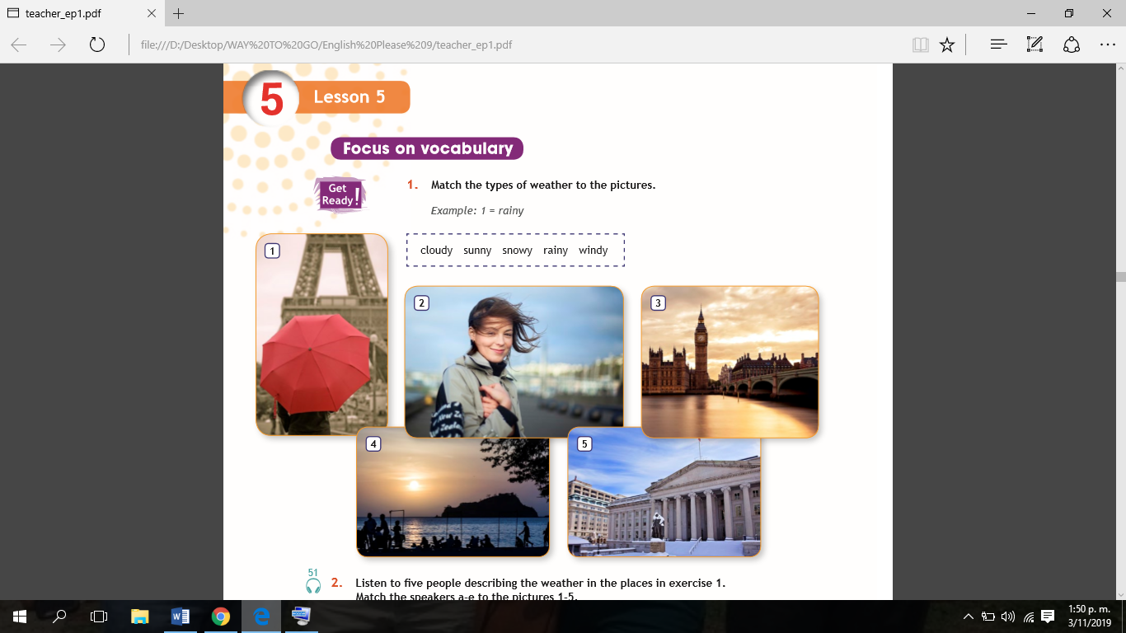  T organises the class into pairs to do the matching task: match the type of weather to the picture. T checks SS answers.  T asks SS to look back at the images and tell her where the places are in each picture (1. Paris, 2. Wellington, 3. London, 4. Santa Marta, Colombia, 5. Washington, D.C.).  Then T asks SS to listen to five people describing the weather in the places in exercise 1. Match the speakers a-e to the pictures 1-5. (Page 64- exercise 2)  T plays audio track 51. SS do the matching task individually in their notebooks and then compare answers with a partner.  T asks SS to say where they think the five pictures in exercise 1 were taken.  In the next exercise, T asks SS to match the adjectives describing temperature to pictures 1-4. (Page 64- exercise 3)  T asks SS to do the matching task individually and then compare answers with a partner. | 20 minutes  Pair work  Individual work /Pair work
Practice | Assessment:  ONE MINUTE PAPER  In order to check students’ learning process, the teacher implements” A minute paper” Technique:  - T asks students to answer two questions in 1 minute:  - What was the most important idea you learned?  - The audio, was easy or difficult to understand for you? Why?  - T gives students one or two minutes to think about the activity without writing anything.  - Then, T gives students a short period of time (1 minute) to write as much as they can.  T collects papers and tells SS that after class, she will read them and analyse their answers, according to their responses she will implement activities that improve their learning. | 20 minutes  Pair work  Individual work /Pair work
Production: | T sends SS outside the classroom and T asks SS to observe the weather.  Then T asks SS to describe the weather where they are today. T checks some SS’ answer  T asks SS to imagine that they are in a different city where they live, choose a city of Colombia and investigate on internet its weather. In collaborative team work they make poster and explain the class the weather of their cities.  T gives SS some material as poster board, marker.  Before starting the activity, T explains SS the categories that she will evaluate through the rubric. | 25 minutes  Ss – ss  collaborative team work
Production: | Assessment:  RUBRIC  the rubric will grade the students’ oral performance.  Oral Presentation Rubric: WHAT’S THE WEATHER LIKE?  Teacher Name: Vicky Cantillo  Student Name: _________________________________________________  After the activity, T explains SS the peer-assessment: learning wall.  LEARNING WALL  T gives students a paper for them to express their opinion making feedback about classmates’ activity, then they stick it on the wall and all students read them. | 25 minutes  Ss – ss  collaborative team work
  CATEGORY | 4. LOW  (1.0-5.9) | 3. BASIC  (6.0-7.9) | 2. HIGH  (8.0-8.9) | 1. SUPERIOR  (9.0-10.0)
  DESCRIPTION | Occasionally describe the weather states of Barranquilla and other cities of Colombia | Sometime describe the weather states of Barranquilla and other cities of Colombia | Often describe the weather states of Barranquilla and other cities of Colombia | Describe correctly the weather states of Barranquilla and other cities of Colombia
  VOCABULARY | Use few words to describe the weather of a city | Use some words to describe the weather of a city | Use proper vocabulary to describe the weather of a city | Use the vocabulary broadly to describe the weather of a city
  PRONUNCIATION | His/her pronunciation and vocalization is not very clear | His/her pronunciation and vocalization is partially clear | His/her pronunciation and vocalization is clear | Pronounce the words correctly and vocalization very well
Wrap-up | T reflects on the topic worked and students make an assessment of the work done and express explicitly about the learnings achieved and what difficulties they had. | 5 minute Individual work
Wrap-up | Assessment:  TRAFFIC LIGHT  At the end, T gives students 3 images to express the level of their leaning.  - T asks student that first image is the weather “HOT”, it means the high level. Second image is the weather “warm”, it means the medium level and third image is the weather “cold” it means the low level. | 5 minute Individual work

Implementation alternatives
- Consider students' learning style
- Analysing the context in which the school is located and what educational resources the school has.
- Look for educational resources that can be exchanged for activities that require the Internet if you don't have the network.
- Adapt activities according to students' learning level.
- For the season flashcards, Teachers are free to select their own pictures and/or flashcards.

Key words
topic | skill | linguistic | vocabulary | grade
The weather | speaking | Present tense of verb to Be | Climate, summer, winter, cold, hot, wet, cloudy | 9°

